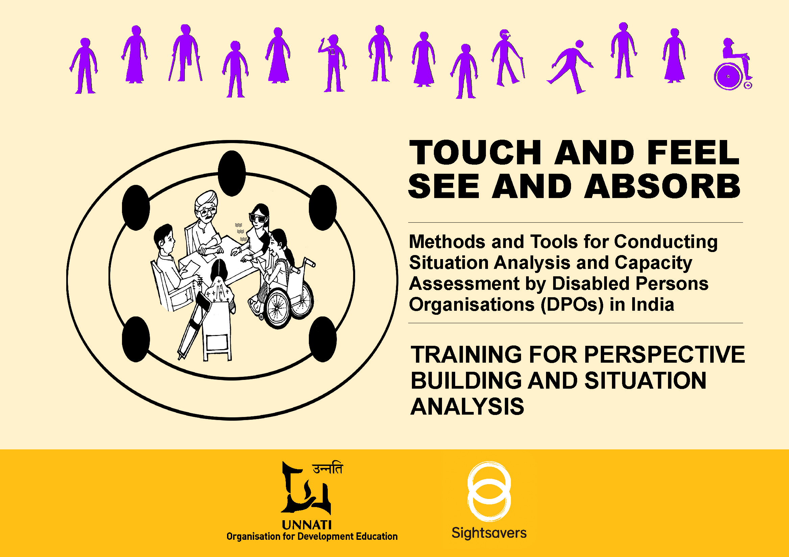
TOUCH AND FEEL
SEE AND ABSORB
  - Methods and Tools for Conducting Situation
Analysis and Capacity Assessment by Disabled Persons
Organisations (DPOs) in India

1 of 3

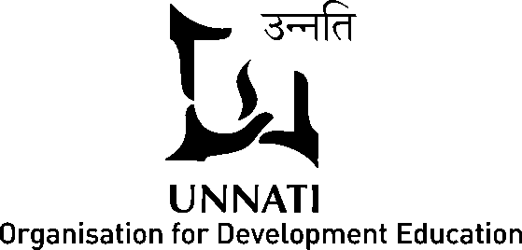

Presented by: Unnati and Sightsavers
Produced by: Unnati Organisation for Development Education
G 1/200 Azad Society, Ahmedabad 380015, Gujarat, INDIA
PH: 91 79 26746145/ 26733296
Email: sie@unnati.org

Project cycle: October 2012 – March 2014
Project Coordinator: Ms. .Deepa Sonpal
Support: Ms.Sandipa Nelson, Ms.Geeta Sharma and Mr.Venkatesh Prasad
Layout: Mr.Ramesh Patel
Illustrations: Mr.Ranjit Balmuchu
Accessible Daisy Format: Saksham Trust, New Delhi
Advisory Committee: Mr Binoy Acharya (Director, Unnati), Prof Neharika Vohra (Professor, IIM-A), Dr Yogesh Kumar (Director, Samarthan), Prof T V Rao (Adjunct Professor, IIM-A), Dr Rajesh Tandon (President, PRIA), Dr Kaustuv Bandhyopadhya (Director, PRIA) and Dr Harish Vashistha (Independent Senior OD Consultant).
Partner NGOs/ DPOs
1. Action on Disability and Development (ADD) and Anna Theresa Disabled Development Trust (ATDDT): Mr. Sashi Kumar, Mr. Subramani Muralidhara, Mr. N V Ranganatha, Ms. Bhuvneshwari and Mr. Venkatesh Balakrishna
2. Disability Advocacy Group (DAG), Gujarat: Ms. Kinneri Desai, Mr. Parag Panchal and Ms. Neeta Panchal
3. National Association of the Blind (NAB), Sabarkantha district branch: Ms. Vishlesha Jani, Ms. Praveena Mehta and
Dr. Bhaskar Mehta
4. Rashtriaya Viklang Manch (RVM), Rajasthan and Madhya Pradesh state branches: Mr.Sonu Golkar, Ms.Rajesh Nimole,
Mr.Om Prakash Sharma, and Dr Victor John Cordeiro
5. Sama Foundation and KARO: Mr. Devaraju Rangaswami, Ms. Sudharani Annayappa, Mr. Paul Ramanathan and Ms. Prascila Christopher
6. Sanchar A.R.O.D and Disability Rights Group (DRG): Mr. Sujeet Karmakar, Ms. Asmita Banerjee and Ms. Tulika Das
7. SPARC India and Uttar Pradesh Viklang Manch (UPVM): Mr. Suraj Yadav, Ms. Shraddha Singh and Mr. Amitabh Mehrotra
Guidance and support from Sightsavers:
Mr. Cyrille Evini and Ms. Susan Pieri

Disclaimer
This toolkit has been developed based on the assumption that organisational development (OD) or institutional building processes have largely remained the domain of experts and professionals. As a result, the existing tools on OD or institutional development have not been demystified and made accessible, limiting the participation of persons with different kinds of disabilities, i.e. persons with visual impairment (totally blind and low vision), persons with hearing impairment and other disabilities to take charge of conducting their own situational analysis and capacity assessment and advocate for their rights. This toolkit aims to offer a preliminary set of tools adapted from the existing set of tools available in the literature. The set of accessible tools has evolved through field-based interventions conducted through three trainings each at eight locations in India. The case studies developed by groups/ DPOs/ NGOs have been drawn up based on real-life examples and have no intent to hurt the sentiments of any particular group/s or communities. There may be many more tools that could be similarly used to conduct situation analysis and capacity assessment of DPOs in the regional context. The experiences from other regions and other tools could be added to this toolkit to offer a wider range. A continuous use of such tools over a period of time will enable an organisation to critically asses and modify the existing tools in the context of disability and perhaps a new set of tools may evolve through practice.

Contents
FOREWORD 9
FOREWORD 12
PREFACE 14
1. THE INITIATIVE AND PROCESS 16
1.1 The Relevance of the Initiative 16
1.2 Identifying Partners and Working out Formal Relationships 18
1.3 Literature Review and Preparation of Compendium 21
1.4 Inception Workshop with Partners and OD Experts 21
1.5 Training of Trainers (ToT) for Capacity Building of Partners 23
1.6 Facilitation Support for Three Trainings at the Field Level 25
1.7 Lessons Learnt Workshop 29
1.8 Monitoring Mechanism 30
2. HOW TO USE THE TOOLKIT 31
3. TRAINING FOR PERSPECTIVE BUILDING AND SITUATION ANALYSIS 34
3.1 Workshop Design (suggested) 35
3. 2 Approaches to Disability 37
3.2.1 Understanding Disability (Reading) 37
I. Models and Approaches to Disability 38
II. Legal Frameworks on Disability 39
III. Status of Disability in India 41
i. Citizenship 41
ii. Socio-cultural Attitudes and Beliefs 43
iii. Health Care 44
iv. Education 45
v. Employment 46
vi. Access to Justice 47
vii. Community-based Inclusive Development/ Rehabilitation 47
viii. Access: Barrier-free Environment 48
a. Access to Built Environment 48
b. Accessible Information and Communication 49
c. Access in Transport 50
d. Access to Goods, Services and Facilities 50
ix. Concerns of Specific Groups 51
a. Girls and Women with Disabilities 51
b. Persons with Mental Illness 53
c. Persons with Multiple Disabilities 54
d. Disability and Disasters 54
IV. Disability Rights Movement in India and the Emergence of DPOs 56
V. Nature and Challenges Faced by BPOs/ DPOs in India 58
3.2.2 Session Plan and Facilitation Note – Approaches to Disability 65
3.2.3 Cases for Approaches to Disability (Handout) 69
i. Safia’s Story (orthopaedic disability) – Charity Model 69
Script for skit - Safia’s Story (orthopaedic disability) – Charity Model 70
ii. Safia’s Story (orthopaedic disability) - Medical Model 73
Script for skit - Safia’s Story (orthopaedic disability) – Medical Model 73
iii. Safia’s Story (orthopaedic disability) – Social Model 77
Script for skit - Safia’s Story (orthopaedic disability) – Social Model 77
iv. Safia’s Story (orthopaedic disability) – Rights-Based Model 81
Script for skit - Safia’s Story (orthopaedic disability) – Rights-Based Model 81
v. Shiva’s Story (visual impairment) – Charity Model 85
Script for skit - Shiva’s Story (visual impairment) – Charity Model 85
vi. Radha’s Story (cerebral palsy) – Medical Model 86
Script for skit - Radha’s Story (cerebral palsy) – Medical Model 87
vii. Murali and Revathi’s Story (hearing impairment) – Social Model 88
Script for skit - Murali and Revathi’s Story (hearing impairment) – Social Model 89
viii. Kariappa’s Story (orthopaedic disability) – Rights-Based Approach 91
Script for skit - Kariappa’s Story (orthopaedic disability) – Rights-Based Approach 91
ix. Rita’s Story (intellectual disability) – Charity Model 93
x. Seema’s Story ( visual impairment) – Medical Model 93
xi. Sejal’s Story (locomotor disability) – Social Model 93
xii. Sheela’s Story (cerebral palsy) – Right-Based Model 94
xiii. Sheeba’s Story (cerebral palsy) – Charity Model 94
xiv. Ria’s Story (cerebral palsy) – Medical Model 95
xv. Shyam’s Story (visual impairment) – Social Model 95
xvi. Ramesh’s Story (orthopaedic disability) – Rights-Based Model 95
xvii. Laxmi’s Story (visual impairment) – Charity Model 96
xviii. Darshana’s Story (hearing impairment) – Medical Model 96
xix. Shailesh’s story (visual impairment) – Social Model 96
xx. Sushila’s Story’s (visual impairment) – Rights-Based Model 97
xxi. Ram’s Story (orthopaedic disability) – Charity Model 97
xxii. Ram’s Story (orthopaedic disability) – Medical Model 98
xxiii. Ram’s Story (orthopaedic disability) – Social Model 98
xxiv. Ram’s Story (orthopaedic disability) – Rights-Based Model 98
xxv. Kumar’s Story (quadriplegia) – Charity Model 99
xxvi. Kumar’s Story (quadriplegia) – Medical Model 99
xxvii. Kumar’s Story (quadriplegia) – Social Model 100
xxviii. Kumar’s Story (quadriplegia) – Rights-Based Model 100
3.3 PROBLEM ANALYSIS OF SOCIAL EXCLUSION 104
3.3.1 How to do Problem Analysis (Reading) 104
3.3.2 Session Plan and Facilitation Notes – Problem Analysis of Social Exclusion 108
3.3.3 Case Studies for Problem Analysis (Handout) 115
xxix. Asha’s Story (visual impairment) 115
Text of talk theatre of Asha’s Story (visual impairment) 117
Picture Story Board of Asha’s Story – Problem Analysis for Social Exclusion 122
PROBLEM ANALYSIS FLOW CHART ASHA’S STORY–1 148
PROBLEM ANALYSIS FLOW CHART ASHA’S STORY– 2 149
PROBLEM ANALYSIS FLOW CHART ASHA’S STORY– 3 150
xxx. Chandramathi’s Story (intellectual disability) 151
Picture Story Board - Chandramathi’s Story (intellectual disability) 154
PROBLEM ANALYSIS FLOW CHART – CHANDRAMATHI’S STORY 168
xxxi. Picture Story for Case Analysis 169
xxxii. Khurshida’s Story (visual impairment) 170
PROBLEM ANALYSIS FLOW CHART – KHURSHIDA’S STORY 172
xxxiii. Pramila’s Story (visual impairment) 173
PROBLEM ANALYSISFLOW CHART PRAMILA’S STORY– 1 175
3.4 Engaging Stakeholder Participation 176
3.4.1 How to Engage Stakeholder Participation (Reading) 176
i. Identification of Key Stakeholders 177
ii. Assessment of Importance and Influence 177
iii. Engagement and Partnership with Stakeholders 183
iv. Developing Effective Strategies for Stakeholder Engagement 185
3.4.2 Session Plan and Facilitation Notes: Engaging Stakeholder Participation 187
Session I - Converting the Problems of Social Exclusion into Achievable Objectives 187
Session II: Stakeholder Analysis 190
3.4.3 Scope and Applicability 202

FOREWORD
Organisational Diagnosis and Change was something that I heard for the first time about fifteen years ago when I ventured from Psychology to Organisational Behaviour. As part of my training in psychology I had learnt that diagnosis was a very important aspect of the process of helping someone wanting to work with self or receive help in improving mental health. The Diagnostic and Statistical Manual of Mental Disorders (DSM) defines and details how to diagnose mental disorders. The DSM goes through frequent revisions and to be able to use it one has to have relevant educational background, extensive training, supervision, and continuous learning. The mindset around diagnosis was that of following a manual, avoid any errors, and reduce subjectivity.

As I moved from psychology to organisational behaviour in my field of teaching, research and practice, I realised that there was a whole area of study and practice around Organisational Diagnosis and making interventions. I dived into the area and read accounts of practitioners and met them. I was always in awe of them and wanted to find out what was their background and training. I was immediately able to see that making an organisational diagnosis was more complex than individual diagnosis. The impact of it was very wide and deep and thus there was heightened need to make the correct diagnosis. However, there was a sense of disbelief on my part that there was no equivalent manual (to DSM), no specific method, and no specific training, and no internship required to undertake such diagnosis. It took me a while to understand the wisdom of multiplicity of method and delink myself from the positivist mindset I had imbibed from my training in psychology. As I worked and trained in the area I could see that if someone with perspective, experience of working in organisations, and wisdom was engaged in the process they derived meaningful insights and were able to sharply diagnose and intervene.

When Deepa Sonpal and Geeta Sharma from Unnati approached me to help with developing a module for training persons with disabilities running Disabled People Organisations (DPOs) in organisational diagnosis and change I was a bit taken aback. I was aware that most of the people who were going to be trained and run diagnosis had no real experience or training in this process. I had already been through one transition and here was a new one, I was being asked to partner with. However, the process was immediately started with exploring methods, meeting experts in the field, thinking deeply of application, ways and means of training, documentation. The team at Unnati worked tirelessly on the development of the Toolkit. The outcome of the work is in your hands.
I must say that I have read through some of it, browsed through other parts, attended the meetings where members of the DPO’s shared their experience of using the methods detailed in this Toolkit and I feel confident that this is very well conceived and executed document. In the times to come it will not only be useful for DPOs it will also be useful for people wanting to engage in organisational diagnosis and change in other sectors. It will also be a good document for students of organisational diagnosis. I am happy to have been taken through one more transition in my mindset of who can do and what is the best way to do organisational change and diagnosis. The Toolkit is detailed; it provides useful information, and give ideas to use methods and tools of diagnosis in various organisations. The illustrations are of very high quality and it will make it easy for the reader/user to use them or find ways of modifying to suit their context. The detailed methodology followed in some of the workshops will provide standardisation for users in diverse context.

The Toolkit marks an important milestone for practitioners and students in the area of organisational diagnosis and change and wish and hope many will use it in ways they deem fit.

Ms. Neharika Vohra
Professor, Organisational Behaviour
Indian Institute of management (IM), Ahmedabad, India

FOREWORD
This project carried out by Unnati is an excellent example of creating something innovative that can be scaled up in a cost-effective and efficient manner. The toolkit developed as part of this endeavour is a much-needed tool in the area of disability empowerment. It will ensure that the development of disabled persons organisations (DPO) will not only be in a professional manner, but also they will be aware of their shortcomings and strengths. This would certainly guide them to work towards their empowerment in a time-bound and effective manner.

The efforts undertaken with 8 different kinds of partners, across India is a testimony to the hard work put in by the staff of Unnati and the eventual product developed by them as it fills an important gap in the Indian disability movement. This innovation will surely go a long way in the annals of disability empowerment as the concept of DPO is relatively new in India and hardly any national level umbrella organisation of all disabled exists.

Nevertheless, it needs to be pointed out that this is a mere beginning in the long journey of empowerment and self-advocacy. There are very few tested tools available that could be used by the DPOs for their development and even those that were available were certainly not accessible for all types of disabilities; but the contribution of Unnati and their partners need special commendation since they have tried tirelessly to meet accessibility requirements to include all types of disabilities.

Sightsavers is proud to have been associated with this unique endeavour and we hope that this will be a mere starting point for the nascent self-advocacy disability movement in India and that more and more disabled people will be empowered and encouraged to organise themselves for the promotion and protection of their rights.

The lessons learnt during the 18 months, process of developing the toolkit have put forth several challenges that need to be met squarely. This point to various socio-economic difficulties that is unique to countries like India and those that need to be tackled with some solutions so that future generations do not have to work on the same failures. Overall, this is a great first step.
Another vital contribution of this kit is the fact that different phases/ approaches / models of disability models have been explained in very simple but pragmatic examples. The comparative merits of all the approaches and models have been discussed in a manner that is both lucid and at the same time comprehensive.

We hope that Unnati will make adequate efforts to take this movement forward and continue to provide guidance to newly forming DPOs.

Mr.Ketan Kothari,
Manager, Advocacy
Sightsavers India

PREFACE
Unnati has a long history of providing educational support to build the capacity of people institutions promoted by disadvantaged sections of society, so that they are able to voice their needs and articulate their requirements. From 1990 to 1999, Unnati provided active support to groups working for their rights and entitlements. Organisational development or promoting institutional building is, however, not being undertaken actively now. The changing scenario prompted us to diversify and work on issues of social inclusion of dalits, mainstreaming gender, and promoting rural and urban governance from 1993. Since 2000 onwards it has made a strategic shift, and begun to focus more on promoting thematic educational interventions, expanding to include mainstreaming disability and disaster risk reduction. The institution building processes are now limited to responding to demands for specific organisations.
The United Nations Convention on the Rights of Persons with Disabilities (UNCRPD) calls upon all governments and agencies working on disability to make a paradigm shift from viewing disability as a curse or a disease to a rights-based mode. Disability is now considered a result of barriers in the environment – social, cultural, eco-political and physical. With our experience on disability and institution building, we were very well placed to integrate our competencies and initiate the process of developing a set of accessible tools to be used by DPOs for their empowerment. With the timely support received from Sightsavers, we are happy to put together a set of accessible tools on situation analysis and capacity assessment developed in partnership with 8 DPOs/ NGOs in India. We hope that the use of these tools will inspire other DPOs globally and add their experiences to the growing body of knowledge on disability that will ultimately lead to empowering persons with disabilities and their representative organisations for inclusion.
We would like to acknowledge the contribution of Ms Vishlesha Jani, an executive member of the National Association of the Blind, Sabarkantha district branch, for her active participation. She passed away suddenly due to heart attack and her active contribution will be a loss not only for NAB but for the disability sector. She was a woman with visual impairment and will remain a role model to many women with disabilities.
The final credit goes to our partners and all the persons with disabilities who participated in the field-level workshops/ trainings for cooperating ceaselessly and diligently undertaking the activities with attention to making the tools accessible.
We also appreciate the role played by the advisory committee members, in particular the organisational development experts, for patiently listening to our queries and guiding the process with great interest.
I would also like to thank the project team, the entire team of Unnati and particularly Mr. Binoy Acharya for taking great interest in guiding and supporting the process.

Ms. Deepa Sonpal
Programme Coordinator

Unnati, 2014

1. THE INITIATIVE AND PROCESS

1.1 The Relevance of the Initiative
Situation analysis (SA) and capacity assessment (CA) are integral to the Human and Institutional Development (HID) processes. To truly develop an effective institution which is owned by all the primary stakeholders, including communities it works with, it must involve all the members of the community in organisational strategic planning and development. As many of the tools used for situation analysis and for capacity assessment are expert-led and do not provide opportunities for communities to participate, there is a need for developing SA frameworks and tools for direct involvement of communities in such processes.
A large number of participatory methods and tools have been developed to encourage the participation of communities in HID/OD processes. Experience suggests that the participatory methods are insufficient in ensuring effective and decisive participation of persons with disabilities. This is because (i) participatory methods, such as job card analysis, problem tree and resource mapping are based on visual presentation (ii) in participatory methods the embedded power structures work to reinforce hierarchies and persons with disabilities, especially persons with visual impairment, hearing impaired, women with disabilities and those with developmental disabilities, are forced to stay away or keep silent. Often, other persons in the community, family or neighbours and relatives speak on behalf of persons with disabilities instead of making an effort to elicit their views or decisions. As a result, the analysis and interests of persons with disabilities is not included in the HID/OD processes of situation analysis. Thus, there is an urgent need for adaptation of the existing knowledge into methods, tools and techniques in the field to ensure that persons with disabilities can participate effectively.
There are many capacity - building institutions and consultants in India like IRMA, PRIA, HRD Academy, CYSD, ASK which have developed training manuals and pedagogy on HID/OD. Internationally a lot of literature is also available on this. However, none of these organisations have designed their programmes targeting persons with disabilities, particularly persons with visual impairment and other disabilities. To the best of our knowledge, there are no specialist organisations working on building capacities of Blind Persons Organisations /Disabled Persons Organisations in India using a pedagogy (framework that can address questions of disability and methods that are universally accessible), which are also led by persons with disabilities.
The United Nations Convention on Rights of Persons with Disabilities (CRPD) and the proposed Rights of Persons with Disabilities Bill in India have opened new doors for the promotion of development which is led by persons with disabilities. Thus, there is an urgent need for building the institutional capacities of BPOs/ DPOs to strategically plan their HID. At the same time, accessible tools need to be created beginning with involving persons with all types of disabilities
Currently, most of the organisations working on disability in India are rehabilitation and welfare-based institutions. There is an urgent need to make a paradigm shift in institutional development processes that is led and managed by persons with disabilities particularly persons with visual impairment and other disabilities. This requires development of Organisational Development and Programme Planning facilitators from among persons with disabilities with appropriate knowledge and skill sets. Besides facilitating the participation of persons with visual impairments and other disabilities within development processes, there is a need to develop a process that is owned by them. This calls for an engagement by persons with visual impairment and other disabilities in an action-research mode at their respective institutional levels. This provides scope for creation of processes, developing inclusive tools of assessment and meaningful participation.
An 18 - month action research project entitled Towards Developing a BPO/DPO - led Pedagogy to Facilitate the Process of Social Change was initiated during October 2012 – March 2014. The project has envisaged wider outcomes that have wider applications, since the project involves developing a knowledge product developed, owned and used by persons with physical disabilities, particularly persons with visual impairment. The process was conceived, developed and led by a project coordinator who has low vision and emphasis has been placed in building the capabilities of persons with disabilities, particularly persons with visual impairment and other disabilities, that may play a lead role to promote socially inclusive development programming in their own and others organisations.
The goal, purpose and outcomes of this initiative were as follows:
Goal:
Inclusive pedagogy (tools and techniques) for organisational development (OD) is developed that can be effectively facilitated by persons with visual impairment and other persons with disabilities for formulating inclusive development programmes.

Purpose:
Persons with visual impairment and other persons with disabilities take a leadership role in situational analysis and capacity assessment leading to a paradigm shift in knowledge development processes in the area of organisational development.

Outcome:
1. Existing situational analysis frameworks are analysed from a disability perspective through a multi-stakeholder consultative process.
2. Inclusive situational analysis framework and tools are developed by the active engagement of leaders and professionals, mainly including persons with visual impairment and other persons with disabilities in an action research mode.
3. A pool of 25 trained facilitators, including 16 persons with visual impairment and persons with other disabilities are developed as facilitators for inclusive situational analysis.
4. Inclusive situational analysis tools are disseminated for wider use.

1.2 Identifying Partners and Working out Formal Relationships
The project has worked with 8 BPO/DPO/ NGO partners who have been involved in co-developing, field testing and finalising the resource kit. Some of the prospective partners were consulted at the proposal making stage itself through prior associations and relationships from across the country and the other partners were taken on board later. The willingness of the DPOs to participate was a primary consideration as the process was more focused on learning and specific adaptations of the tools identified.

Once the project was approved and the formal contract was signed with Sightsavers, an introductory note was sent to the groups who had agreed to participate in this process followed by personal visits. The purpose of the visits made to the partners was to clarify the roles and responsibilities and the processes to be followed. We also met the heads/ leaders of the organisations and some of the staff that were deputed in this process. A face-to-face interaction also helped to build greater rapport, and clarifications were sought more comfortably. We also built a greater understanding of DPOs and found that largely they are membership based and involvement of members in activities is on a voluntary basis. Hence, the membership is floating depending on the availability of time with particular individuals, and issues taken up by the DPO in a particular phase. Most of the members are engaged professionally elsewhere for their living. In cross-disability organisations we were only able to find 20-30% representation of persons with visual impairment. Representation of persons with hearing impairment is very less.

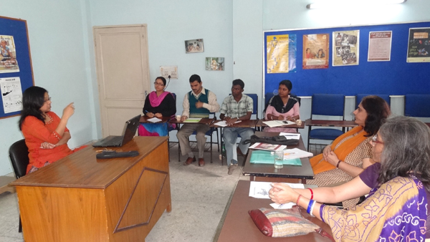

Preliminary meetings with partners – SANCHAR and SPARC

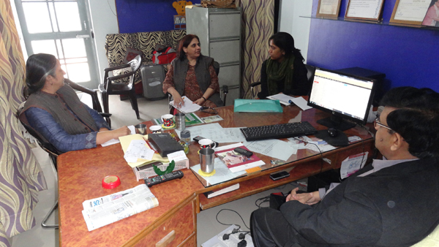
Visits were made to all the 8 partners to discuss the initiative in detail during November – December 2012.

The partners in the process were:
- Dr Jaishree Mukherjee and the staff of ADD, India, based at Bangalore that promotes DPO federations in Tamil Nadu, Karnataka and Andhra Pradesh. For this exercise we worked with the Tamil Nadu Federation, ATDDT.
- Mr Paul Ramanathan, KARO, which is a DPO based in Bangalore and is supported by Sama Foundation.
- Rashtriya Viklang Manch – Dr Victor Corderio, who is presently working as a consultant to World Blind Union, is based at Bangalore and the Secretary, Mr Sonu Golkar, is working with Leonard Cheshire Disability at Bangalore. We decided to work with two State branches of RVM – Madhya Pradesh and Rajasthan.
- SPARC in Lucknow is headed by Mr Amitabh Mehrotra and is a rehabilitation institution promoting DPOs in Uttar Pradesh.
- SANCHAR in West Bengal is headed by Ms Tulika Das and is working in rural India. Through Community - Based Rehabilitation (CBR) approach it helps persons with disabilities in developing Disability Rights Group (DRG) to raise their voice collectively to gain their rights. As a capacity - building institution it also works with several NGOs and DPOs in 17 Indian States. In this project we worked with SANCHAR and DRG in rural West Bengal.

- Dr Bhaskar Mehta is the Vice President of the National Association for the Blind (NAB). We worked with the Sabarkantha district branch of NAB in Gujarat.
- Ms Neeta Panchal is the secretary of the Disability Advocacy Group Gujarat.
After the heads of the institutions participated in the Inception Workshop and the nominated participants attended the Training of Trainers a formal contract was worked out with each for implementing field - based trainings elaborated in the following sections.

1.3 Literature Review and Preparation of Compendium
We collected literature on organisational development (OD) and particularly related to Situation Analysis and Capacity Assessment by contacting several OD experts globally as well as nationally. A 156 - page compendium of existing tools on Situation Analysis and Capacity Assessment was prepared to be used as resource material for the select participants from each DPO at the Training of Trainers (ToT) programme.
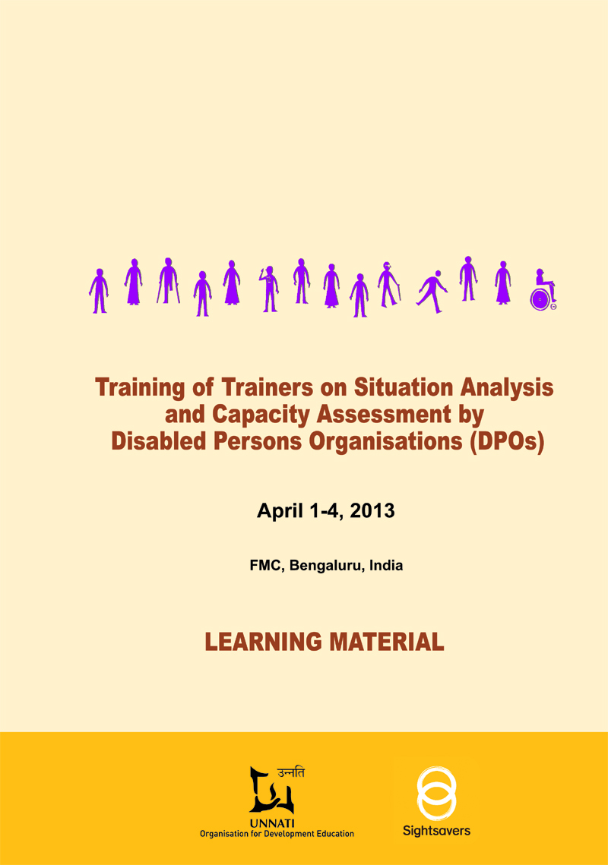
Dialogue and discussions were also held on various tools used in OD with several experts through personal visits and discussions over email. They were:
- Prof Neharika Vohra, Indian Institute of Management (IIM), Ahmedabad
- Prof T V Rao, Adjunct Professor, IIM, Ahmedabad
- Dr Rajesh Tandon from PRIA, New Delhi
- Dr Kaustuv Kanti Bandhyopadhya PRIA, New Delhi
- Dr Nivedita Kothiyal, Institute of Rural Management, Anand (IRMA)
- Dr Yogesh Kumar from Samarthan – Centre for Development, Bhopal
- Fr. Jimmy Dabhi, Behavioural Science Centre (HDRC), Ahmedabad
- Mr Stephens, SEARCH, Bangalore

1.4 Inception Workshop with Partners and OD Experts
An Inception Workshop on Developing Accessible Tools on Situation Analysis (SA) and Capacity Assessment (CA) by Disabled Persons Organisations was organised at Ahmedabad, during February 14-15, 2013. The objective of this workshop was to develop a common understanding on the relevance and application of identified frameworks, tools and techniques on SA and CA and discuss the means to adapt them to enhance the participation of persons with visual impairment and other disabilities to conduct their own situation analysis and self-capacity assessment of their DPO. Presentations were made
Cover page of the compendium
on the identified tools, and discussions were held on their adaptability with advice by OD experts who were present. Based on this feedback, the final learning material for the participants of the ToT was prepared as a compendium. On the suggestions by partners this material was translated also into two vernacular languages for the convenience of the participants (Hindi and Gujarati).
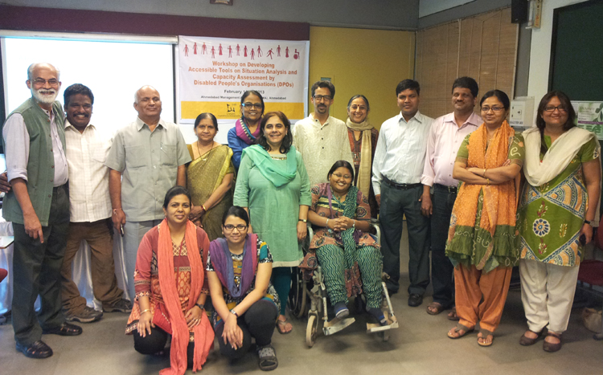
In this workshop, the identified tools on SA and CA were shared and discussions were held on how these could be made accessible and be suitably adapted. The workshop also focused on discussing the modalities of operation. One resolution from the workshop was that it is not absolutely required that new tools be developed, but as a result of this process the existing tools would be modified to enhance active participation of persons with disabilities, particularly persons with visual impairment. The process should be conducted in such a way that the examples of SA and OD conducted by DPOs and BPOs from the disability sector would be articulated and clearly documented and made available in the form of a toolkit with steps and facilitation tips. This would be uploaded on the organisation’s website and be made available as Open Access globally. Moreover while attempting to make adaptations at the field level beginning from the ToT and then through the trainings conducted by the partners from June 2013 onwards, the steps and methodology for enhancing the participation of persons with visual impairment and other disabilities would be captured, documented and included in the final toolkit.
Group photo of the Inception Workshop
The other major learning was that there are no examples in the OD literature on disability. This initiative is therefore pioneering this and would be able to generate such examples. Secondly, the main aim of this initiative is to enhance the participation of persons with different kinds of disabilities and build effective DPOs, Hence, instead of organisational development, perhaps it would be more appropriate to say the that this process is about Institution Building which is a much broader term. In this case it is about Building Effective DPOs.
The definition of a DPO or SHG of persons with disabilities was discussed at the Inception Workshop. Some groups felt that only a group comprising persons with disabilities could be considered as a DPO, while some others felt the parents for children below 18 years or for those with disabilities who are not able to speak for themselves need to be included. Some felt that if 70-80% of the members, including the Executive Council, comprise persons with disabilities, then other members could be non-disabled committed to disability due to various reasons. This could be as a parent or a relative or an academician who has studied or worked on disability.

An advisory group of eminent experts on Organisational Development was also formed to guide and provide inputs to this research. This team comprises Prof T V Rao (Adjunct professor), IIM-A; Prof Neharika Vohra, Professor, IIM-A, Dr Rajesh Tandon and Dr Kaustuv Bandyopadhyay, PRIA, New Delhi; Dr Yogesh Kumar, Samarthan Centre for Development Support, Bhopal; Dr Harish Vashistha, Senior OD Consultant and Mr Binoy Acharya, Director, Unnati.

1.5 Training of Trainers (ToT) for Capacity Building of Partners
Training of Trainers (ToT) on Developing Accessible Tools on Situation Analysis and Capacity Assessment by Disabled Persons Organisations (DPOs) was organised during April 1-4, 2013, at Bengaluru for the participants deputed by the respective organisations. A detailed training design was prepared in consultation with senior OD consultants who are part of the advisory for this initiative and some of them were present for the ToT and also conducted some of the sessions. The objectives of the ToT were to:
- Develop understanding of the various participatory tools on Situation Analysis and Capacity Assessment
- Understand its applicability for DPOs in the changing context
- Make suggestions for making the tools accessible for persons with visual impairment and other disabilities: hearing impaired, cerebral palsy and orthopaedic disabilities

Each organisation/ DPO had deputed two participants for the ToT and the resource persons for the programme were Mr Venkatesh Balakrishna, Founder Director, ADD India; Dr Victor John Corderio, World Blind Union; Prof Neharika Vohra, IIMA; Dr Yogesh Kumar and Mr Venkatesh Prasad, Samarthan, Dr Harish Vashistha, Senior OD Consultant; Mr Binoy Acharya, Director Unnati and the project team: Ms Deepa Sonpal, Ms Sandipa Nelson and Ms Geeta Sharma from Unnati.
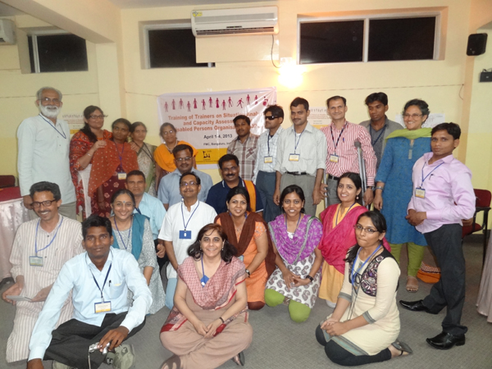
During the ToT the focus was not only to simplify the tools but also orient the participants to the various usable tools on SA discussed and finalised at the Inception Workshop in February 2013, and could be used at the field level to enhance the participation of persons with visual impairment.
Group photo of the participants at the ToT

The participating organisations were expected to go back and conduct three training programmes at the field level with the core committee members of their organisations in the local language and extensively document the process:
i. Perspective building and situation analysis (SA)
ii. Building effective institutions and DPOs
iii. Self-capacity assessment (CA) of their respective DPO
The above activities were conducted by the participants of the ToT with facilitation support from OD experts within a span of six months by each DPO.
In the ToT there were in all 17 participants from the DPOs/NGOs (6 persons with visual impairment, 1 with low vision, 1 with cerebral palsy, 5 with locomotor disability and 4 non-disabled) along with other resource persons and OD experts.
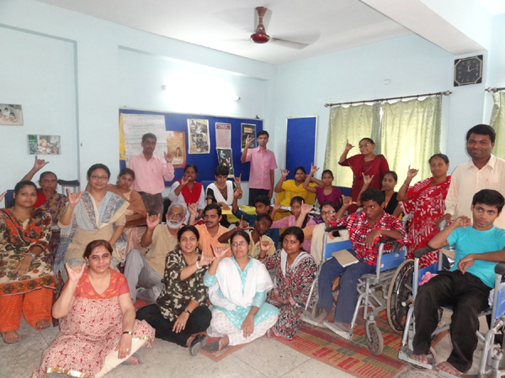
Material was provided to the participants in accessible formats: in Braille, tactile diagrams, text files in Word convertible through a text to speech synthetic speech software, and techniques like reading aloud all that was written on charts were followed. Most of the material was also provided in 2 vernacular languages – Hindi and Gujarati. The OD facilitators tried to observe and learn how persons with various disabilities learnt and participated in the process.

1.6 Facilitation Support for Three Trainings at the Field Level
After the ToT each BPO/DPO was assigned a mentor to guide, provide hand-holding support and to conduct three trainings/ workshops at the field level as follows:
All the 8 partners conducted three trainings each on:
    - Perspective Building and Situation Analysis
The first part of the training on perspective building and situation analysis covered the approaches and models on disability viz. charity, medical, social and rights-based model/ approach for building the perspective of the participants and emphasising the differences between the approaches. It was discussed how persons with disabilities are viewed under each of these and the need for using a combination of these while making field based interventions. Each partner was supported to prepare 4 case studies on the approaches and some partners also developed skits. The scripts of some samples are translated into English and included in the toolkit. In all, 7 sets of cases were prepared.
Group photo of one of the 1st trainings at Sanchar

In the second part, emphasis was laid on situation analysis, on how society views/ why it excludes or denies participation of persons with disabilities in the development process. This was conducted by analysing the cause and effects of social exclusion of persons with disabilities by using the metaphor of a tree (Problem Tree Analysis). Case studies were prepared from life experience of persons with disabilities in India in consultation with the respective groups. The case studies focused on multiplicity of problems like poverty, discrimination on grounds of gender and disability, low awareness among persons with disabilities about their rights and in society about disability, limited access to basic services like health, education, access to schemes, justice, information in accessible formats and barrier-free environment. In all, 5 case studies were prepared. It was emphasised to the participants that it was important to work on the root causes as they are structural in nature to promote inclusion instead of the effects in order to make a long-term impact. The examples developed during these trainings along with the case studies are included in the toolkit
Preparatory meeting with one of the partners (NAB) for the trainings
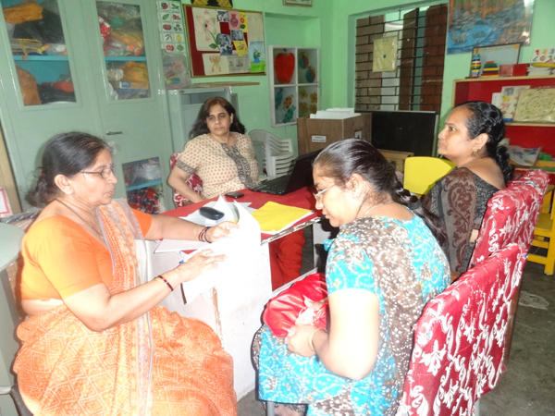
After analysing the causes and its effects the participants were enabled to select one cause and formulate an objective converting the causes or negative state into positive doable/ achievable statements. Taking one objective as a sample, Stakeholder Analysis was conducted to make a list of stakeholders, and in some cases, if time permitted, analyse the level of influence and control/ power the particular stakeholder had for achieving the objective identified on a three - point scale (high, medium, low). A long list of stakeholders, about 50-60, were identified from village to district to state to national level, to enable the participants understand the varied levels at which interventions are required. From a list of 50-60 stakeholders identified, some were selected to work out strategies of engagement/ participation. The idea was to explain to the participants that such an in-depth analysis is required with adequate planning for an intervention to be made effective.
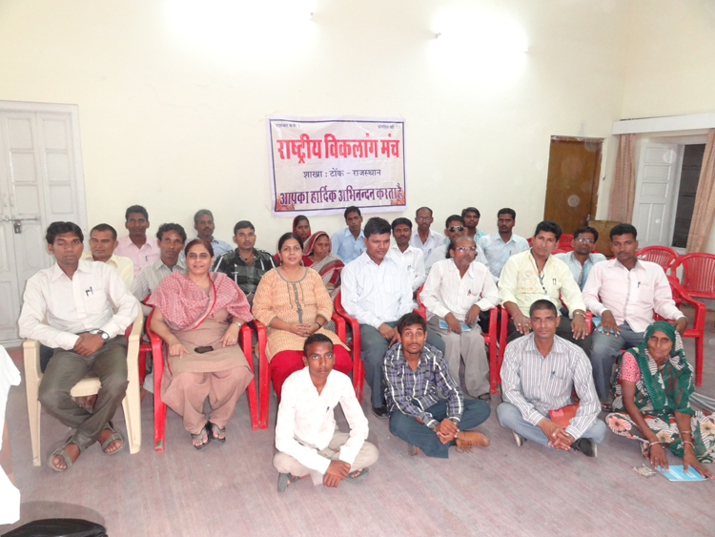

ii. Building Effective Institutions/ DPOs
In this workshop the participants were oriented to the elements of an organisation: vision/ mission, structure, strategy, human resources, programmes/ activities, culture and leadership. From these it was emphasised that the vision/ mission of an organisation, based on the socio-political, economic context, are the most vital elements as they define the purpose or genesis for the formation of an organisation. The difference between vision and mission was explained through a case study developed specifically for this group. Some organisations even developed a skit and the script of this has been translated into English and included in the toolkit. The groups were then facilitated to make a tentative vision/ mission of their own DPO, keeping in view the causes of social exclusion identified in the first training. After the workshop they were asked to share these processes with other members of the group at the grass roots and with the wider committee members before finalising them. Some examples have been generated and are included in the toolkit.
Group photo of one of the 2nd trainings

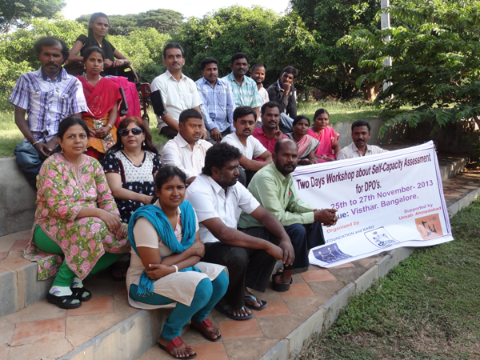
- Capacity Assessment
The third workshop/ training focused on enabling the DPOs to assess their capacity in the context of the current reality/ environment/ challenges. The analysis derived from the first workshop on situation analysis and social exclusion of persons with disabilities was referred to as a base as well as the vision/ mission defined in the 2nd workshop/ training that defines the purpose of the DPO. For assessing the organisational capacity of the DPO, eminent OD specialist, Marvin Weisboard’s Six-Box Model was used to assess the relevance, gaps and what needs to be done for improving the DPO under the following heads: 1. Purpose 2. Structure 3. Relationships 4. Helpful Mechanisms 5. Rewards and
6. Leader. If time permitted, another tool, SWOT (Strengths, Weaknesses, Opportunities and Threats) Analysis, was also demonstrated with how to cull out some strategic directions. For assessing the individual capacities required, Job Analysis of the various office bearers as per the prevailing structure was done and the groups were asked to use the profile generated and then evaluate the performance of existing office bearers, and accordingly take decisions for giving rewards and electing new office bearers. It was felt that such analysis would enhance the efficiency and effectiveness of the DPO.
Group photo of one of the 3rd training at KARO, Bangalore

Prior to the workshops each DPO worked in conjunction with the OD facilitator to develop a detailed training design with session plans to facilitate each workshop. This process included preparing relevant case studies and learning material to be given to the participants in accessible formats. While conducting the workshops/ trainings, emphasis was laid on facilitating the participation of persons with visual impairment, low vision, hearing and speech impaired persons, persons with cerebral palsy and other disabilities. This process followed was extensively documented and facilitation support was extended whenever required. These are included in the toolkit in the process to be followed and in facilitator’s notes. It also contains the various examples generated during the process as future reference. All three workshops/ trainings were intellectually stimulating and exhausting too as most participants had never applied an analytical approach to their own lives and then transcending it to the DPO. The OD facilitators deputed to each group attended all the trainings carried out by the DPOs and supported the facilitation and documentation process.
All the 8 partners completed 3 trainings each. In all there was a total of 160 participants with 104 men and 56 women (24 persons with visual impairment, 6 with low vision, 14 persons with hearing impairment, 6 persons with cerebral palsy, 84 with locomotor disabilities, 14 with other disabilities and 12 non-disabled). This is excluding the facilitators and OD consultants
Extensive feedback was given on the modules prepared by the ToT participants/ facilitators and support was also extended to develop locally relevant material/ case studies, skits, in the local language. In places where the participants found it difficult to articulate the steps to be followed while conducting an exercise, the modules developed by some DPOs that were in order were shared for greater clarity and adaptation.

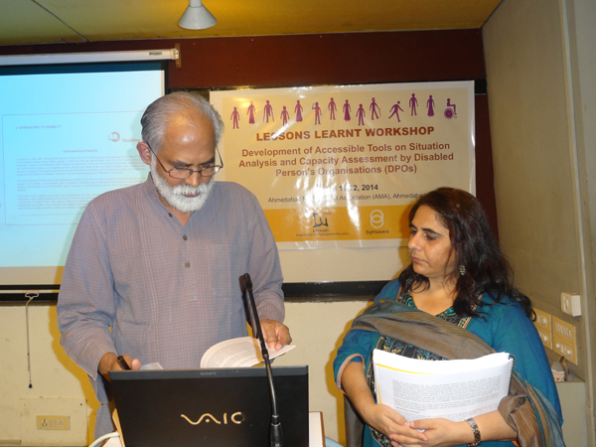
1.7 Lessons Learnt Workshop
A two day lessons learnt workshop was conducted on March 11-12, 2014 in which the groups shared the challenges faced, the lessons learnt and the emerging direction to be taken by the DPOs in their respective areas. It was acknowledged that the Toolkit was comprehensive and unique as it had clear steps for conducting the activities along with the facilitator’s note to guide the trainer. It has covered how the tools could be used with persons with visual impairment, hearing impairment and other disabilities. These need to be used again and again over a period of time in order to standardise the techniques and add experiences from across the globe. Several cases and examples from the disability field have been generated that would add values to the field of literature on organisational development.
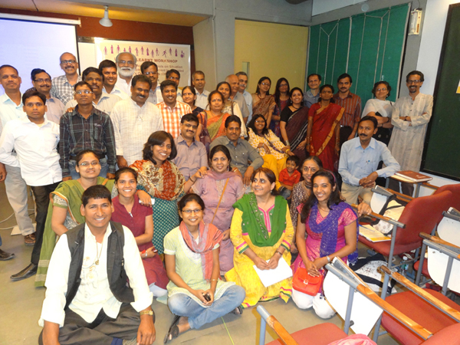
The challenges articulated relate mainly to the nature of voluntary involvement of persons with disabilities who not only face social barriers for inclusion but also physical barriers that restrict their mobility. As the level of education and employment among persons with disabilities is very low, sustainable strategies need to be worked out for the survival and growth of DPOs to act as pressure groups for self advocacy and undertake activities that would combat social exclusion and enable persons with disabilities to lead a dignified life in society.

1.8 Monitoring Mechanism
A Programme Management Committee (PMC) comprising the heads of the organisation, the project team and OD experts in the form of an advisory committee was constituted to monitor and determine the direction of the progress made in the project. Two PMC meetings were held and all decisions regarding the nature of support to be extended and the plan of action in the next phase were taken at these meetings. The 1st PMC was held with the Inception Workshop and the 2nd one was held with the ToT conducted for the participants.

The 3rd round of PMC meeting was conducted informally through mail and meeting in person. The fourth PMC was held together with the Lessons Learnt workshop in March 2014, the end of the project period. The challenges faced and lessons learnt have been consolidated in a separate chapter.

2. HOW TO USE THE TOOLKIT
This Toolkit has been developed based on centrality of participation of persons with disabilities with an aim to not only empower but also emancipate them from the current situation. The Tools used in the kit, the processes and facilitation notes have been elaborated so that the participation of different types of persons with disabilities could be enhanced. The tools aim to create an educational process wherein persons with disabilities have access and control over the process and its outcomes.
This Toolkit has the initial sections on Foreword, Preface, Contents, About the Initiative and Process and How to Use this Toolkit.
The main body of the Toolkit has been divided into three thematic parts. These are:
Training for Perspective Building and Situation Analysis
Training for Building Effective Institutions/ DPOs
Training for Capacity Assessment by DPOs
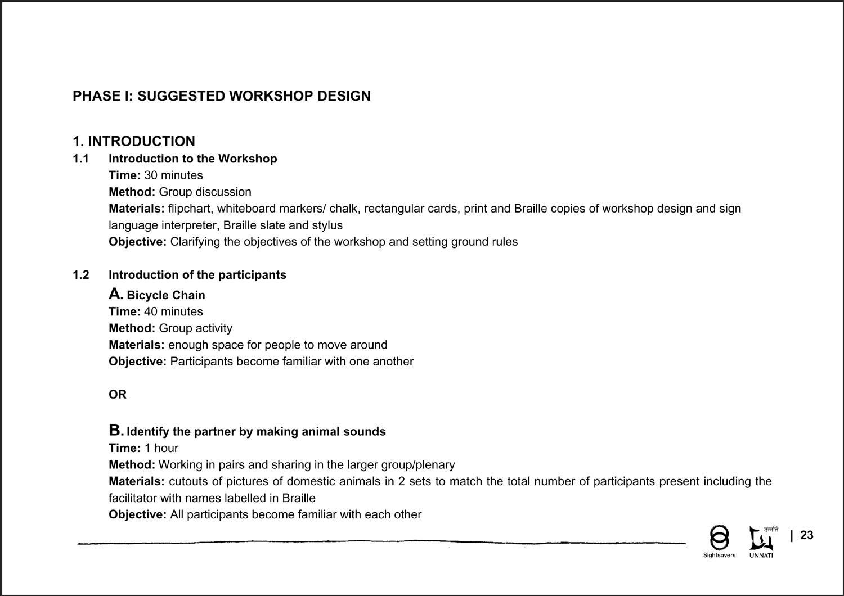
Each part contains the following:
- Workshop Design (Suggested): The workshop design is a sample design or schedule of the workshop that briefly provides an overview of the sessions, the time required and the objectives of each. It also provides an insight into the various sections, these and topics that would be covered in a particular phase.

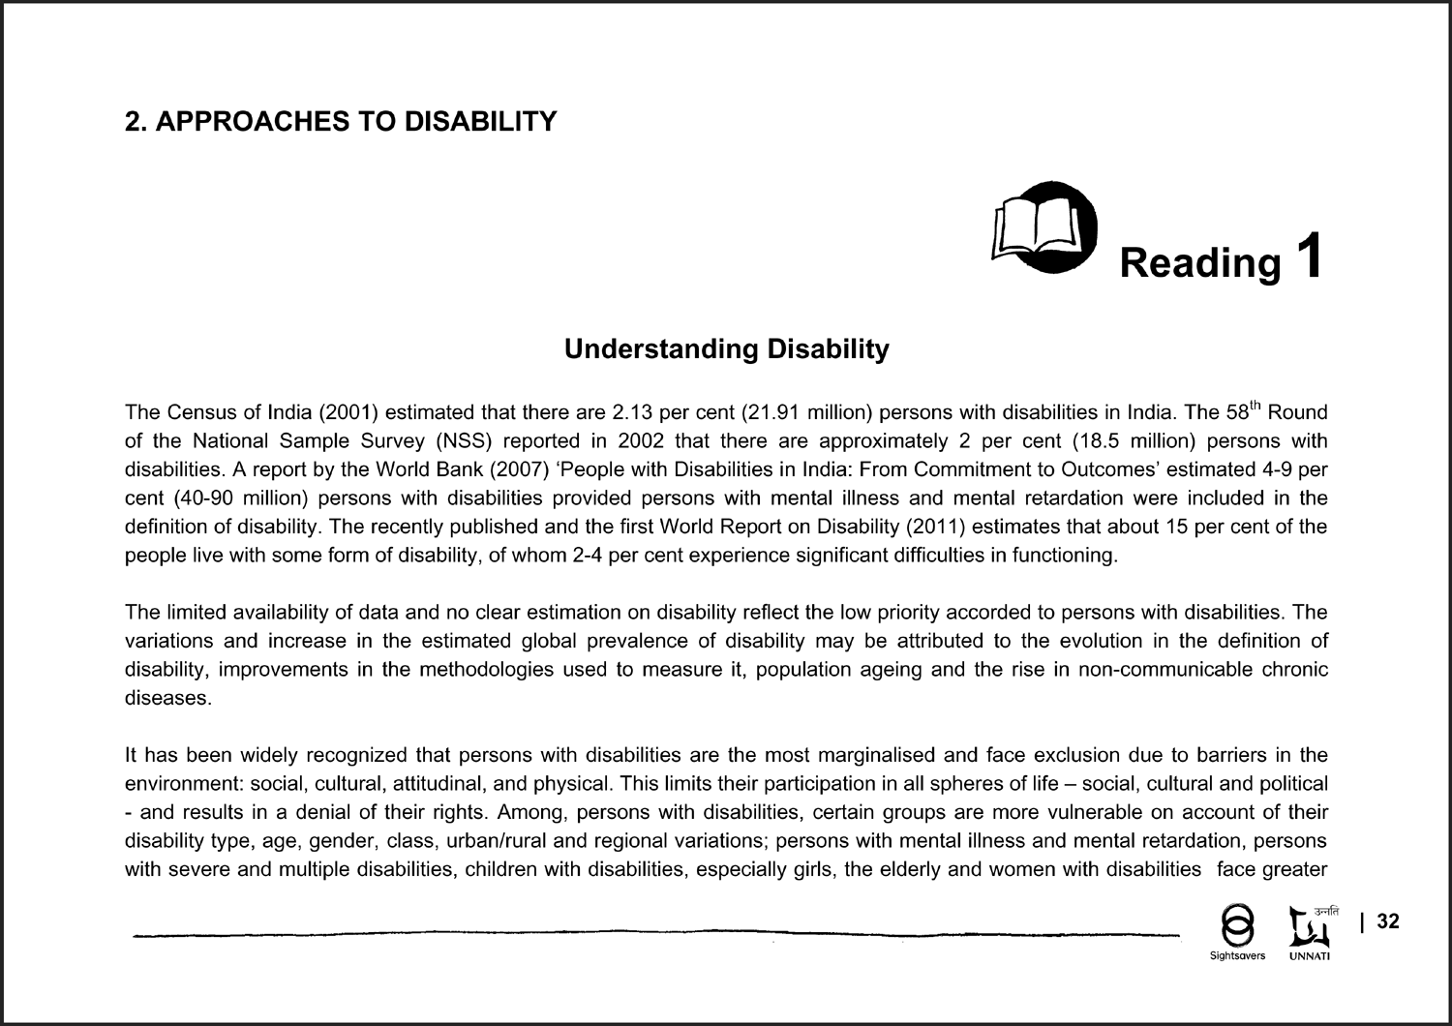
ii. Reading: Whereever required each of the subsections begins with a Reading on the particular theme. It explains in detail the concept and issues that need to be understood by the facilitator for facilitating the session. It would serve the purpose as reference or background material. Depending on the level of the participant, the readings may be used or shared with them in accessible formats.
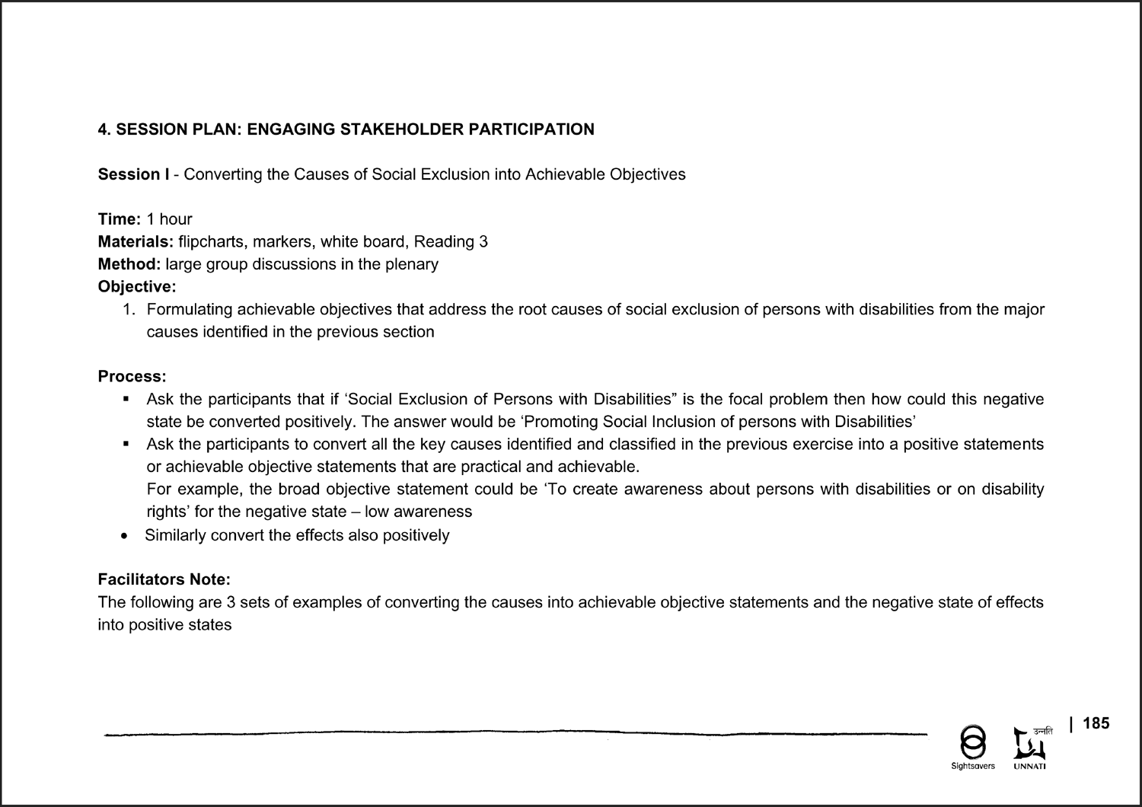
iii. Session Plan and Facilitation Notes: The session plan and facilitation notes cover the following:
- Time is indicative of the approximate duration a particular activity would take for a group of 15 – 20 participants. This may vary with the number of participants, their level of understanding and exposure and their participation.
- Method refers to the methodology to be used for the particular activity.
- Materials include a list of all the materials required for conducting the activity – stationery, handouts and readings,
- Objectives specify the expected outcome – what the participants would learn during the activity and what this will lead to by way of an increase in their knowledge and understanding, exploration of attitudes or acquisition of skills.
- Process The process includes step-by-step instructions for conducting the activity. The activities provide the participants with an opportunity to either experience or reflect on their personal beliefs, attitudes and behaviour. There is an emphasis on collective learning. Based on their experience or reflection, the participants could be enabled to generalise and relate to the larger reality. Wherever relevant, they may be encouraged to use this new understanding to explore how it can be specifically applied to their work.
- Facilitator’s Notes: The facilitator’s notes include points that the facilitator may need to bear in mind while working with different kinds of groups. It also includes possible responses and hints on how the discussion may be handled, key points that need to be highlighted and the preparation that the facilitator may need for doing so. It focuses mainly on communicating with different types of persons with disabilities from varied backgrounds. Many tips on communicating with persons with visual impairment, speech and hearing impaired and other disabilities have been addressed. In short, it explains how the tool could be made accessible. Examples generated from field-level exercises have also been inserted for guidance. Prior preparation is required by the facilitator depending on the types of participants and diversity in the group. Photographs of certain actions and processes have been included to provide ideas to the facilitators. The process has been described in the session plan hence the photographs contain captions only.

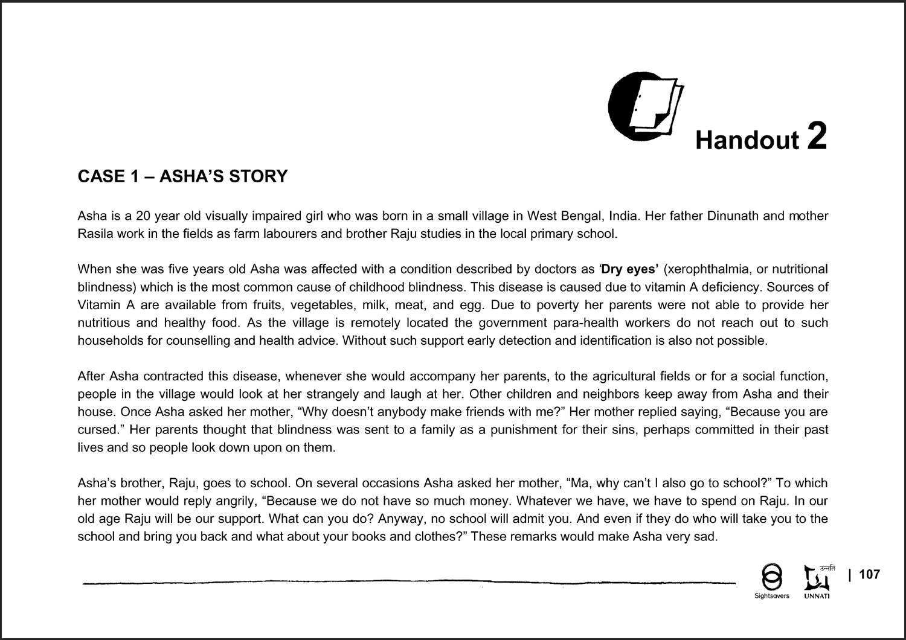
- Cases as Handouts: Some activities have Cases that will be required to be distributed to the participants. These may be case studies, scripts of skits and picture story board. These have been included at the end of the particular activity for which they are intended.

All the activities included in this Toolkit have been used with rural and urban groups of persons with disabilities – persons with visual impairment (totally blind, low vision), speech and hearing impaired and other physical disabilities. Adaptations may be made by the facilitators for making the tool accessible by using locally available material.

3. TRAINING FOR PERSPECTIVE BUILDING AND SITUATION ANALYSIS
This phase on ‘Perspective Building and Situation Analysis’ aims to first develop the perspective of the members of the disabled persons organisations (DPOs) on the current situation of persons with disabilities and the various approaches / models adopted for including/ mainstreaming persons with disabilities. The approaches / models on disability have been classified under four categories: Charity, Medical, Social and Rights Based. It is important to first build the perspective of the participants and then clarify their concept of functioning. Ideally, a people’s institution like a disabled persons organisation (DPO) is expected to work on a rights - based approach in combination with the social model that speaks about engaging the participation of all stakeholders.

As stated by the Convention on the Rights of Persons with Disabilities (UNCRPD), disability is a result of impairment and its interaction with the barriers in the environment. But most DPOs in India are essentially engaged in accessing benefits of social security schemes for persons with disabilities. In terms of advocacy they are mainly engaged in staging demonstrations/ protests for obtaining entitlements. It is important to understand the relevance and true meaning of rights-based approach, and the power in the collective strength of user groups for advocacy and accessing justice and rights. A combination of approaches is required as donations/ funds are also necessary for the functioning of a DPO along with medical assessment, corrective surgeries and aids and appliances. Therefore, all the approaches are necessary while operating at the field level to be used with discretion by members of the DPO.

The second step is to identify the root causes of social exclusion of person with disabilities as they are structural in nature. Only if the root causes are addressed will it be possible to make significant changes in society. It is seen that most often the interventions / programmes developed to address the deprived sections of society like persons with disabilities tend to address the effects or what may seem most apparent and evident at the surface. This holds the possibility of bringing about cosmetic changes and can be considered as symptomatic treatment. In the third step, it is important to make attempts to change the causes of social exclusion into achievable objectives. The fourth step is to make a list of stakeholders against each objective and assess the level of influence and importance / control/ power they may have for fulfilling the objectives: Based on this analysis, strategies of engaging their participation for fulfilling the stated objectives can be worked out. However, there may be several overlaps in this process and a couple of objectives may be achieved by allying with some stakeholders.

3.1 Workshop Design (suggested)
APROACHES TO DISABILITY
Time: 3 hours
Method: Case analysis or presentation of skits
Materials: Flipcharts/ whiteboard, markers, handouts 1 of cases [one each on charity, medical, social and rights - based models/approaches in Braille, large print, pictures depicting the story and Reading 1 on Understanding Disability.
Objective:
- Participants will be able to describe the main characteristic of the approaches – charity, medical, social and human rights
- Participants will be able to illustrate the impact of the approaches with examples from their own lives
- Participants will be able to illustrate from their own experiences about the current context / scenario on disability
- Participants will be able to illustrate from their own experiences the impact / consequences of different models and approaches on disability

PROBLEM ANALYSIS OF SOCIAL EXCLUSION
Time: 6 hours
Method: Group discussion and enactment of skit based on cases and touch and feel method
Materials: Flipchart, markers, white tape, prints of cases in handouts 2 and in accessible formats, regular print, large print, Braille and picture story board, case study recorded in the form of talk theatre in the local language. Reading 2 on Exploring the Cause- Effect Relationship of Social Exclusion.

Objective:
- Participants will be able to describe based on their own experience the situation of persons with disabilities and identify and analyse the problems of social exclusion
- Participants will be able to illustrate with examples from their own experiences the needs of persons with different disabilities and demonstrate the different methods of ensuring participation of persons with different types of disabilities in group processes

ENGAGING STAKEHOLDER PARTICIPATION

Session I: Converting Causes of Social Exclusion into Achievable Objective
Time: 1 hour
Method: Large group discussion
Materials: Flipcharts / whiteboard / blackboard, relevant pictures of some stakeholders, the cause-effect flow chart prepared in the previous session
Objective: The participants will be able to convert the problems or barriers to social inclusion based on their own experience into achievable objective/ outcomes.

Session II: Stakeholder Analysis
Time: 2 hours
Method: Small group and large group discussion
Materials: Flipcharts, whiteboard / blackboard / markers and Reading 3 on Engaging Stakeholder Analysis.
Objectives:
  - The participants will be able to demonstrate from their experiences how the problems are converted into achievable objective
  - The participants will be able to develop a list of stakeholders for achieving the stated objective in their own environmental context
  - The participants will be able to analyse the level of influence and control or power each stakeholder has based on their own experiences for meeting the stated objective
  - The participants will be able to work out suitable strategies to engage the participation of all the stakeholders for fulfilling the stated objective deriving insights from their own experiences

3. 2 Approaches to Disability

3.2.1 Understanding Disability (Reading)
The Census of India (2001) estimated that there are 2.13 per cent (21.91 million) persons with disabilities in India. The 58th Round of the National Sample Survey (NSS) reported in 2002 that there are approximately 2 per cent (18.5 million) persons with disabilities. A report by the World Bank (2007) ‘People with Disabilities in India: From Commitment to Outcomes’ estimated 4-9 per cent (40-90 million) persons with disabilities provided persons with mental illness and mental retardation were included in the definition of disability. The recently published and the first World Report on Disability (2011) estimates that about 15 per cent of the people live with some form of disability, of whom 2-4 per cent experience significant difficulties in functioning.

The limited availability of data and no clear estimation on disability reflect the low priority accorded to persons with disabilities. The variations and increase in the estimated global prevalence of disability may be attributed to the evolution in the definition of disability, improvements in the methodologies used to measure it, population ageing and the rise in non-communicable chronic diseases.

It has been widely recognised that persons with disabilities are the most marginalised and face exclusion due to barriers in the environment: social, cultural, attitudinal, and physical. This limits their participation in all spheres of life – social, cultural and political - and results in a denial of their rights. Among persons with disabilities, certain groups are more vulnerable on account of their disability type, age, gender, class, urban/rural and regional variations; persons with mental illness and mental retardation, persons with severe and multiple disabilities, children with disabilities, especially girls, the elderly and women with disabilities face greater exclusion on account of their special vulnerabilities.

The eradication of barriers is essential to facilitate human development to enable all persons to lead a dignified life and to ensure an equal access to opportunities.

The understanding of what constitutes disability has undergone a considerable change over the last 3-4 decades, and there is an increasing acceptance and recognition of disability as a development and human rights issue.

Globally, persons with disabilities account for more than 1 billion, of whom nearly 200 million experience considerable difficulties in functioning. Recent studies show that 85-90 per cent of persons with disabilities reside in developing countries. A majority of the persons with disabilities are not only poor but the poorest of the poor (Yeo, 2005). In India, due to a ‘stigma’, persons with disabilities are often secluded from public view; hence there are no correct estimates of the number of persons with disabilities.

I. Models and Approaches to Disability
Disability has for long been viewed as a specialised field and excluded from the mainstream development debates and practice. After the Independence in 1947, the Medical/Charity Model grew to address disability and informed policy decisions. Till date, the impressions of this model are deeply embedded in Indian society. The emphasis in this is on service provision and rehabilitation, the basic premise being to treat the ‘disease state’ or the ‘problem’ requiring medical intervention in the form of treatments, cure and rehabilitation. Persons with impairment are viewed as ‘abnormal’, as ‘patients’ and as dependent ‘objects’ requiring special medical help, care and at times segregation into special institutions or ‘asylum’ with the support of medical professionals to restore them back to ‘normal’ functioning.

The recent discourse on the Social Model considers disability as a social construct and a human rights issue. It is the interplay of social, cultural, economic, political and environmental factors that act as a ‘barrier’ to the impairment, requiring change. Disability is thus not only a pathological or health phenomenon but also about ‘discrimination’ and ‘exclusion’. This model, in any way, does not reject the requirement of the role played by rehabilitation intervention – efforts for minimising disability, cure, treatment, aids and appliances, access to basic social services (education, employment, transport) and a barrier-free built environment, but considers these as a basic right of all human beings.

Lately, the understanding on disability centres around the International Classification of Impairments, Disability and Handicaps (ICIDH-1 and ICIDH-2) and the International Classification of Functioning, Disability and Health (ICF-WHO, 2001) advocated by the World Health Organisation. This definition aims at integrating the medical and social model and is sometimes termed the bio-psycho-social model of disability (World Bank, 2007). This model begins with a health condition that gives rise to an impairment leading to activity limitation, consequently affecting the ability to participate due to barriers. Disability can be split into three components as are commonly used in applied disability research: (i) impairments like visual hearing, speech, mental and paralysis focus on the intrinsic limitations; (ii) functional limitations refer to difficulties experienced in undertaking personal activities with bodily functions like seeing, walking, speaking, lifting, irrespective of an impairment and; (iii) activity limitations are those that are experienced while carrying out activities of daily living such as bathing, dressing and participation limitations like going out to work, school, play or shopping. The first two, impairment and functional limitations, are consistent with the medical model and activity limitations relate to the social model.

The definition of disability adopted informs all policy matters and decisions influencing practice. The International Classification of Functioning, Disability and Health’ (ICF), the conceptual framework adopted by the World Report on Disability, 2011 combines elements of the medical and social models by emphasising the importance of the interaction between health conditions and contextual factors, both personal and environmental (bio-psycho-social model). Disability is the umbrella term for impairments, activity limitations and participation restrictions, referring to the negative aspects of the interaction between a person (with a health condition) and that person’s contextual factors (environmental and personal) (World Report on Disability, 2011).

The changes in the perspective and definition of disability have also resulted in a change in the nature of development interventions moving from medical and welfare-based interventions to mainstreaming persons with disabilities in all development processes aimed at inclusive development.

II. Legal Frameworks on Disability
The last 3-4 decades have witnessed various developments at the international level that have contributed to a change in the perspective of and approaches to disability and an emphasis on the inclusion of persons with disabilities in all development processes. . Some of the key developments are recounted here:

The first specific recognition and priority to persons with disabilities was accorded in 1981 when it was declared as the International Year of Disabled Persons. This led to a series of affirmative measures such as the adoption of the World Programme of Action Concerning Disabled Persons during the UN Decade of Disabled Persons (1983-1993). The World Programme of Action sought to promote effective measures for minimising disability, rehabilitation and realisation of equal opportunities for persons with disabilities.

This was followed by the drafting and adoption by the UN of the Standard Rules for Equalisation of Opportunities for Disabled Persons in 1993. These rules provided governments with guidelines on actions to be taken to promote equal opportunities for persons with disabilities for all aspects of human development, including education, economic and political.

In 2000, the Millennium Development Goals (MDGs), accepted by 189 countries as a set of quantifiable, time-bound goals required to achieve sustainable gains in human development by 2015, did not originally have any reference to disability. As a result of concerted efforts by civil society and Disability Rights Groups, the General Assembly at its 65th session adopted the resolution (A/RES/65/186), “Realization of MDGs for Persons with Disabilities for 2015 and Beyond”, an indication of the building momentum for mainstreaming disability in all aspects of development.

The Convention on the Rights of the Child, 1989 makes specific note of the rights of disabled children to education and training to achieve the greatest degree of self-reliance and social integration possible. The Jomtien World Declaration on Education for All, 1990 stresses education for all and recognises individual differences as a challenge and not as a problem.

The United Nations Convention on the Rights of Persons with Disabilities (CRPD), 2006 is the first international treaty that has created space for a paradigm shift in the approach to and understanding of disability. The CRPD moves forward from a charity-based medical model perspective of rectifying/ curing the impairment to changing the social, attitudinal and physical environment that obstructs the full and equal participation of persons with disabilities in all aspects of development, including the decisions that affect their lives. It does not offer any definition of disability nor has it classified the types of disabilities; instead, it states that “disability is an evolving concept and that disability results from the interaction between persons with impairments and attitudinal and environmental barriers that hinder their full and effective participation in society on an equal basis with others”. India is a signatory to the Convention and has ratified it in October 2007.

These developments have also prompted action by United Nations Economic and Social Commission for Asia and the Pacific (UNESCAP) at the Asia-Pacific regional level for promotion of the rights of persons with disabilities. In 2005, the Biwako Millennium Framework for Action towards an inclusive, barrier-free, rights-based society for persons with disabilities in Asia and the Pacific provided a mandate and guidelines for governments and other stakeholders for addressing the goals of the 2nd Asian and Pacific Decade of Disabled Persons (2003-2012). The Incheon Strategy, to “Make the Right Real” for Persons with Disabilities in Asia and the Pacific, has now been adopted to ensure a disability-inclusive post-2015 development agenda with a set of regionally agreed time-bound, measurable goals and targets to address the challenges, that have not thus far been addressed, in the new Asian and Pacific Decade of Persons with Disabilities (2013-22).

Since the late ‘80s, India has expressed its intent to promote the development and safeguarding of the rights of persons with disabilities by enacting four pieces of legislation, viz. the Mental Health Act, 1987; Rehabilitation Council of India Act, 1992; the National Trust for Welfare of Persons with Autism, Cerebral Palsy, Mental Retardation and Multiple Disabilities Act, 1999; and the Persons with Disabilities (Equal Opportunities, Protection of Rights and Full Participation) Act, 1995. Being a signatory to the CRPD, India is now attempting to bring its laws on disability in consonance with the understanding espoused by the CRPD for which a Draft Bill on Rights of Persons with Disabilities, 2012 has been prepared and is under consideration. A National Policy on Disability was prepared and launched in 2006, following which States are expected to formulate their respective policies on disability.

III. Status of Disability in India

i. Citizenship
Persons with disabilities experience profound exclusion and are isolated from community life on a daily basis. This is reflected in the low enumeration of the prevalence of persons with disabilities in the country at around 2 per cent while the recent WHO estimates it to be around 15 per cent, if a more comprehensive definition of disability is considered. The differences in enumeration of disability can be attributed to the reluctance of dominant forces in keeping ‘perpetuating’ the invisibility of persons with disabilities, as employing appropriate counting measures will provide the required information and knowledge base for further policy research.

This clearly indicates that persons with disabilities have not been viewed as a significant vote bank. This denial is clearly related to fulfilling the demands and needs of emerging groups, being also excluded from the socio-political discourse in the country. In a right’s mode of operation, it is persons with disabilities and their families, through Disabled People’s Organisations (DPO), that are best equipped to demand their civil, political and social rights. As there is no proper enumeration, the goal of universal suffrage remains incomplete. The names of many persons with disabilities do not even appear on the electoral list. Even if they do, the inability of exercising choice is hindered by inaccessibility to polling booths, with no transport facilities to reach these booths and lack of availability of information in accessible formats. Thus, persons with disabilities are disenfranchised from having a ‘voice’ in the selection, representation and influencing the political decision-making process in the country.

The scope and meaning of citizenship not only relates to rights and entitlements, but implicitly assumes certain duties and responsibilities to be fulfilled by the citizens by contributing to their own welfare and the welfare of others. The very denial of civil, political and social rights alienates the individuals from the role of a citizen and participating as an equal member of society. Thus, accounting the prevalence of disability in any society or, for that matter, of any oppressed group helps to ‘centre stage’ their contribution and informs and shapes the policy environment for investment in capacity building. This will not only enable their contribution but also reduce the development costs shared by care givers.

Factors such as physical inaccessibility to polling booths, limited transport facilities to reach them and lack of availability of information in accessible formats affect the exercise of choice by persons with disabilities during elections. Advocacy by a few groups of disabled persons has led to measures being taken by the government to provide ramps and information in Braille. These measures need to be taken from a holistic perspective as partial accessibility will have a limited effect on their ability to exercise their choice in the selection of candidates. A change in the mindset of people and ensuring through legal measures that persons with disabilities are not discriminated against are equally important factors for the full realisation of their citizenship and political rights.

Persons with disabilities also do not have the space for representation in and influence over the decision-making process in the political arena. Their access to decision-making forums, from the local to the national level, is extremely limited. There is provision for representation in panchayats and nagarpalikas for women and SC/ST but there is no such space for persons with disabilities to represent in the governance system. This restricts their ability to place their demands in such forums. The representation and voice of women and girls with disabilities are especially low and neglected in the political arena.

ii. Socio-cultural Attitudes and Beliefs
It is the culture of a community that influences the attitude, beliefs and values that society holds towards a particular section or category of people that determines the image portrayed about the particular section. The world over, generally, persons with disabilities are viewed negatively as individuals to be ridiculed, looked down upon and a burden on society as they are incapable of contributing productively.

The highly stratified and complex society in India puts persons with disabilities in the lowest rung of the ladder. The nation is predominantly influenced by Hindu religious philosophy; hence, the ‘Theory of Karma’ plays a vital role in perpetuating a derogatory and subordinate status, where disability is a misfortune due to bad deeds in previous births or the misdeeds of parents. At a profoundly serious and spiritual level, disability represents divine justice. This attribution to metaphysical factors has played a major role in developing a fatalistic attitude among persons with disabilities and their families and in compelling them to accept the conditions as ‘God’s will’ and to take a back seat.

This is reinforced by religious texts, as in the laws prescribed by Manu in the ancient religious scriptures and the local sayings and proverbs; often persons with disability are not called by their name but by their type of disability and in a derogatory manner. The media and, to a large extent, the Indian cinema have played a dominant role in reinforcing these beliefs. In the past two decades several films have attempted to project the needs of persons with disabilities to transgress the boundaries traditionally defined. Apart from experiencing restrictions on mobility due to an inaccessible physical environment, persons with disabilities experience ‘social restrictions’; due to the stigma, they are barred from attending occasions considered culturally auspicious like marriages. This is especially evident in cases of persons with intellectual disabilities and persons affected by HIV/AIDS. A negative attitude towards persons with disabilities also has an impact on the development interventions.

Although the family and the community are the primary agencies of oppression for persons with disabilities, they are also the source that can provide the support and encouragement required to overcome the barriers. In India, most families are of an extended nature and the culture of looking after the ill and the infirm prevails. This attitude can be harnessed to recognise the need for compassion and care at the same time for enabling persons with disabilities to contribute towards their own welfare/development. As emphasised by the social model, persons with disabilities, their families and the community need to be enabled to understand that disability, like gender and caste, is a social construct and a change in the mindset is essential. This will not only enable persons with disabilities to positively contribute to the development process but also cut the development costs entailed.

iii. Health Care
Poverty is found to be both a cause and consequence of disability worldwide; persons with disabilities account for one-fifth of the global poor. Extreme vulnerability and ill-health as a result of poor access to nutritional and health services results in disease, impairment and disability, leading to low productivity and low participation in economic, social and political development process. This setting - in of an ‘exclusionary’ process is a vicious cycle, not only exacerbating poverty but also furthering marginalisation and exclusion. Around 70 per cent of the causes of disabilities in India are a result of communicable diseases. The 360 million people who live below the poverty line are more susceptible to impairments as they are more likely to suffer malnutrition, living in crowded and unsanitary conditions, have limited access to medical care, consult traditional healers and are poorly educated. The Census further enumerates that 75 per cent of persons with disabilities live in rural areas, 49 per cent of this population are literate and only 34 per cent are employed. The male - female ratio of 58:42 reflects the gender disparity owing to a high prevalence of female infanticide, foeticide and a low preference given to girl child.

A large number of disabilities in India are preventable but a large number of children suffer from malnutrition. The National Family Health Survey-3 (NFHS-3) indicates that almost half of the children under age five are too short for their age, 20 per cent are too thin for their height and 43 per cent are underweight due to chronic malnutrition. Access to health care during pregnancy and early child care are poor as three out of every five births in India take place at home. In the three years preceding the NFHS-2, conducted by the Union Ministry of Health and Family Welfare, 35 per cent of pregnant women received no antenatal care. Full immunisation coverage declined from 59.2 to 48.5 per cent in 5 years. Access to delivery of health services remains an issue of concern due to reasons of awareness, attitude, physical access, communication and poverty.

The need for health services by persons with disabilities is much higher than that for the non-disabled and they also tend to incur much higher expenditure. The arena of mental health is greatly neglected, both in terms of policy and implementation, and there is very little data available on this issue. Despite a proliferation of health insurance agencies in the market, only five per cent of households report that they have any kind of insurance that covers at least one member of the household and persons with disabilities technically do not get coverage under most insurance schemes in the country.

Using NSSO sources, the World Bank has estimated that accidents comprise 18 per cent of disabilities where for men over 35 per cent of these injuries occur at the place of work and for women 60 per cent occur at home. The census further enumerates that 75 per cent of persons with disabilities live in rural areas, 49 per cent of this population is literate and only 34 per cent are employed. The male female ratio of 58:42 reflects the gender disparity owing to high prevalence of female infanticide, foeticide and low preference is given to girl child. The NSS data (58th round) indicates that among persons with disabilities, women are around 13 per cent less likely than men to seek treatment viz. assessment, diagnosis or rehabilitation. The need for health services by women with disabilities is much higher than that for women without disabilities and they also have to incur much higher costs due to inaccessibility in transport, health services and information and communication.

iv. Education
Educational status is a key human development indicator that is used to assess the status of a particular population. The educational attainment rates are much lower for persons with disabilities, with 52 per cent illiteracy against a 35 per cent (Census, 2001) average for the general population. The illiteracy rate is particularly high for children with multiple, visual and intellectual/mental disabilities. The share of out-of-school children with disabilities is five and a half times the general rate (World Bank, 2007). Among children with disabilities the attendance at school never rises above 70 per cent for boys and around 66 per cent for girls. (NSS, 2002). The report clearly identifies that this is due to several barriers of inter-agency/ inter - departmental co-ordination. The system of early identification of children is weak with discrepancies in data of identified children by the Sarva Shiksha Abhiyan and the Census. The physical accessibility from home to school is a barrier, especially in rural areas, as there may not be proper roads. Even if the children do manage to reach school, the premises are not barrier free with no accessible toilets and water points. The prevailing attitudes of the teachers as well as those of the parents and community members are particularly not encouraging towards inclusive education. Literacy rates among women with disabilities (32 per cent) are lower than for men (68 per cent). These rates are even lower in rural areas and for specific groups of disabilities (mental illness and retardation, multiple disabilities and speech and hearing).

v. Employment
The level of education is directly related to employment; with poor educational background there will in any case be limited opportunities for employment. The World Bank report has clearly stated that a large number of persons with disabilities are capable of productive employment with the support of aids and appliances. The employment rate is 60 per cent lower, on an average, than the general non-disabled population. Contrarily, there was a decline in the employment rate from 42.7 per cent in 1991 to 37 per cent in 2002 (NSSO 58th round) as the employment status of persons with mental illness and mental retardation had not been covered. The general prevailing attitude in society is that people with disabilities are unproductive; hence they are compelled to stay at home and are not exposed to employment opportunities. In fact, often, it has been found that one member of the household stays back at home to take care of the ‘sick’. This adds to the double burden cost of disability.

Despite a three per cent reservation on all public employments, only certain stereotyped jobs have been identified as suitable for employment, leaving only 0.44 per cent of posts filled (World Bank, 2007). Employment reservation in the government sector is applicable for only three types of disabilities – locomotor, hearing and visual impairments. For the private sector, there is no quota system that is followed, but the PWD Act 1995 provides space for an incentive policy. The National Centre for the Promotion of Employment of Persons with Disabilities (NCPEDP) conducted a survey of ‘top 100 multinational companies’ in the country in 1999 and found that the rate of employment of persons with disabilities in the private sector was a mere 0.28 per cent, 0.05 per cent in multinational companies, and only 0.58 per cent in the top 10 IT companies in the country.

There are some examples of companies showing a better performance where persons with disabilities have been employed. The link between the national network and special employment exchange and private establishments is poor as a result of which the job placement ratio is low. The National Handicapped Finance and Development Corporation (NHFDC) was established in 1997 but till 2005 it managed to support less than 20,000 persons (World Bank, 2007). The limiting factors were low awareness and a wide gap in the loan disbursement procedure. The Vocational Training Centre offers stereotype options and no effort is made to update the skills in view of the changing demands. NGOs are entering the arena of imparting vocational training with no accreditation process being followed.

Amartya Sen, in his argument for fairness and justice for persons with disabilities, emphasises the two types of handicap related to disability. One is the ‘earning handicap’ as a person with a disability may find it harder to get employment and may also receive a lower compensation. They may also be engaged in an employment not suited to or much below their level of skill and qualification. The other is the ‘conversion handicap’ i.e. to live in the same way or do the same things as the non-disabled; persons with a disability may need more income – the disadvantage of converting money into a good living – like buying essential support services.

vi. Access to Justice
Rights of persons with disabilities do not find explicit mention in all laws pertaining to human rights. Experience has indicated that unless specifically mentioned, their rights are often overlooked by administrators of justice. Persons with disabilities are not consulted fully and concertedly in the development of legislations, amendments, and formulation of rules and policies. Their representation, if at all, is negligible and not inclusive of persons with all types of disabilities.

The Persons with Disabilities Act, 1995 provides for a Commissioner in every State to safeguard the rights and facilities made available to persons with disabilities, receive and address complaints of denial of their rights and non-compliance with the legal provisions, by-laws, regulations, etc. made for their protection. This mechanism, an affirmative measure, has not received adequate publicity (especially in accessible and user - friendly formats in vernacular language) or been effectively decentralised for its optimal utilisation. Often, the Commissioner is appointed without the requisite background and understanding of disability. Free legal aid and support mechanisms are not easily accessible for persons with disabilities, especially in rural areas, for women with disabilities and for high support groups (persons with mental illness, multiple and severe disabilities).

vii. Community-based Inclusive Development/ Rehabilitation
The shift in perspective from a charity or medical model situates the problem in the individual needs to be rectified, to a social and human rights-based model that identifies barriers in the environment, i.e. social, cultural, economical, political and physical, that interact with the impairment leading to disability. This entails a shift in control and power from the hands of experts and professionals and institutional care to community-based inclusive rehabilitation/ development (CBID) wherein all stakeholders are responsible and accountable for the inclusion of persons with disabilities. The economic cost of providing for the care of persons with disabilities is very high that includes the direct cost of treatment and travel. The indirect cost includes the cost of care giving as most often it is the immediate female family members, i.e. mothers and sisters that are expected to take care of the person with disability at home. This may take away valuable time of adult female members of contributing to the family income and also refrain the girl child from education. The other is the opportunity cost of income forgone by the unutilised potential and capacity of persons with disabilities by not engaging them in the development process. Rehabilitation measures traditionally focused on the impairment aspect, neglecting the other two aspects, of activity and participation limitations. Most often women and girls with disabilities are the last to receive services in a male - dominated and patriarchal society. The vulnerability is further compounded by factors of poverty, caste, class, gender, religious ethnicity and rural-urban disparities.

viii. Access: Barrier-free Environment

a. Access to Built Environment
The rights and entitlements for and by persons with disabilities in the country cannot be realised unless and until the environment, a means through which these can be so realised, is made accessible and barrier free.

Accessibility, in general, is still perceived as a specific need and requirement for persons with disabilities. The current approach relies more on creating separate facilities for persons with disabilities that require special design, adaptations and modifications. The development of standards is not informed by the users due to limited interface and dialogue between user groups and implementers. The scene is worse in rural areas where limited efforts have been made to explore the possibilities of accessibility. There is limited understanding of the principles of universal design that are inclusive and can help create accessible environments benefiting all, regardless of ability or disability. Without this, the need for accessible environments cannot be broadbased.

Most public as well as private buildings have not used the principles of universal design and are inaccessible for persons with disabilities. This includes buildings for public use as well as independent housing. The situation is far more critical in overcrowded areas where the lack of accessibility both in homes and toilets makes it difficult to live independently and with dignity. The provisions for creating a barrier-free environment in the PWD Act 1995, especially where access to public buildings is concerned, are not mandatory and lack accountability mechanisms.

While standards for accessibility, based on universal design, are available and evolving, limited awareness, technical skills and resources for implementing these standards act as constraints. Technical courses do not incorporate the principles of universal design in their curriculum, leading to a large vacuum in informed and skilled professionals.

There are a few groups that have acquired the skills for conducting audits of buildings and plans but the available expertise is not adequate to meet the requirements. In the few initiatives taken to incorporate the accessibility features, the attempts have been partial with a focus primarily on ramps. The maintenance of such features is not attended to, reducing their usability in the long run.

Both access to information and a barrier-free built environment are a prerequisite for providing opportunities to persons with disabilities to exercise self-determination, avail themselves of their entitlements and citizenship rights and for fulfilling obligations.

b. Accessible Information and Communication
Mainstream information and communication materials, mediums and systems (print, audio-visual, face to face and/or technology based) are generally not designed to be accessible. Inaccessible information and communication not only restricts the access and opportunities of persons with disabilities to various goods and services but also limits their independent functioning, participation and productivity. This is especially true in the case of persons with communication difficulties and learning disabilities.

Persons with low vision and persons with speech and hearing impairment are unable to access information at most places used by the public due to very limited use of large print, contrasted colours, captioning, audio and video descriptions and sign interpretation. Persons with intellectual/ learning disabilities are unable to understand information presented in a complex manner. Very few public and even fewer private websites are accessible. Assistive devices are usually not available at cost-effective and affordable prices. The lack of inter-sectoral coordination and research leads to problems such as incompatibility of assistive devices and technology used by persons with disabilities with mainstream ICT devices such as TV and the Internet. Research in ICT and accessible technology for vernacular languages are extremely limited. In the limited instances of the use of features to create accessibility, standards are not usually adhered to.

c. Access in Transport
The way the modes and nodes of public transport (road transport and pedestrian infrastructure, buses and bus stations, rail transport and platforms, air transportation and airports, maritime transport and sea ports, traffic signals and signage) are currently designed makes it extremely difficult for persons with disabilities to use them. Private transport is inaccessible to most on account of design as well as economic reasons. In rural areas, the situation is exacerbated due to poor quality of roads and means to reach the nearest points for using transport. Inaccessible transport not only restricts the access and opportunities of persons with disabilities but also affects their independent functioning, participation and productivity. It limits their contact with the outside world and restricts their visibility.

d. Access to Goods, Services and Facilities
Persons with disabilities are unable to access many goods, services and facilities that they are entitled to due to several factors, including inaccessible designs of public places, transport and information and communication, non-sympathetic as well as discriminatory attitudes of service providers, including the government and the private sector, and their own low levels of awareness of their rights as well as redressal mechanisms. The first basic premise of obtaining the access to basic service for a person with disability is the disability certificate. Apart from low awareness due to the unavailability of information in accessible formats (large font, Braille and audio), the medical centres/ hospitals responsible for issuing this certificate are not accessible. In rural areas, due to a weak transport system, it is rather cumbersome to bring the person with multiple/ severe disabilities to the centre; this is compounded by the cost of transportation that has to be borne by the family members as most of them happen to be living in abject poverty. This is further exacerbated by the non-sympathetic attitude of the staff issuing the certificate as, due to procedural reasons, persons with disabilities may have to visit them more than once. Reservations have been provided for persons with disabilities in some schemes; however, disaggregated data is not collated for persons with disabilities for most of the schemes. Support systems for ensuring that reservations and other affirmative actions are implemented are mostly not in place.

ix. Concerns of Specific Groups

a. Girls and Women with Disabilities
The intersectionality of caste, class and religious ethnicity in the Indian society further creates a nexus of an oppressive structure. This particularly affects the status, condition and position of women with disabilities as they experience triple burden on the basis of gender, disability and developing country status. Both gender and disability are socially constructed; hence a political process of challenging the existing power structures is required to bring about change. Women in Indian society hold a subservient position and are victims of violence and discrimination. This is evident in the unequal sex ratio which is 940:1000 (India) and 918:1000 (Gujarat); low preference for the girl child as is evident in the practice of female foeticide and infanticide. The health and nutrition of women is low and women and the girl child experience discrimination with regard to the sharing of food in the family and access to health services. In this scenario a girl child with disability is likely to face more discrimination than a boy with disability. In many cases the parents even admit that if a girl child with disability is fed less she would die sooner.

More men with disabilities are married and are able to find non-disabled partners while women with disabilities are more often single or married to another person with a disability from a lower family status. The NSS data indicates that the incidence of widowhood among women with disabilities is four times higher than that among non-disabled women. The share of women with disabilities who are married is half that of women without disability. The role identity of women with disabilities poses considerable challenges for them. Marriage and motherhood are difficult achievements for women with disabilities due to prevailing socio-cultural attitudes, creating a situation of ‘rolelessness’ for them in a society where these two aspects contribute significantly to a woman’s role and status as a woman. Most often girls with disabilities are married in the same household as her sister to a consecutive brother or even to the same man as marriage is likely to protect her sexuality. Persons with disabilities are often not seen as ‘normal’ human beings and are considered ‘sexually incompetent’, especially women with disabilities are considered incapable of leading a ‘normal’ family life and bringing up children. Disability after marriage for a woman with disability leads to conflict and in many cases she is a victim of abuse and domestic violence despite working hard. A disabled woman from a lower class and caste background is likely to be more affected as being landless; her main occupation is agricultural labour and cattle rearing which require considerable physical work.

Globally, women make up three-fourths of the persons with disabilities in low and middle income countries and between 65 and 70 per cent of them live in rural areas. Conversely, the International Labour Organisation (ILO) states that women are at an increased risk of becoming disabled through their lives due to neglect in health care, poor working conditions and gender-based violence. However, there is very little research carried out in developing countries to understand the condition of women with disabilities.

In a patriarchal society like India many of the gender-related issues faced by women are experienced also by women with disabilities. The UNDP, Human Development Report, 1995 states that women with disabilities are twice as prone to divorce, separation and violence as non-disabled women. Women with disabilities, especially with intellectual disabilities, are more prone to sexual violence. It has also been frequently reported that hysterectomies are forcefully conducted on young adolescent girls by families and in government-run institutions to save them from unwanted pregnancies.

Women with disabilities are not able to access the benefits of government services like health, education and vocational training due to their immobility. They are also refrained from reaping the benefits of rehabilitation programmes, even if these are delivered at their doorstep through community-based rehabilitation (CBR) services, if the CBR worker happens to be a male.

The impact of violence and constraints experienced by disability type also varies, e.g. a woman with a physical disability may experience limitations in physically escaping from the situation, while a woman with intellectual disability may be doubly victimised as she may face problems in communicating what has happened to her. For the gender and caste dimension, it would be useful to make attempts to learn lessons from the dalit and women’s movement and also for disabled people’s movement to ally with them to gain strength in numbers. Research on the status and concerns of women with disabilities will also enable in throwing light on the realities at the grass roots.

Effective strategies need to be devised where systematically undertaken research Informs policy. Advocacy also needs to be carried out so that existing policies can be implemented. The Convention on the Elimination of all Forms of Discrimination against Women (CEDAW) has adopted General Recommendation No.18 on women with disabilities, requesting State parties to include reports on the violation of rights for women with disabilities. However, a sample survey of periodic reports shows little consistent reporting on discrimination experienced by women with disabilities.

b. Persons with Mental Illness
Mental illness forms 13 per cent of the global burden of disease (WHO, 2001). Unipolar depression is the third largest contributor worldwide to the global burden of disease (Global Burden of Disease, 2004 updated). 450 million people suffer from mental and behavioural disorders. Its prevalence is far higher than what is apparent. With an increase in the complexities of life and the dwindling of stress reduction mechanisms, mental disorders are on a steady rise. Census, 2001 estimates that mental illness comprises 10 per cent of all disabilities in Gujarat. Co-morbidity with physical disorders is common.

Less than one per cent of the health budget is spent on mental health. Most of this is spent on hospital and institutional services for severe mental illnesses. Not sufficient attention has been paid to common mental disorders. Preventive and promotive services for mental health are almost non-existent. Private ‘out of pocket’ accounts for 90 per cent of the total spending on mental health.

There is an acute shortage of trained mental health professionals in Gujarat (4 psychiatrists for 1,00,000 population; less than 50 clinical psychologists and very few trained psychiatric nurses and social workers) and NGOs working on mental health. This is exacerbated by the inadequate training capacity of existing institutions in the State. Most of the mental health services are provided at hospitals for mentally ill or hospitals that have a medical training component. Community-based approaches have been piloted in 2004, but are not commonly practised.

Mental health is neither integrated in mainstream health programmes nor is there inter-sectoral coordination. Absence of advocacy groups affects the demand for more services. Low levels of information and awareness and the stigma attached to mental illness lead to even a lower utilisation of services. Less than 5000 persons sought services at the district level in 2001. At the PHC/CHC levels, there are no records of utilisation.

In Gujarat, 16 districts have been covered under the District Mental Health Programme. A draft Mental Health Policy was developed for the Department of Health and Family Welfare in 2004.

c. Persons with Multiple Disabilities
Persons with multiple disabilities are affected by two or more disabilities (cognitive, sensory, movement, eg. deaf blindness, mental retardation with cerebral palsy) and require interventions by specialists more than one. According to NSSO, 2002, 10.63 per cent of all disabled persons have more types of disability than one. The effect of multiple disabilities is more than a combination of two individual disabilities.

Majority of the training of special educators has focused on single disabilities and the attempts to provide training for multiple disabilities are very recent. A National Institute for Empowerment of Persons with Multiple Disabilities was established in 2005 that focuses on creating awareness and developing human resource for providing services to persons with multiple disabilities. Since there can be many combinations of multiple disabilities, it is difficult to cover the entire range of combinations. The educational needs of persons with multiple disabilities are different from non-disabled children or children with single disabilities. The integration of children with multiple disabilities in mainstream schools or in special schools for single disabilities is challenging. Although multi-disciplinary teams are required for their assessment and rehabilitation to develop individualised plans and monitor the progress, such coordination and collaborative planning and action is rarely seen.

The levels of awareness and understanding about the needs and issues of persons with multiple disabilities are low, both among their families as well as service providers. Networking among families or service providers working with persons with multiple disabilities is very poor. Special educators have limited opportunities for in-service exposure and training to equip them with the necessary knowledge and skills.

d. Disability and Disasters
Disasters, man-made (situations of conflict and war) or natural, are known to result in injuries, consequently leading to disability. They also have an adverse impact on persons with existing disabilities. For both these groups, the process of overcoming the short-term and long-term consequences of disaster is rather cumbersome due to their already vulnerable states – their socio-economic status, lack of voice and the inaccessible evacuation, response and recovery efforts in most disaster situations. There is a greater likelihood of their being abandoned due to lack of planning, inaccessible transport, facilities (camps/ shelters) and services. Disaster situations create new impairments and disabilities. While persons impaired during a disaster may be visible, those that are more likely to be neglected are persons with disabilities existing before the disaster.

Disruption of post-disaster services affects all and particularly persons with disabilities as they are excluded from the mainstream services as well as processes of relief and rehabilitation. Moreover, their needs are likely to be ignored, more because other survival needs assume a higher priority both among people as well as relief organisations. Also when resources are scarce, there is a possibility that they face neglect and discrimination. The kind and degree of follow-up and referrals that they require for physical and psycho-social rehabilitation is difficult as people relocate and tracking processes are not so organised. Re-integration into normal activities of the community like attending formal /informal education centres or earning livelihood, accessing services of health and education is much slower due to the impairments and issues of accessibility.

Efforts for community-based disaster risk reduction and disaster preparedness are recent and the role of vulnerable groups in disaster management processes, including that of persons with disabilities, remains unexplored. The needs of persons with disabilities continue to be excluded over the more long-term recovery and reconstruction efforts; thereby the opportunity to ensure that towns /cities are accessible and inclusively resilient to future disasters is often missed. In Gujarat, after the 2001 earthquake there was an attempt by civil society groups and Disabled Persons Organisations to advocate the inclusion of accessibility in the designs of all the buildings that were reconstructed.

Disability is not as yet a part of the agenda of most development organisations, even though the social model has led the focus away from the person–centred health and welfare approach followed until very recently. Most examples of mainstreaming disability in disaster situation are reactive and not proactive wherein persons with disabilities need to be included before, during and after the disaster. Even the Hyogo Framework for Action (2005 – 2015) adopted by the World Conference on Disaster Reduction to make the world safer from natural hazards is not inclusive of disability.

However, the Sphere Standards launched by a group of international NGOs for humanitarian aid has developed several tools to improve the quality of assistance to people affected by disasters and accountability of States and humanitarian aid to beneficiaries and donors. The Sphere Standards have included persons with disabilities along with children, elderly, gender and HIV/ AIDS. The specific standards relate to participation and representation of all groups in assessment, response, targeting and monitoring and evaluation. The standards also refer to aid workers’ competencies and responsibilities, management and support of staff. At the mid-term review of the Biwako Millennium Framework in 2007, an explicit strategy was formulated for disability inclusion in Disaster Risk Reduction (DRR), including in the Hyogo Framework for Action with concepts of universal design to be incorporated in infrastructure development in disaster preparedness and post - disaster reconstruction activities. Article 11 of the CRPD focuses on Situation of Risk and Humanitarian Emergencies covering persons with disabilities in situations of risk, including situations of armed conflict, humanitarian emergencies, and the occurrence of natural disasters.

Even in normal situations, there is a dearth of trained rehabilitation experts, the more so in rural areas. Mustering adequate human resource in disaster situations is even more difficult, especially on a sustained basis. Community-based skills in these areas are not honed to be able to fill in the gap. Girls and women with disabilities and persons with mental illness and multiple disabilities are the most vulnerable in disaster situations.

IV. Disability Rights Movement in India and the Emergence of DPOs
The advent of the disability rights movement could be traced back to1887 with the setting up of the first centre for the visually impaired in Ludhiana and the first school for the visual /hearing and speech impaired was set up in 1902 at Mysore. Following this the trend for initiating special schools/ centres/ vocational and rehabilitation centres for catering to various types of impairments continued. The Alma Ata declaration in 1978 accepted community-based rehabilitation (CBR) as a global strategy to address the issues and concerns of persons with disabilities. Since the ’90s CBR is being implemented by NGOs to reach out to persons with disabilities in rural areas too at their doorstep.

The concept of self-advocacy by disabled people’s organisation could be traced back to the formation of uni - or single - disability group called the National Federation of the Blind (NFB) that was formed in the ’70s and advocated the rights of the blind as well as other persons with disabilities. Seeing this other uni - or single-disability organisations and several parents groups of children with disabilities were also formed. The All India Confederation of the Blind (AICB) was set up in September, 1980. It has now emerged as a premier self-help national level-organisation of the blind with vide recognition within and outside the country. The Confederation is engaged in a wide array of activities for addressing issues and problems concerning persons with visual impairment (blind and low vision) in the country. It runs schools for the visually impaired, produces material in accessible formats, provides vocational training and is engaged in lobbying and judicial activism. Its membership constitutes of 24 local organisations working for the blind in 13 States (website: www.aicb.org.in)

In the early ’90s the first cross-disability organisation that was set up to advocate the rights of persons with disabilities was the Disability Rights Group (DRG). It was also motivated by the limited efforts towards inclusion of disability in laws and policies. It is primarily a Delhi-based loose network of people with disabilities, their families and supporters, which enjoys a pan-India support through the National Disability Network. DRG's objective is/was realising equal opportunities for persons with disabilities as a matter of right as opposed to the charity model that was prevalent in the ‘90s and continues to exist in society's general outlook towards disability. It is consistently engaged in advocating the rights of persons with disabilities and is actively engaged in influencing the policy environment.

A group of people with different disabilities established Action on Disability and Development in India as an NGO in 1989 in Bangalore. The main purpose was / is to enable persons with different disabilities advocate their rights for inclusion and to mainstream disability into existing structures. Recognising the phenomenal potential of the mainstream NGO sector in India, especially in rural areas, it developed a strategy and a methodology to influence and equip them to work with persons with disabilities as they do with other people living in poverty and with discrimination. It motivates persons with different disabilities to form self-help groups (SHGs) in villages and at the block level. Over the years, it has successfully equipped over 200 NGOs to work with over 100 thousand persons with disabilities to improve their quality of life. ADD India is a resource agency. ADD India works in partnership with NGOs engaged in various issues such as education, livelihood and health. Presently it is partnering with 45 NGOs and DPOs. It has formed federations of disabled people in one district each in Andhra Pradesh, Karnataka and Tamil Nadu.
Since then, with the support and efforts of several international and national NGOs and some State governments, collectives/ self-help groups of persons with disabilities from cross-disabilities have been initiated. These groups of persons with disabilities initiated with the intent of promoting self-representation and advocacy for their own rights and entitlements are also recognised as disabled persons organisations (DPOs). For the past two decades DPOs from various parts of the country have been active and have achieved some legal changes like the Persons with Disabilities Act 1995, the National Trust Act 1999, the ratification of the UNCRPD, formation of the Rights of Persons with Disabilities Bill 2012 and suggested amendments to the Right to Education Act to include the rights of children with disabilities. They have influenced policy making like formation of the National Policy on Disability and subsequently several States have formed their respective policies. Advocacy efforts have also facilitated the inclusion of persons with disabilities in the Census 2001 and 2012, ensuring accessible electoral process, specific budgetary allocation in the 11th and 12th Five-year Plans and formulation of Rights of Persons with Disabilities Bill in line with the CRPD.

While there is a varied understanding on what DPOs should be and what they should be doing, for our purpose we examine here the nature of their organisation and what they are currently engaged in doing.

V. Nature and Challenges Faced by BPOs/ DPOs in India
Overall the spread and the number of uni-disability and cross-disability organisations are sparse in the country. Most BPOs or uni-or single-disability organisations and DPOs’ cross-disability organisations are semi-structured informal collectives. They do have an operational informal structure to facilitate the implementation of activities undertaken. But very few have bye-laws or statuses and Memorandums of Association. Neither the groups nor the federations are registered, but some of course have begun this process. Most DPOs are either supported or mentored by INGOs or NGOs or by the State government. These are membership-based organisations or self-help credit and thrift groups and the members offer their services on a voluntary basis as activists. The INGO/ NGO/ Government staff are deputed to provide support on an on-going basis and also extends financial support for conducting the activities undertaken by the DPOs.

The following could be some of the challenges faced by the BPOs/DPOs that have been derived from secondary literature and personal interaction. These could, however, vary from region to region based on experience. The challenges have been enumerated below to enable other stakeholders who do not have direct interaction with DPOs. This brief will enable them to devise a suitable methodology and identify participatory tools to enable the DPOs conduct a Situation Analysis and Self-Capacity Assessment. When the DPOs will conduct the exercises at the field level with their core committee members, it is hoped that we will get a more vivid picture of their situation and what they want to be and become and the challenges faced.

- Identity: Most often BPOs/ DPOs are aided in all ways by a supporting or mentoring agency and are dependent on these for resources. Hence, the programmes and activities are guided and influenced by the perspective of the supporting agencies. Although in terms of vision and mission they are clear that the inclusion of disability and emancipation of persons with disabilities is their main goal, DPOs have not yet been able to systematically analyse their role to determine their identity so as to be able to draw up long-term plans with clear strategic direction. Most of them are clearly in a nascent stage of group formation and group building.

- Approach: Most DPOs are either implementing activities like access to government and social security schemes, access to aids and appliances, access to ration cards, inclusion in BPL list as a single unit or undertaking policy advocacy at the State and national level to gain economic independence. Depending on the circumstances and resources available, the individual DPO develops its programmes and implementation plans. Although the composition and formation of DPOs may need to be from a rights-based perspective, the programmes and activities are conceived from welfare-based perspective as suggested by some studies/ evaluations and international discourses. The experiences and lived realities of persons with disabilities most certainly demand economic independence and accessibility as a prerequisite. The DPOs have yet to systemically define a political agenda from the social model perspective to make an ardent impact on society and combat the overriding power structures, challenge the socio-cultural beliefs like the karmic theory that continues to systematically exclude persons with disabilities. Currently DPOs consider demanding their entitlements as demanding their rights.

- Capacity / Leadership: The leadership of DPOs is mostly driven by elite, urban educated individuals and the youth. Most persons with disabilities reside in rural areas and not well educated and employed. The daily struggle for an independent living and overcoming isolation and structured exclusion limits their participation and contribution for a larger cause of mainstreaming disability and asserting their rights. Most often the concerns and needs of persons with disabilities are not directly represented but are communicated on their behalf by other actors and stakeholders. Persons with disabilities have not developed their political consciousness to be able to critically analyse their situations and address their concerns as a collective agency from the grass roots to the international levels. The identity of persons with disabilities gets defined by acquiring a disability certificate and those that have less then 40 per cent disability tend to be left out of the process. Anyways, having a disability does not necessarily ensure participation in collectively challenging the socio-political structures. There are very few examples of persons with disabilities in advocacy positions from a rights-based perspective.

- Heterogeneity/ Intersectionality: Persons with disabilities are not a heterogeneous group and the practical needs and the policy advocacy issues and concerns vary with the nature and type of impairment and are influenced by caste, class, gender and religious ethnicity. These factors further compound the disadvantageous position and subject persons with disabilities to marginalisation and exclusion. At the DPO level it is only the mild to moderate level of persons with disabilities that are active and at the forefront. In a cross-disability DPO the participation of women with disabilities, hearing impaired, deaf blindness, multiple disabilities and intellectually disabled is limited or nil in some cases. Children with disabilities have not received much consideration and it is most often parents of children with disabilities that come to the forefront and speak on behalf of their children.

- Alliances: The closest allies of persons with disabilities and DPOs are agencies that directly support them. In fact, the genesis of most DPOs is these agencies that have envisioned mobilisation and the setting up of collectives. So far most movements and struggles for rights by different sections like dalits, tribals, minority and women’s groups have excluded the agenda of persons with disabilities. Similarly, persons with disabilities have also not strived to connect with and broadbase their movements by participating in and contributing to the larger level struggles. This further reinforces the belief that disability is a specialised field and needs to be addressed separately.

- Self-image: Persons with disabilities belong to and are socialised in the same oppressive society that perpetuates the biased views, prejudices and cultural beliefs and values. Hence many are deeply influenced by the karmic theory and carry a negative self-image, low self-esteem and self-confidence. Often behaviours and expectations are governed by dependency syndrome and easy recourse to charitable favours. Very little attempts are made to oppose paternalistic attitudes imposed by society, friends, relatives and care givers due to lack of opportunity, exposure and access to information, services and other opportunities that may help break the shackles of dependence and change inter-personal relations with all stakeholders and develop collective identities that act as a radical force to inspire and conscentise other persons with disabilities.

- Mobilisation: it is a challenge to mobilise persons with disabilities into collectives and sustain their participation in the long run as they are scattered geographically, regionally and comprise all age groups. Poverty, inaccessible transportation, distances, inadequate information and dependence on others to even attend meetings are the major limiting factors. The other factors are of language and communication, especially in tribal regions where different dialects prevail. Most often persons with disabilities are not literate and familiar with a common language as they are often secluded from socio-economic life. Among cross-disability groups again persons with hearing impairment, autism and multiple disabilities like deaf blindness tend to get marginalised as they communicate differently and their basic needs for support and management and common interests for advocacy also differ. The reason for forming the groups does not come as a basic need by persons with disabilities as often daily life itself is a struggle. As a strategy to sustain, most DPOs focus on credit and savings as a strategy to provide continuity to the groups.

References
___Adlakha, Renu and Others (eds.). (2009): Disability and Society: A Reader, Orient Blackswan Private Limited.

___Albert, Bill (2004 a): ‘Briefing Note: The social model of disability, human rights and development’: Enabling Disabled

___People to Reduce Poverty, Disability KaR (Knowledge and Research) Research Project.\

___Amartya Sen (undated), Disability and Justice

___Coleridge, P. (1993): Disability, Liberation, and Development, OXFAM (UK and Ireland), Oxford.

___Dalal, A.K. (2000): 'Social Attitudes and Rehabilitation of People with Disabilities: The Indian Experience,' Journal of Rehabilitation, Vol. 5, pp 15-21.

___Department for International Development (2000): Disability, Poverty and Development, Issues Paper, DFID.

___Elwan, Ann (1999): Poverty and Disability: A Survey of the Literature, The World Bank.

___Gill, Mehar Singh (2007): ‘Politics of Population Census Data in India’, Economic and Political Weekly, January 20, pp 241-249.

___Government of Gujarat (2003): Priorities for Mental Sector Development in Gujarat: The Mission Report; Care Department of Health and Family Welfare

___Government of India:
- Census of India. (2001)
- Provisional Population Totals (2011)
- National Policy for Persons with Disabilities (2005), Ministry of Social Justice and Empowerment

___Handicap International and European Commission: (2009): Mainstreaming Disability into Disaster Risk Reduction: A Training Manual

___Hans Asha and Patri Annie (2003) et.al. ‘Women Disability and Identity’, Sage Publication, New Delhi

___Ilagan Venues M (2003), ‘Ensuring the Inclusion of the Gender Dimension in the Ongoing Work for Disability Rights

___Convention’ UNESCAP, Meeting Document, August 18-22, 2003, Bangkok, Thailand.

___Indian Institute of Management (2004): Managing Mental Health Sector in Gujarat: An Overview of Strategic Priorities,
Vikalpa Vol 29 (1) Jan.-Mar.
  - (2007): Mental Health Care Pilots in Gujarat: Processes, Outcomes and Learning.

___Jeffery Roger and Singal Nidhi (2008), ‘Measuring Disability in India,’ Economic and Political Weekly, March 12.

___Mehrotra Nilika (2004); ‘Women, Disability and Social Support in Haryana; Economic and Political Weekly, December 25.

___Miller, Carol and Albert, Bill (2005): ‘Mainstreaming Disability in Development: Lessons from the Women’s Movement’
Disability KaR Research Project.

___Mitra Sophi and Sambandhmurti Usha (2006), ‘Disability Estimates in India: What the Census and NSS Tell Us,’ Economic and Political Weekly, September 23.

___Mohapatra Sruti and Mohanty Mihir (undated), Abuse and Activity Limitation; Study on Domestic Violence Against
Disabled Women in Orissa, India, Swabhiman, Orissa, India.

___Oliver, Michael (1996): Understanding Disability: From Theory to Practice, Palgrave, New York.

___Sayer, A. (2003): Equality and Moral Economy, Lancaster University, Department of Sociology

___Sightsavers (2012): Policies and Schemes of Central and State Governments for People with Disabilities

___Sightsavers and Christian Blind Mission (2012): Voicing Concerns: Road Map and Strategic Document on Advocacy
and Campaigning.

___Thomas Maya and Thomas M.J. (2003), ‘Addressing Concerns of Women with Disabilities in CBR, UNESCAP Workshop on Women with Disabilities August 18-22, 2003, Bangkok, Thailand.

___Thomas, Phillippa (2004): ‘DFID and Disability: A Mapping of the Department for International Development and
Disability Issues, Disability Knowledge and Research Programme.

___United Nations
  - (1993), Standard Rules on Equalisation of Opportunities for Persons with Disabilities
  - (2007), United Nations Convention on the Rights of Persons with Disabilities
  - UN Enable: Disability, Natural Disasters and Emergency Situations
  - http://www.un.org/disabilities/default.asp?id=1546
___UNDP (1995), Human Development Report 1995, Geneva, 1995.

___UNESCAP (2005): Biwako Millennium Framework for Action, Asia and Pacific Decade of Disabled Persons 2003 – 2012.

___UNNATI - Organisation for Development Education (2004), Understanding Disability – Attitude and Behaviour Change for Social Inclusion
  - (2006): Mainstreaming Disability Issues

___UNESCAP (2005): Biwako Millennium Framework for Action, Asia and Pacific Decade of Disabled Persons 2003 – 2012.
  - 2012.:The Incheon Strategy to “Make the Right Real” for Persons with Disabilities in Asia and Pacific 2013 – 2022.

___INISDR (2005): Hyogo Framework for Action 2005 – 2015: Building the Resilience of Nations and Communities to Disasters

___UNNATI and Handicap International (2008): Civil Society Engagement for Mainstreaming Disability in Development Process

___World Bank (2007): People with Disabilities in India: From Commitments to Outcomes

___World Health Organisation and World Bank (2011): World Report on Disability

___World Health Organisation (2004 updated 2008): The Global Burden of Disease
Website: http://www.who.int/healthinfo/global_burden_disease/GBD_report_2004update_full.pdf

___Yeo, Rebecca (2005): ‘Disability, Poverty and the New Development Agenda’, Disability Knowledge and Research Programme.

3.2.2 Session Plan and Facilitation Note – Approaches to Disability

Time: 3 hours (do this exercise with suitable breaks)
Method: Case analysis or presentation of skits
Material: Flipcharts/ whiteboard/blackboard, markers, handouts of cases [one each on charity, medical, social and rights-based models/approaches] in Braille, large print and pictures depicting the story and Reading 1 Understanding Disability; and one set of cases from Handout 1

Objective:
- Participants will be able to describe the main characteristic of the approaches – charity, medical, social and human rights
- Participants will be able to illustrate the impact of the approaches with examples from their own lives
- Participants will be able to illustrate from their own experiences about the current context / scenario on disability
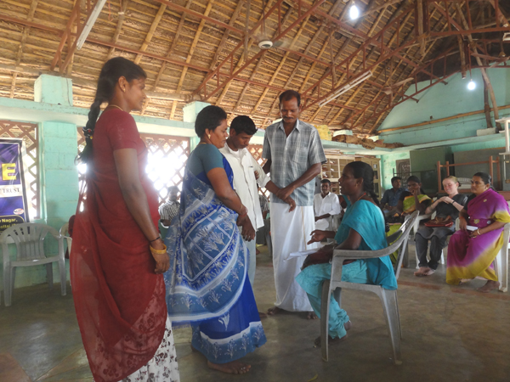
- Participants will be able to illustrate from their own experience the impact / consequences of different models and approaches on disability

Process:
- Divide the participants into 4 groups e.g. counting numbers 1, 2, 3, 4
- Try to maintain a balance between the type of disability and experience
- Give each group one case study (one approach) from one of the sets of cases (Use one Handout from the set of cases
I – V) included as Handout in the toolkit. Give one case per group and make sure to remove the name of the model or approach
- Ask one person to read the case in the group
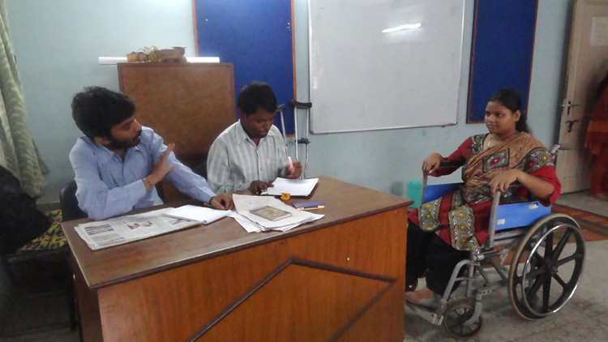
- Ask the group to identify the key issues in the story and answer the following questions for analysing the case
Photo of skit being performed from the cases
- What is the situation of person with disability described in the case?
- What were the interventions made?
- What is your opinion on the treatment of persons with disabilities in each case?
- What are the positive and negative aspects in each of the interventions made?
- What is the approach adopted in this case towards disability?
- What does a person think when he/she is doing charity?
Photo of skit being performed from the cases

- Does anybody want to bring changes in the existing situation?
- Which of these approaches / combinations do you think should be used in our work with persons with disabilities and why?
- Is it appropriate to send all persons with disabilities to the hostel/institutions?
- Would the parents send away their child if he/she is non-disabled?
- Give half an hour to the groups to discuss and then share their analysis/ findings in the plenary.
- Before sharing their analysis ask each group to read aloud their case/ story for the benefit of the larger group and tell the sign language interpreter to explain to persons with hearing impaired.
- Note down the points articulated by the group after further sharpening them, on 4 separate charts to distinguish the approaches (a sample table of responses provided under facilitator note may be referred to)
- After each presentation reiterate the discussion in the previous case and establish the differences in approaches
- Ask the participants to assess the situation of persons with disabilities in their region and assign a per cent to the number of persons with disabilities being looked upon/ viewed / approached by society in each of the 4 models/ approaches

Facilitator’s note:
- Develop four case studies highlighting the four above mentioned approaches to disability. Some examples of cases have been provided as handouts. Some sets of cases represent one person with a particular disability sharing the effects of different approaches, while others have used different types of disability in different sets of cases. Some also have a script to do skits so the sub groups can also be asked to prepare a skit of the case and present it.
- Let the sign language interpreter explain the entire session to help the participants with hearing impairment to understand the concept. If need be, the sign language interpreter should be briefed beforehand on the methodology and purpose of the session.
- While presenting the skit write the name of the characters in big bold letters and string it either on the chest or the stomach of the participant enacting that role for persons with hearing impairment. Let the character announce her/ his name while entering the skit for the first time so that persons with visual impairment are able to relate.
- Use microphone whereever necessary as persons with cerebral palsy may have difficulty in following.
- For persons with visual impairment narrate the scenes, if the skits are presented, to help them follow the shift from one scene to another.
- Make extra efforts to enable the participation of persons with different types of disabilities as per the need.
- If the participants are unable to determine the percentage of persons with disabilities living in a particular model/approach then ask the participants to provide examples as there would be a high tendency to personalise the problem and view it from an individual perspective.
- Explain the difference between needs and rights. When needs are not fulfilled they are converted into laws, and these are termed as rights. Persons with disabilities have the same rights as non-disabled.
- Demonstrate to the group that it is important to take all group members along and make processes inclusive. Even persons with disabilities need to take self initiative to be included.
- 75-90 per cent of persons with disabilities live a life that is characterised by a welfare/charity approach in India. While discussing, highlight that the attitudes and perspective of society, and not just dependence on welfare, need to be considered.
- In the medical approach, the person’s medical needs are attended to some extent but other needs are not addressed.
- In the social model, support is received from many stakeholders; the abilities of persons with disabilities are recognised more than the disability. All stakeholders in this case are informed, positive and supportive.
- Less than 2 per cent persons with disabilities in India enjoy the rights-based approach.
- The responses elicited from the participants will help to gauge a comparative understanding of all the 4 approaches.

3.2.3 Cases for Approaches to Disability (Handout)

i. Safia’s Story (orthopaedic disability) – Charity Model

Safia lives with her mother and two elder brothers in a remote village of South 24-Pargana district of West Bengal. Now 15 years old, Safia lost her mobility due to spinal cord injury at the age of 8 years. Her family tried their best, but with limited income it was not able to continue her treatment for a long time. Safia became completely dependent on her mother. After a few years, the brothers refused to take any responsibility of Safia and her mother, and began to live separately with their own families. Safia and her mother now live in a small hut.

Due to aging and ill health, Safia’s mother is not able to do any work to earn a living. There is a belief within the community that if one helps the aged, ailing and disabled persons, then one is freed from sins. Many times the neighbours would give them food and old clothes out of mercy, but this was not enough for their living. This forced Safia to start begging. Gradually, with the help of her mother, Safia started begging, sitting beside the main road of their village. With her earnings, they can only manage one meal a day.

During Durga Puja (a major Hindu festival in West Bengal), Safia heard that one of the Puja Committees of their village would be distributing new clothes and blankets among the poor households. The place was far from Safia’s house but somehow she managed to reach there and got the clothes and blankets. Knowing her condition, one of the members of the Puja Committee gave hundred rupees more to Safia. Safia’s life continues like this.

Script for skit - Safia’s Story (orthopaedic disability) – Charity Model
Scene I
(At the home of Safia who has locomotor disability)
Safia’s Mother (Alema): What happened?
Safia: Mom, please come here!
Safia’s Mother (Alema): Oh God! We haven’t done any harm to anybody. Then why did this happen to me? My two sons are not looking after me. My only daughter has become disabled at the age of eight years. We have taken her to many doctors and spent a lot of money, still she is not able to stand and walk. Now we have to beg for our survival.
Safia: Mom, why are you calling names to God? Does he hear you at all? If he did hear, then we wouldn’t be in such a poor condition. You didn’t continue my education, then I might have been able to earn some money. Now we have no other option but to beg.
Neighbour: Alema, how are you and your daughter?
Safia’s Mother (Alema): It’s going on as you see.
Neightbour: Did you get rice and dal for today?
Safia’s Mother (Alema): No, we didn’t get much for today. Tomorrow we will go near the main road, then we might be able to get a little more…
Neighbour: You take this packet of rice and dal and have your meal.
Safia’s Mother (Alema): Thank you. May God bless you!
Neighbour: Safia, how is it going on?
Safia: Yes, it’s fine….
Neighbour: Alema, I have to go now, I still have to cook some food….
Safia’s Mother (Alema): All right…

Scene II
(Next day)
Safia’s Mother (Alema): Safia, let’s go to the main road and see how much we can gather….
Safia: (on the main road) Mom, we can sit here…..
Safia’s Mother (Alema): Yes. Many people go by this road…
Beside the main road….two pedestrians are discussing the coming Durga Puja (a festival celebrated in October, specially in West Bengal)
Pedestrian: Do you know Durga Puja will start next week. I have heard that Mukul Sangha Club will give blankets and new clothes during the Puja to the poor and disabled people of our village…..
Safia’s Mother (Alema): Can you tell me who will give blankets and new clothes?
Pedestrian: I have heard that Mukul Sangha which is located near the big ground will distribute these during the Puja. You can go there with your daughter….
Safia’s Mother (Alema): When will they give?
Pedestrian: After five days…..
Safia’s Mother (Alema): Will we also get blankets and clothes?
Pedestrian: Yes, you and your daughter will also get them. You should go there together.
Safia’s Mother (Alema): OK…Safia, we will go there and then we will get new clothes and blanket.

Scene III
(At the premises of Mukul Sangha Club after 5 days)
Safia’s Mother (Alema): Safia, let’s go….We have become very late…the van driver took a long time to come…
Safia: Mom, if there is a big crowd there, then how will I go?
Safia’s Mother (Alema): What will you do Safia? We still have to go…
Safia: No, mom….I can’t go further. Please call someone from the club…..
Safia’s Mother (Alema): Oh God! What a crowd is there…Hello, can you tell me where to go to collect blankets and new clothes?
Member of Mukul Sangha Club: Yes, you have come to the right place….from here you will get blankets and clothes. For whom did you come?
Safia’s Mother (Alema): I have come for my daughter…She can’t walk…I have asked her to sit outside the club…
Member of Mukul Sangha Club: Come, let’s see….Oh God! How did you bring her with you?
Safia’s Mother (Alema): What shall I do? We came in a van…otherwise it is difficult for me to bring my daughter….
Member of Mukul Sangha Club: OK, I will see what we can do for you…we will do one thing, help her to sit in this chair….
(With the help of her mother and the club member, Safia sat on a chair)
Member of Mukul Sangha Club: Safia, sit here for a while….I will bring the new clothes and a blanket for you… Take it…. Keep this 100 rupees and enjoy your Puja with your mom…. We are feeling very sad for you. This year we could only do this much, but next year we will definitely try to give something more….
Safia’s Mother (Alema): May God bless you!
Member of Mukul Sangha Club: Safia, enjoy your Puja with your mom….
Safia: Yes, sir… of course…. We will come back again next year.

ii. Safia’s Story (orthopaedic disability) - Medical Model
Safia lives with her mother and two elder brothers in a remote village of South 24-Pargana district of West Bengal. At the age of 8 years, Safia lost her mobility due to spinal cord injury. Her family tried its best for her treatment and contacted an Orthopaedic Surgeon attached to the National Center for the Orthopaedically Handicapped. The doctor suggested a surgery for Safia. But after the surgery Safia’s mobility did not improve. She could stand with difficulty but was not able to walk.

As per the doctor’s instruction, Safia contacted the rehabilitation unit that receives assistive devices through a government scheme. She found that the manufacturers produced assistive devices one size larger than required. The scheme did not provide for fitting of these devices as per the individual needs of children and persons with disabilities. The rehabilitation unit gave her a wheelchair and a pair of crutches and shoes free of cost. After coming back home, Safia found that she was not able to use the wheelchair comfortably either in her small room or on the uneven roads of her village. Before the surgery she was able to do her daily activities by crawling on the ground, so she again started doing the same. Now her crutches and wheelchair are left in a corner of her hut and she has given them up.

Script for skit - Safia’s Story (orthopaedic disability) – Medical Model
Scene I
Safia’s Mother (Alema): Oh God! How can I manage all this…the room is very dirty and I have to clean it….Safia is growing but can’t do anything on her own, even combing her hair …..
Safia: Mom, please help me in combing my hair…. But slowly
Neighbour: Safia’s mom…. How are you?
Safia’s Mother (Alema): As usual ….
Neighbour: And how is Safia?
Safia: Oh aunty, please come and sit here….
Neighbour: Do you know, there is a big hospital in Kolkata for those who are unable to stand and walk….
Safia’s Mother (Alema): What shall I do by knowing all this?
Neighbour: They provide treatment free of cost…
Safia’s Mother (Alema): We have spent a lot for her treatment….still there is no improvement…..
Neighbour: But you can take her to this hospital… they will provide a wheelchair, crutches and special shoes free of cost…
Safia: Mom, please talk to my elder brother…. Please ask him to take me to this hospital….
Safia’s Mother (Alema): OK…I will talk to your brother…let’s see, if he is willing to go with us…
Neighbour: Alema, I have to go now…but you should definitely visit the hospital….

Scene II
(Safia arrives at the Hospital for Orthopaedically Handicapped in Kolkata with her mother and elder brother)
Safia: Mom, I am not able to walk any more…
Safia’s Mother (Alema): Doctor, I came for the treatment of my daughter…
Doctor: What has happened to her?
Safia’s Mother (Alema): She met with an accident at the age of 8…since then she has been unable to stand and walk…
Doctor: Did you consult a doctor for treatment before?
Safia’s Mother (Alema): Yes, we had taken her to a local doctor in our village…
Doctor: We have to do an operation immediately…. Then she will be fine…
Safia’s Mother (Alema): Oh God! Do we have to spend a lot for this operation?
Doctor: You don’t worry about the expenses….here we operate free of cost and after the operation, she will be able to walk
Safia’s Mother (Alema): Really! Will she be able to walk?
Doctor: Yes. I have done many operations….now you can see these people moving around….before the operation they were like Safia ….but now they are able to move around, Safia will also be able to walk around like them.
Safia: Doctor! Will I be able to walk?
Doctor: Yes, you will be able to…but you need to do some diagnostic tests before the operation…I am giving you the prescription…you talk to one of our Hospital Staff (Deben) for these tests….Deben, please come here…
Deben: Yes, sir…
Doctor: You take this patient and her family members with you, keep a record of her name and address and let them know the date of the operation…. You please go with him….he will give a date for the operation.
Deben: Please come with me… What is the name of your daughter?
Safia’s Mother (Alema): Safia Khatun…
Deben: How old is she?
Safia’s Mother (Alema): 10 years
Deben: Please come with your daughter on the 15th of this month for her operation… you have to come by 10:00 a m
Safia’s Mother (Alema): How many days are left for the operation?
Deben: Come next Saturday…

Scene III
(After Safia’s operation at the hospital)
Doctor: How are you, Safia?
Safia: Still having pain in my leg…
Doctor: You are still having difficulty in standing up and walking…isn’t it?
Safia: Yes…
Doctor: Don’t worry… the pain will gradually reduce. But she needs to wear a pair of shoes and has to use a wheelchair…. You please take it from Deben… Deben, come here….
Deben: Yes, sir…
Doctor: Listen, give a pair of shoes and a wheelchair to Safia and instruct her on how to use them… Safia, please go with him…now I have to go for an outdoor visit.
(Safia is given a wheelchair from the hospital)
Safia: Mom, I will go home in my wheelchair….
Safia’s Mother (Alema): Oh! How nice…
Safia: Mom, now I will be able to go out and roam in the neighbourhood like others on my wheelchair…
Deben: It will be very helpful for you…
Safia’s Mother (Alema): Now you don’t need to spend the whole day sitting inside the home…
Safia: Yes, mom, I will go to Zarina aunty’s house… how do I use this wheelchair?
Deben: I am helping you…now see how you can use it…

Scene IV
(Safia arrives in front of her house…)
Safia: Brother, why does this wheelchair not go inside the house? Please try…it will go… Oh no it’s not going in!
Safia’s brother: Mom, government aids are of no use…
Safia: Let me try to stand up…
Safia’s Mother (Alema): Yes, it will be better…
Safia: Oh God! I can’t stand… the shoes are bigger than my size…
Safia’s brother: I told you earlier that we are wasting our time…you will not be benefited…
Safia: Mom, now what shall I do?
Safia’s Mother (Alema): All our efforts have gone in vain…the shoes and the wheelchair will now sit in a corner of the house…

iii. Safia’s Story (orthopaedic disability) – Social Model
A few months back, a young lady who was the community-based rehabilitation worker (CBR) of a local NGO working with persons with disabilities, visited Safia’s house. After a long discussion with Safia’s mother, she became aware about her condition. Thereafter, she started visiting Safia’s house once in a week to work with her and help her in doing her activities of daily living. This was the first time when Safia received support to manage her disability on her own and enjoy her life like others.

With the help of the CBR worker, she started using her crutches and wheelchair which were modified as per her requirements. This support helped her to gain self-confidence. From then on, she began to receive information on the entitlements of persons with disabilities.

Gradually, the field staff started working with her family members and neighbours to remove social barriers (physical and attitudinal barriers) which restricted Safia’s inclusion in mainstream society. A slope/ramp was made at the entrance of the hut to enable Safia come in and go out in her wheelchair. The CBR worker met the panchayat head (Pradhan) to discuss the levelling of the village road so that Safia could use her wheelchair. The CBR worker also discussed all the poverty alleviation and livelihood schemes so that Safia could also access these. Safia started visiting her neighbour’s house and got the opportunity to meet other people including persons with disabilities living in the same village, by using the wheelchair.

Script for skit - Safia’s Story (orthopaedic disability) – Social Model
Scene I
Safia: Mom, What shall I do now?
Safia’s Mother (Alema): It’s our fate….you can’t do anything…..you have to be confined to the home…
NGO worker: Is anyone there in this house?
Safia’s Mother (Alema): Who is calling?
NGO worker: I am Uma. I have come from an NGO…(sanstha)
Safia’s Mother (Alema): Please come in!
NGO worker: Is she your daughter, Safia?
Safia’s Mother (Alema): Yes, sister…Please sit here…
NGO worker: Does she do anything on her own?
Safia’s Mother (Alema): No, sister…I have to do everything for her…but I am getting old and now it’s difficult for me to do all this….she can’t do anything on her own…
NGO worker: If you can give some time for her, then I will teach her some activities of daily living…
Safia’s Mother (Alema): She will be able to do the daily activities! But how is this possible?
NGO worker: You will see…. She will be able to take care of herself and also help you in cooking as her hands are functioning….
Safia’s Mother (Alema): Let’s see…if anything happens with your effort….
NGO worker: Only you have to spare some time for Safia, initially….
Safia: Umadi, will I be able to do things on my own?
NGO worker: Yes, you will….you don’t need to depend on anyone else…. What is this? (points out to the wheelchair lying in one corner)
Safia: I have got this wheelchair donated by a big hospital in Kolkata….
NGO worker: Why don’t you use it? Is it bigger than your size?
Safia’s Mother (Alema): Yes, sister…We brought it with great difficulty, but she couldn’t use it…it’s difficult to take it out from our house.
NGO worker: The condition of the road is also very bad…Safia, today I will help you in using this wheelchair….
(With the help of her mother and Umadi, Safia was put onto the wheelchair…)
NGO worker: Alemadi, do you know how to move a wheelchair on the road?
Safia’s Mother (Alema): I don’t know, Sister….

Scene II
NGO worker: Oh God! The condition of the road is so bad…Why don’t you visit the panchayat for improving this road?
Safia: Why do we not visit the panchayat? They will not do anything….
NGO worker: the panchayat is for the development of your village….I would like to talk to your brother…please ask him to meet me…

Scene III
NGO worker: Your sister could not use this wheelchair…but if you make a ramp in front of your house, then she will be able to go out….
Safia’s brother: Ramp! What do you mean by this?
NGO worker: We can make a ramp with mud, this means a slope… once this is made it would be easy to take the wheelchair out from the house and then Safia will be able to go out on her own…
Safia’s brother: But for this we need to spend a lot….
NGO worker: You don’t have to spend money….the only thing you have to do is to gather some mud from your village…then you and I will make a ramp…
Safia’s brother: OK, I will do that…
NGO worker: OK… we will do it on Monday…

Scene IV
NGO worker: Safia, how are you? Are you using your wheelchair?
Safia: Yes, Umadi…
NGO worker: Alemadi, are you facing any problem in using this wheelchair?
Safia’s Mother (Alema): No, not at all…It is because of you that my daughter is able to go out now….
NGO worker: Does Safia help you in the household work?
Safia: Do you know? I can now use the wheelchair on my own…
NGO worker: Oh, very good! Alemadi, I told you that you only have to give some time for her, then she will be able to do everything on her own… Safia, today I will take you around the neighbourhood… will you introduce me to your neighbours?
Safia: Yes, of course… let’s go to Jarina aunty’s house…
NGO worker: Could we go this way?
Safia: Yes…Jarina aunty is sitting there…
Jarina: Safia is coming in her wheelchair….Safia, will you work with us?
NGO worker: All of you are involved in zari (embroidery) work…
Jarina: Safia, who is she?
Safia: She is Umadi. She helped me in learning the activities of daily living…
NGO worker: I have come from an organisation which works with children and persons with disabilities. Safia’s mother is getting old…. So, I am helping Safia to do everyday work on her own… with our help she will become independent like others. Could she join you and learn zari (embroidery) work?
Jarina: Yes, she can learn and do the work with us…
NGO worker: She is having difficulty in walking but her hands are all right…
Jarina: Safia, from tomorrow onwards you can come here…
Safia: OK aunty, tomorrow I will certainly come…
NGO worker: You may not know that there is an Act for persons with disabilities and they also have equal rights. They have to fight for their rights…
Safia: Umadi, what are my rights?
NGO worker: You have the right to education, right to employment…But you were not able to continue your education….I will teach you at home…. But you should help other children with disabilities in your village to continue education…
Safia: Oh, that’s great! If you help me to complete my studies, then I will help other children to go to school…
NGO worker: OK, now we have to go…
Safia: Jarina aunty, I will come tomorrow…

iv. Safia’s Story (orthopaedic disability) – Rights-Based Model
Safia became aware about a government scheme Mahatma Gandhi National Rural Employment Guarantee Scheme (MGNREGA) that aimed to provide employment to any person demanding work so she visited the gram panchayat for collecting information about the scheme. The panchayat pradhan behaved very rudely and said that she was good for nothing and it would be better for her to stay at home.

Safia shared her experience with her friends who had other disabilities. One of her friends with hearing impairment also shared that although the pradhan behaved well when he asked for the information on the status of job allotment under this scheme, he had to sit there for hours, and till date he had not been given any employment.
Suddenly, it struck Safia that they were all trying to get their entitlements, ensured by the State, through Disability Law individually. The Pradhan who is powerful was ignoring their needs and rights. So she proposed that if they would go to the panchayat as a group then the pradhan may take the necessary steps for distribution of Job Cards, as per the law the panchayat is bound to do so.
So they all decided to visit the panchayat as a group. On seeing a group of adults with disabilities the pradhan gave time to listen to their demands and assured them that he would personally look into this matter for early distribution of Job Cards and other entitlements.

Script for skit - Safia’s Story (orthopaedic disability) – Rights-Based Model
Scene I
(Safia goes to the panchayat to collect an application form for applying for a Job Card under the MGNREGA Scheme…)
Joydeb (Panchayat Member): Sir, please sign in this income certificate
Panchayat Pradhan: Joydeb, did you check all the documents? Is everything all right?
Joydeb (Panchayat Member): Yes, sir…everything is fine
Panchayat Pradhan: Be sure that everything is fine…otherwise we may be in trouble…who has requested for this income certificate?
Joydeb (Panchayat Member): This girl, sir (Pointing out to a woman standing near by)
Panchayat Pradhan: Who is she?
Joydeb (Panchayat Member): She is the daughter of Panchu…
Panchayat Pradhan: Oh! She has become a woman now… What will you do with this income certificate?
Panchu’s daughter: I have to submit this certificate in my college to get concession in fees….
Panchayat Pradhan: OK it’s fine… Joydev, have you noticed that our panchayat is growing… girls are now studying in colleges….
Joydeb (Panchayat Member): We are doing well…isn’t it?
Panchu’s daughter: Thank you sir… I have to go now…
Panchayat Pradhan: OK. Continue your studies, we are there for you…. Joydev, whatever the opponents say, but we are working for the benefit of the people…
Safia: Sir, please give me an application form for the job card…
Joydeb (Panchayat Member): Application form for a job card!
Panchayat Pradhan: Are you Safia?
Safia: Yes, sir…
Panchayat Pradhan: You are living in north colony… what will you do with a job card?
Safia: I will work under the MGNREGA scheme…
Joydeb (Panchayat Member): Too many non-disabled people are there in the queue and till date we have not been able to give them a job at all…and you are saying that you will work…
Panchayat Pradhan: OK, now tell me one thing…is getting a job very easy nowadays? Is it like a fruit? Whoever will come will, we will pluck it from the tree and give it? Joydeb, let’s talk to her and make her understand that it’s not so easy…
Now you listen, Safia, you are a disabled girl… you go home… If anything (facility) will come for people like you, I will let you know. OK. Now you go… What will you do if you get a job? Will you be able to do it? You should think before you come to us…go, go home…
Safia: Then, I will not get the form?
Panchayat Pradhan: Many people are sitting here for a job. Instead of giving them, how can I give an appointment to a girl with a disability?
Joydeb (Panchayat Member): You are absolutely correct… How is this possible?
Panchayat Pradhan: Listen, if anything will come for disabled persons, then I will help you to get it. We always help you in getting things…during the Puja, you have got new clothes and blankets… now you go… we have a lot of work to do…
Joydeb (Panchayat Member): Go… and let us do our work…

Scene II
(Safia shares her experience with other young adults with disabilities living in her village…)
Safia: Do you know? They refused to give me an application form for applying for a job card…
PWD 1: I have got a job card, but haven’t got a job till date…
PWD 2: I have also had the same experience…
Safia: I think, we all have to go to the panchayat together and demand our rights.
Other PWDs (Together): You are right…we will go together…
Scene III
(Safia and her friends come to the panchayat….)
Joydeb (Panchayat Member): Sir, we have to finish all these pending tasks
Safia and her friends: May we come in, sir?
Panchayat Pradhan: We are doing good for the people, but still they are saying that we are here for making money and for our own benefit…
Joydeb (Panchayat Member): This is true…if you work for your country, you have to face all these comments…
Safia and her friends: May we come in, sir?
Joydeb (Panchayat Member): Yes, come in…Sir, Safia has come with all her other disabled friends…
Panchayat Pradhan: What do they want?
Joydeb (Panchayat Member): Sir, Safia had come before for a job card…
Panchayat Pradhan: Oh yes, Safia came earlier… Joydeb, you will do one thing…You note down their details, I mean names, addresses etc. of all of them and give them to me…Listen, you are the people for whom I am sitting in this chair… I always think how I can help you…next time when some work will come under MGNREGA, all of you will get a job…Joydeb, did you speak to the BDO (Block Development Officer) about employment of persons with disabilities in our panchayat?
Joydeb (Panchayat Member): No, sir, I was busy in some other work…
Panchayat Pradhan: No, you have to do it first. How can you forget that we are sitting here for them?
Joydeb (Panchayat Member): OK sir, today I will speak the office
Panchayat Pradhan: Don’t worry, all of you will get a job… now you go home.
Safia and her friends: OK, sir…
PWD 1: Safia, you were refused because you came alone… today we have come together and that is why the Pradhan has taken immediate steps for our employment. Now we must demand our rights collectively….

v. Shiva’s Story (visual impairment) – Charity Model
Shiva is a boy with visual impairment by birth and lives in South India. There is very little acceptance of his disability by his family and community. His mother has sympathy, but is tired due to constant nagging and stigma extended by the family and the community members. He is not allowed to participate in any social gathering/occasion; the family’s economic condition is weak. One day a Swamiji (ascetic) from ashram for the disabled visits the village to create awareness about the activities of the ashram, Shiva’s parents approach the Swamiji, and Shiva is admitted to the ashram. In the ashram the Swamiji provides shelter, clothes, and food. The parents visit the ashram once in 2 to 3 months, and never take Shiva back home. Shiva lives in the ashram as a burden for his entire life.

Script for skit - Shiva’s Story (visual impairment) – Charity Model
Scene I
Shiva: (sitting in a corner of the house with his hands on his head) I am a burden on every one
Mother: Why are you sitting here my son Shiva?
Father: Why are you consoling him? You are always behind him. He is a useless burden on us and has made our life miserable. (Looking at his son) Your mother does not have any other work. She is always thinking about you.
Shiva: Dad, please take me to the toilet!
Father: Hey, don’t call me Dad, you are always like this, learn it on your own. Don’t be a burden on us. I am fed up of you!
Neighbour (approaching Shiva’s mother): Why are you crying sister!
Mother: My husband always harasses me due to my son’s disability.

Scene II
Neighbour: (Meets the Swamiji visiting the village and briefs him about Shiva)
Swamiji: Please take me to Shiva’s home. We provide food, clothing and everything free for such people at the ashram. We will provide him with a comfortable life.

Scene III
(Swamiji visits Shiva’s home)
Mother: Swamiji, please help us, my husband always scolds me, I don’t know what to do with my child.
Swamiji: Send your child to our ashram; we will take care of him.
Father: (pleads to the Swamiji with folded hands) Please! Take my child there, I am fed up of him, everything should be done for him, take him, please take him away!
Shiva: My father always scolds me, please take me to your ashram Swamiji!
Swamiji (looking at the parents): I will take him but you should come to the ashram and see your child often.
Father: Is it okay if I come once in a year?
Mother: (crying) I don’t want to send Shiva away.
Neighbour: (holding the mother’s hand) Please let your child go, they will take care of him. You are not able to take care of him.
Father: (scolding the mother) Let him go, so that we will be free!
The child goes with the Swamiji.

vi. Radha’s Story (cerebral palsy) – Medical Model
Radha is a three-year-old girl, she is suffering from cerebral palsy as a result of which she is not able to walk, speak properly, recognise others, and is always sleeping in bed and has stiffness of muscles. She was born in Chimmanakatti village, Badami taluk, Bagalakote district of Karnataka. In this village there is no access to medical services and her father and mother work as labourers on the farm. Radha’s parents noticed that their child was not able to walk at the age of 3 years and took her to the Bagalakote district hospital at the behest of the ASHA Workers (Health Worker). When the doctor assessed the child, he told the parents that she suffered from cerebral palsy and she would not be normal like other children. The doctor provided medicine for her fits/seizures and taught some physiotherapy/ exercises to be done at home every day for lifetime. After this the parents lost interest in their child, and the mother would do exercises and give medicines to Radha whenever she found time.

One day Radha told her mother that she would like to play and sing with the other children in the village. But the mother replied that the doctor had asked her to take medicine and some exercises every day and nothing more; so she should keep quiet and stay in bed all day long.

Script for skit - Radha’s Story (cerebral palsy) – Medical Model
Scene I
(At home)
Mother: (tells the father) Please give water to Radha.
Father: (grumbling) You are always ordering me.
Mother: Oh! She is not eating, she is very adamant!
ASHA Worker: (visits the home) How are you?
Father: Oh! My child had fever, she is three years old but she is not able to do anything on her own,
Mother: We have visited so many temples and are praying, nothing is improving.
ASHA Worker: You should visit the hospital and get a check-up done.
Mother: I want my daughter to be fine, I have only one child.

Scene II

(At the hospital Out Patient Department (OPD)
Doctor: (looks at the parents) What is the problem?
Mother: My child is very sick, she is only lying down all the time. She cannot do anything on her own, cannot hear, get up, walk, her hands are always stiff, we are fed up in life, we have visited so many temples but there is no improvement
Doctor: Did you show your child to a doctor before? Now the child is three years old, what were you doing all these years?
Mother: No, we do not know what we should do?
Doctor: (examines the child) Yes, the child has a serious problem. You have to do exercise for this child, and give medicines regularly all her life. The child will not improve fully but the problem might reduce.
Father: Oh! Then for our entire life we will have to serve her, feeding the child is also such a difficult task.
Doctor: What is the child’s name?
Mother: Her name is Radha.
Doctor: Give this medicine every day, and the physiotherapist will teach you some exercises that need to be done every day for the child.
Physiotherapist: How are you Radha? (looks at the parents) OK, you should always move the legs and hands, allow the child to move her legs in the water while bathing. The child may not cooperate, but you should continue to do these exercises. Come and show her to me after three months.
Father: When should we do the exercise?
Physiotherapist: Every day morning, and at least 10 times in a day, you should keep doing it throughout the day.

Scene III
(At home)
Father: (to the mother) What are you doing?
Mother: I am making Radha do her exercise, you go and eat. She is very adamant and is not letting me do her exercise.
Other children: (visit the house) Let Radha play with us kaki (aunty) (sign language)
Mother: No, she cannot play with you, you go and play, let her eat medicines, do exercise and rest, she cannot play or go to school. Go away!

vii. Murali and Revathi’s Story (hearing impairment) – Social Model
One day a CBR worker from an NGO identifies two children, Murali and Revathi with hearing impairment in Siddapura village. The CBR worker discusses with the parents about the children’s future. Along with the parents, the CBR worker approaches and requests the school headmaster for admitting these children to the local school. The headmaster shares his concern that the school does not have any qualified/equipped teachers to teach these children. The CBR worker sends a sign language teacher who regularly visits the school. After completion of education the children join a computer training centre. The centre is equipped to train persons with hearing impairment. Murali and Revathi successfully complete the training and they get jobs in a mutlinational company.

Script for skit - Murali and Revathi’s Story (hearing impairment) – Social Model
Scene I
(At home)
CBR Worker: I am from an NGO, please give me your details as I have come to do a survey.
Father: I live with my wife and two children. My children do not go to school, because they cannot hear and speak. Murali is 8 years and Revathi is 12 years old.
CBR Worker: We should enrol your children in a school. Why have you not been sending them to school so far? We will speak to the school authorities, and help them to go to school. Every child should go to school, and develop equally like other children. The government provides facilities for children with disabilities through the programme called Sarva Siksha Abhiyan (SSA).

Scene II
(At the school)
CBR Worker: Good morning, sir!
Headmaster: Good morning!
CBR Worker: We work with children with disabilities. This man is Basavaraj, and his children have speech and hearing impairment. It is always essential that children go to school and develop fully. So we request you to kindly admit these children to your school.
Headmaster: But these children are disabled! We are not trained to provide education to children with such disabilities.
CBR Worker: We have volunteers, they will train your teacher in sign language. We will also send a sign language interpreter to regularly visit your school and support the teachers and these children
Headmaster: OK if you will be sending a sign language interpreter, then we are willing to enrol these children.

Scene III
(After 6 years, at the multinational company)
CBR Worker: (Introduces the two children) I saw your advertisement in the newspaper, and so have brought Murali and Revathi for a job here. They can speak/communicate through sign language and they have very good skills in operating computers.
Multinational Company Owner: We provide employment opportunities to the persons with hearing and speech impairment. We want persons with disabilities to improve in life. We are happy that you have brought them here. If they perform well, we will offer them a promotion too.

viii. Kariappa’s Story (orthopaedic disability) – Rights-Based Approach
Kariappa, a young man who works in an iron factory, met with an accident while at work and lost his right hand. The employer terminated his job. Kariappa began to feel sad and miserable sitting at home. One day he came to know about a disabled persons organisation (DPO) called Sabalikaran and requested its help. The leaders of the DPO went and met the employer with a request to re-employ Kariappa but the employer refused. Then the DPO and Kariappa filed a case against the employer with the Commissioner for Disabilities. The Commissioner for persons with disabilities summoned the employer and explained to him about the PWD Act 1996, Sec. 47 (1) which states that if any person becomes disabled while at work, he/she cannot be removed from the job and from the grade at which he/she employed. The employer understood and re-employed Kariappa. Kariappa also became a member of the DPO and began to work for the rights of other persons with disabilities.

Script for skit - Kariappa’s Story (orthopaedic disability) – Rights-Based Approach
Scene I
(At the employers office)
Kariappa: Sir! I have lost my hand at your factory. I have incurred a huge hospital bill. Kindly help me in settling it. Also please assign some other work that I can do with one hand.
Employer: Please go back home. Don’t come back to work from tomorrow. I have nothing to offer you.

Scene II
(At home)
Kariappa’s Father: What happened, my son?
Kariappa: I approached the owner of the factory where I had been employed for the past 10 years but he has sent me back home and has refused to pay the expenses incurred at the hospital.
Father: Let us go to the organisation working for the rights of the persons with disabilities.
Kariappa goes and complains to the DPO. The DPO representative approaches the factory owner along with Kariappa to talk to the employer.

Scene III
(At the factory with the owner)
DPO representative: What happened, why are you not letting Kariappa work in your factory? It is not correct that you are refusing to support him after he met with an accident at your factory. He is an old employee too.
Employer: He has lost one hand, what will he do? How can we keep him for work now? The machine he operated requires accuracy and he needs to use both his hands.
DPO representative: He has lost his hand while working for you, so you have to take the responsibility.
Employer: Now he is disabled, he cannot work, I will not take him back – please take him away!
DPO representative: (consoles Kariappa) OK, let us go to the organisation in Bangalore; we will fight and get back your job.

Scene IV
(At the Office of the Commissioner for disability)
CBR worker: (introduces Kariappa, and briefs about his difficulty)
Commissioner for Persons with Disabilities: OK, let us meet the employer and negotiate; otherwise, we could challenge them legally and get justice.

Scene V

(The Commissioner for Persons with Disabilities summons the Employer again along with Kariappa and CBR worker)

CBR Worker: What compensation are you going to give?
Employer: We cannot give anything as he is unable to work.
Commissioner for Persons with Disabilities: Do you know the rule? There are policies regarding disability. You cannot remove the worker because he lost his hand. You should pay for his treatment, which you have not done, and you have also terminated his services. Now you have to take him back, otherwise we will file a case in the court and take legal action against you.
Employer: I am not aware of such rules. I will re-employ him in that case

ix. Rita’s Story (intellectual disability) – Charity Model
Rita is a young girl with mild intellectual disability. Her disability is not accepted by the family and community. Her mother has sympathy but is tired due to negative comments and stigma. Rita helps her mother in household work, feeding cattle, etc, Though Rita is not a burden on the family, due to stigma and myths attached with her disability, Rita’s family decided to send her to a residential home/school as she would become a hurdle for the marriage of her two elder sisters and brother. At the residential school Rita is given some work according to her capacity. After being admitted to the residential school Rita never comes home. She works hard to contribute each penny being spent on her without complaining. All her basic needs such as food, shelter and clothing are being fulfilled by the school. Her family comes to meet her once in 2/3 months but she will have to spend her entire life at the institution, away from her family. She is never asked what she would like to do or become.

x. Seema’s Story ( visual impairment) – Medical Model
Sima is born with paediatric cataract in both her eyes in a remote area of Kutch district (Gujarat, India), where no medical services are available. Her parents work as wage labourers, Sima’s problem was diagnosed at the age of 2 years, she was operated at the age of 2 ½ years. As she is not able to see properly, after functional and clinical assessment, she has been diagnosed as a person with low vision. She is not able to read the regular print but is able to read large fonts after magnification. She has not got admission in the local village school as the teacher thinks that she will not be able to study in the regular classrooms with other children. She is admitted to a special school at Palanpur so that she can study with other students like her. She has got the benefits related to disability but has never had the chance to showcase her abilities in her village. After the Std.10th exam she is admitted for vocational training at a centre to become a telephone operator.

xi. Sejal’s Story (locomotor disability) – Social Model
Sejal is a young and enthusiastic girl of 24 years. She has locomotor disability and is unable to walk as both her legs are paralysed due to polio. As the school is sensitised and made accessible, she is easily admitted to the local village school. She procures assistive devices and benefits from the nearby rehabilitation centre with the support of her teacher who has undergone a foundation course in disability management. Sejal performs well at her school and motivates other girls with and without disabilities. She even represents her school in district and state-level singing competitions. Gradually, she and her mother begin to be invited for parents-teachers association (School Management Committee) meetings. Besides her schooling, she decides to learn computers from a local vocational training centre. At present she is studying in college pursuing B.Com and is giving tuition to primary school students.

xii. Sheela’s Story (cerebral palsy) – Right-Based Model
Sheela is a young girl with cerebral palsy, and lives in a remote village of Banaskantha district in Gujarat, India. Earlier she did not have control over her neck movements and was not able to speak properly. At the age of five years she was identified by the Community-Based Rehabilitation (CBR) worker who linked her with speech and occupational therapists. Her parents were also made aware of her disability and about ways to support her in different activities. Gradually, her speech improved and she also gained sufficient control over her neck muscles. Sheela was then admitted to the local primary school and provided extra support by the teachers in the school for her education. She was provided with assistive devices and accessible educational material from the school itself. From the 10th standard she started attending block-level meetings of persons with disabilities organised by the local disabled persons organisation (DPO). She also attends various seminars related to disability: Acts, leadership training through the Banaskantha district’s DPO. Currently, she is pursuing her graduation and has become an active member of the DPO. She guides and supports other persons with disabilities for getting admitted to the village school and access social security schemes etc. She is also actively working with the local civil society organisations to motivate other persons with disabilities to access their right to vote.

xiii. Sheeba’s Story (cerebral palsy) – Charity Model
Sheeba is an 11-year-old girl affected by cerebral palsy (CP). She lives in a slum at Lucknow in Uttar Pradesh, India, with her mother, grandmother and younger sister. Sheeba’s mother is the sole earning member in the family and she works as a domestic help in nearby affluent households. She often falls ill and hence several times the family has to go hungry. Often, other people come to distribute food and other things like blankets in the slum. This family readily takes it/is as they are not able to buy warm clothes in winter. Once a social worker came to know about its situation and began to provide it with food and other items on a regular basis. The family survives partly on the charity given in cash and kind by the social worker.

xiv. Ria’s Story (cerebral palsy) – Medical Model
Ria is a 13-old-girl and is affected by CP. She is an only child of her parents. Ria’s family was not able to diagnose her disability. It approached many doctors for several years. Later the doctors advised it that Ria should wear calipers and these were provided by the hospital. As the calipers were uncomfortable Ria often cried and insisted that they be removed. Ria was not able to speak and was not mobile, so her family did not send her to school. Then Ria’s uncle, who is a teacher in the local primary school, encouraged the family to send her to school. But when it went to admit her to a nearby school she was refused admission. So her uncle found a special school and admitted her to it. In this school there are many children like Ria and no one teases her. She has been provided with a wheelchair by the school and is also provided the support of a physiotherapist. With the help of the wheelchair she is able to move around the house and inside the school. But she is not able to move outside the house as the roads are not compatible for the wheelchair.

xv. Shyam’s Story (visual impairment) – Social Model
Shyam is a 14-year-old boy with visual impairment and lives with his parents and brother. He goes to school with his brother where initially he had to face a lot of difficulties. But since his parents became members of the School Management Committee (SMC) they shared his difficulties with the school authorities. Since then a ramp has been built with guiding strips to facilitate his mobility inside the school. Now Shyam is fairly mobile and is able to commute to and from the school. The teachers speak aloud and explain what they teach in the class. A special educator has been assigned to the school and all the teachers began to learn Braille so that they could teach other visually impaired children. His friends and classmates do not tease him in the school. Shyam has begun to learn computers and wants to become a computer engineer.

xvi. Ramesh’s Story (orthopaedic disability) – Rights-Based Model
Ramesh is a 25-year-old young man who lost his leg in an accident four years ago. After the accident he stayed at home for one year and did not like to come out of the house. One day he met a CBR worker who encouraged him to participate in the activities and meetings of a disabled persons organisation (DPO). Slowly he began to participate in the meetings of the DPO and take interest in its activities and enjoyed solving the problems faced by other persons with disabilities. He has become an active member of the DPO. He has got his disability certificate and also his pension. Now he has begun to disseminate information about schemes for persons with disabilities to other members of the DPO. One day he came to know about a girl called Zoya who was affected by locomotor disability. Even though she is qualified, her application for the job of a teacher at the local school was not accepted on the pretext that she would not be able to look after the rowdy children. This incident was brought to Ramesh’s notice and he approached the principal. But the principal refused to listen to him. Ramesh then approached the panchayat and explained the provision of 3 % reservation for persons with disabilities. The principal was forced to accept Zoya’s application. Now Zoya is employed as a teacher at the primary school and she encourages other children with disabilities in their studies. She is also an active member of the DPO.

xvii. Laxmi’s Story (visual impairment) – Charity Model
Laxmi is a young girl with visual impairment born into a poor family that resides in an interior village in Sabarkantha district of Gujarat. The family is used to receiving alms from the neighbours and would often be seen begging at the nearby temple. As Laxmi grew up, the parents found it difficult to keep her at home as someone had to stay back to look after her. So she was admitted to a residential school for the visually impaired girls at Ahmedabad. When she was old enough, the residential institution where she grew up arrange for her to get married to a visually impaired boy. The couple now survives on alms given by the nearby temple and lives in a small flat donated by a philanthropist.

xviii. Darshana’s Story (hearing impairment) – Medical Model
Darshana is a girl with hearing impairment. With the support of relatives and others in the community she was operated on and a hearing aid was provided. The parents felt that now their problem was solved and expected that she would now begin to speak. To their dismay this did not happen as speech therapists were not available in the region to train her. The teachers in the school were also not able to communicate with Darshana and the children in the school often teased her. Darshana was found sitting in a corner of the classroom in the school.

xix. Shailesh’s story (visual impairment) – Social Model
One day a community-based rehabilitator (CBR) worker from an NGO saw Shailesh, a young boy with visual impairment, walking without slippers on the road, accompanied by a man. The CBR worker called out to the man and began to speak to him. She found out that he was a teacher in the local primary school and Shailesh was his son who accompanied his father to school. She found that the boy was intelligent and with support he would be able to study in the same school. With the aid of Braille books, Shailesh began to study and even participate in various competitions at the school. With the support of his father, the CBR worker, teachers and friends, he was able to complete his schooling and graduate as a qualified teacher. Today he is employed as a teacher in a government primary school and supports his family.

xx. Sushila’s Story’s (visual impairment) – Rights-Based Model
Sushila lost her eyesight in childhood as a result of high fever. She was sent to a residential school for the visually impaired but as she was not comfortable there she was admitted to the local primary school. With the support of the local NGO, CBR worker, parents, teachers and friends she was able to study well. While in school she developed partial deafness. As Sushila was a bright child she enthusiastically participated in the different activities conducted in the school: sports, cultural events and various inter-school competitions. She completed her school education and as she was keen on learning computers she went on to receive professional training. Sushila also takes interest in supporting other women and persons with disabilities in completing their education and address the issues faced by them. She is a member of a local association of persons with disabilities. After completing her education, she faced problems in getting employment. With the support of the local disabled persons association she filed a case under the PWD Act 1995 and was finally recruited in a public sector enterprise. She continues to hold office in the disabled persons association and support young enthusiastic persons with disabilities.

xxi. Ram’s Story (orthopaedic disability) – Charity Model
Ram is a 40-year-old truck driver and resides in a village called Rampur in Uttar Pradesh. He is married and has two children. His family is very caring and he is respected by the community. Last year he met with an accident while driving, as a result of which his left leg was injured and it had to be amputated. He is now unable to drive the truck and has lost his means of livelihood. His family has to struggle to meet its basic needs. His wife knows tailoring but has never used her skills to earn a livelihood. She tries to explore the possibilities but is not confident. Ram began to sit near the temple as he was very depressed. Soon people began to take pity on him and gave him money and other things in kind from which he could partially meet the needs of his family. Slowly, this became a habit and a means of living. His wife has become complacent and has begun to depend on this income for survival. Whenever there is a community function the leftovers are sent to his house.

xxii. Ram’s Story (orthopaedic disability) – Medical Model
After a few months an NGO worker passing by the temple sees Ram and speaks to him about his condition. She advises him to visit the State hospital where he can get surgical treatment and some support for prosthesis and orthotics. With this support he would be able to start work again and regain his mobility. Ram visits the hospital with his wife and the doctor advises him a surgery after which he would need to use an artificial limb. With the support of a Trust a surgery was conducted and Ram was provided with an artificial limb. He began to feel hopeful and went to meet his ex-employer for a job. The employer was very rude to him and refused to take him back even though Ram was willing to do anything he would let him do. He also tried elsewhere but the response was negative. He once again began to feel depressed and remained confined to home most of the time. He stopped using the artificial limb on a regular basis and hence when he tried to use it once in a while for going out, it causes him a lot of discomfort due to recurring sores.

xxiii. Ram’s Story (orthopaedic disability) – Social Model
After several months when the CBR worker visits him she is happy to see that Ram has undergone the surgery and has also received an artificial limb. When she inquires about his livelihood she finds that he is unable to engage himself in gainful employment, is still at home and is not even using the artificial limb. She realises that it is not because he does not want to work, but due to insensitivity of the employers. The CBR worker puts him in touch with a rehabilitation centre that provides him support for mobility training. This agency also speaks to his ex-employer and convinces him to provide Ram with an alternative position, at par with his previous salary package. The employer is initially reluctant but agrees to keep him on a temporary basis. Gradually, Ram begins to take initiative in orienting new drivers on safe driving. The employer is also pleased with Ram’s performance and slowly become more open to employ other persons with disabilities. Ram has applied and got a disability certificate and also becomes aware about concessions and loans available for the disabled at low interest rate. The CBR worker facilitates the obtaining of a loan and Ram begins to avail a travel pass and applies for a loan.

xxiv. Ram’s Story (orthopaedic disability) – Rights-Based Model
Ram begins to meet other persons with disabilities and together they discuss certain entitlements that they could avail. The group realises that if they assert their rights collectively, much could be achieved. They discuss various options and based on the experience of the group members and the local needs, they decide to buy a few tempos/ auto rickshaws and lend them for services and delivery of goods and supplies. Initially, they face a number of challenges for registration, purchase, etc. During this process they meet many stakeholders and have dialogue with them. They have to convince them about their efficiency and performance, more so because they were a group of persons with disabilities. A few years later they become a role model and a source of inspiration for other such groups in the neighbouring region. This group also advocates the rights of persons with disabilities in making the built environment barrier free, making the rickshaw meter audio enabled, etc. The group has also has begun to take up other social issues of the community.

xxv. Kumar’s Story (quadriplegia) – Charity Model
Kumar is the eldest son of Nagaraj and Nanjamma who live in Kanakapura Taluka of Bangalore South district. Kumar has two younger sisters and a younger brother. The parents’ major source of income is through bangle selling in the rural areas and the family is managing with the income received through this petty business. As Kumar grows up he regularly attends school. During this period, along with his parents he participates in a car festival in a nearby village. The family travels to the festival by an auto (3-wheeler vehicle), which unfortunately meets with a road accident. Due to this accident Kumar’s spinal cord is damaged and his lower limbs are paralysed. Medical treatment / regular physiotherapy has not helped him to recover normalcy. He has become dependent on others, as he always has to remain in a lying down position in the bed. He has developed bed sores, and due to loss of bowel and bladder movement, he has been advised to use a catheter to prevent urine infection. Even though the parents are attending to his medical and personal needs as far as possible, Kumar is frustrated at being unable to do anything and has even tried to commit suicide two or three times.

xxvi. Kumar’s Story (quadriplegia) – Medical Model
Kumar has been identified by a Christian Missionary, Kanakapura, who has come forward to provide residential care, and necessary nursing assistance to him on a day-to-day basis. But for this Kumar has to travel down to St. John’s Medical College Hospital at Bangalore once in every three days to replace the catheter. He is not able to use the public transport system as it is not accessible and he has to hire a vehicle, which is very expensive. This has further deteriorated the financial condition of the family.

xxvii. Kumar’s Story (quadriplegia) – Social Model
This situation continues for a few years until he is identified by a CBR project Sourabha working in the Kanakapura taluka. Through the CBR project he has begun to receive support for physiotherapy treatment through its technical team and a vehicle is being sent to enable him to visit St. John’s Medical College Hospital at Bangalore regularly. This has given him new insight into life, and he starts using these facilities. He has been provided with a foldable wheelchair and training on daily life skills in managing his disability and vocational training to become independent.

At this point of time, active members of the local DPO cum-self-help group of Sourabha CBR project approaches his family members and influences them to become a member. Since Kumar is unable to take part in the SHG meetings, first his younger sister represents him. Later on when he starts using the wheelchair, his parents assist him in participating in these meetings.

xxviii. Kumar’s Story (quadriplegia) – Rights-Based Model
Once Kumar becomes independent he is nominated as a member in the federation of the SHGs/DPO supported by Sourabh CBR Project. He contests the general election of the federation, and becomes the President. The federation initiates a day care centre for children with severe disabilities and starts a computer training unit. Kumar’s personal experience is aired by the All India Radio Station.

In his interview, Kumar shares the challenges faced and how he has overcome them. Many people with similar disabilities telephone and share their feelings with him. Many others also assured him of support. One of the listeners supports him with a telephone booth, another installs the telephone. Once he starts his own telephone booth his financial condition improves.

Through Kumar’s efforts, income generating activities are being initiated and now the federation offers employment to persons with disabilities. Kumar has arranged for his sister’s marriage and has also assisted his brother in setting up a petty shop. He has even applied for a house under the Indira Awas Yojana and has not only been able to build a house for himself, but also secured similar benefits for some of the members of the federation.

Consolidation of Responses on the Models/ Approaches
Responses to Cases Classified Based on the Models/Approaches
- Impact on the persons with disabilities
CHARITY MODEL | MEDICAL MODEL | SOCIAL MODEL | RIGHTS-BASED MODEL / APPROACH
- Persons with disabilities not being able to do anything on their own  - Low self- confidence of person with disabilities  - Profound isolation, neglect, considered a burden and increased dependency  - Habit formed to take/ always seek help  - Persons with disabilities fearful and think that they can’t do anything  - Feeling of despondent  - Children with disabilities separated from the family  - Considered as an obstacle/hurdle in sibling’s marriage | - Persons with disabilities not able to use aids and appliances due to barriers in the environment  - There is no change in the condition of persons with disabilities even after receiving medical intervention  - Participation in social and community activities restricted  - Excluded, disrespect and considered dependent  - Psychological trauma for persons with disabilities | - Persons with disabilities become independent  - Able to do the daily living activities independently  - Confidence increases  - Independent, confident able to pursue education and take decisions  - Confidence level increases  - Become independent (start earning)  - Children with disabilities get a chance to go to regular school and stay with the family | - Persons with disabilities demand their entitlements ceaselessly  - Persons with disabilities themselves make an attempt to change this situation  - Admission taken at local level in inclusive school  - Positive attitude of persons with disabilities  - Persons with disabilities become conscious of this right to equality  - An organisation of persons with disabilities formed  - Persons with disabilities able to seek their rights collectively/unitedly  - Persons with disabilities able to hold dialogue /negotiate with stakeholders

- Caregivers’ perspective
CHARITY MODEL | MEDICAL MODEL | SOCIAL MODEL | RIGHTS-BASED MODEL / APPROACH
- Neighbours not aware of the abilities of persons with disabilities  - Non-acceptance of persons with disabilities  - Negative perceptions of family and community  - Family dependant on donation and food (dan-dakshina)  - No attention given to the child with disability  - Society looks with mercy at persons with disabilities  - Society reacts based on superstitions and prejudices  - Parents especially the mother burdened and helpless | - Disability a disease that needs treatment  - Emphasis on curing the disability  - Functional and clinical assessment carried out  - Admission taken to special school far from home  - Limited awareness about disability among family and community  - Non-acceptance by family and society  - Family and community not aware of how to support persons with disabilities  - Provided with aids and appliances | - Sensitive educational facilities provided for  - Obtained aids and appliances with the support of the teachers,  - Sensitised family and stakeholders  - Study material was provided in accessible formats e.g Braille  - All stakeholders contribute positively, including the School Management Committee (SMC), parents and teachers  - Teachers speak aloud in the class to explain whatever is written on the blackboard for persons with disabilities / visual impairment  - Persons with disabilities rehabilitated in the community  - NGOs/ CBR worker played a prominent role | - Guidance provided by CBR workers  - Early Identification and access to therapies  - Assistive devices and accessible educational materials received from the school  - Society accepts persons with disabilities and helps them get their rights  - Persons with disabilities play a motivational role to other persons with disabilities and provide an example to society

- Impact on development
CHARITY MODEL | MEDICAL MODEL | SOCIAL MODEL | RIGHTS-BASED MODEL / APPROACH
- Immediate material needs provided for without thinking about the future/ development of person with disability  - Abilities and skills of persons with disabilities not recognised  - The needs of persons with disabilities decided by the authorities at the residential institutions and provided in a charity mode  - Not all persons with disabilities can be accommodated at the ashram/residential institutions | - Tendency to make the disabled able-bodied  - Views persons with disabilities as a patient, fail to see future life  - Disability supersedes abilities of persons with disabilities  - Choices for pursuing further education restricted  - All children with disabilities cannot be accommodated in special schools | - Aids and appliances tailor-made, suited to the requirements of persons with disabilities  - Physical environment made barrier free  - Persons with disabilities included and receive opportunities to participate in social functions/occasions  - With the emphasis of CBR intervention school is made accessible  - Children with disabilities educated in an inclusive school  - Government resolutions (GRs) play an important role  - Persons with disabilities get opportunity to engage in livelihood activities  - Stakeholders convinced about the abilities of persons with disabilities after positive performance | - Persons with disabilities receive training on rights and guide others on their rights  - Individual persons with disabilities start helping other persons with disabilities after becoming independent  - The strength of group for persons with disabilities leads to rights and demonstrates unity  - Capacity enhanced of persons with disabilities  - Accessibility promoted for all  - The DPO plays a prominent role in obtaining the rights of persons with disabilities

3.3 PROBLEM ANALYSIS OF SOCIAL EXCLUSION

3.3.1 How to do Problem Analysis (Reading)
This tool is for identifying the cause and effect relationship of any local problem. This could be used at any stage in the project cycle. This could also be used as a complementary technique to Stakeholder Analysis. The main purpose of this exercise is to understand the underlying development causes of the issues that continue to exclude certain sections of the population and the impact they have on their lives. This exercise is usually done in a workshop setting. This technique is best used in small groups of 6-8 persons and helps in building stakeholder consensus. This technique could be used with a variety of stakeholders and in this way consensus could be built on the issues to be addressed, the potential constraints and challenges in addressing the issues or problems, the resources required to address the problems and build meaningful relationship among them.

To begin with, the main/ focal problem is identified and placed in the centre. It is important that the participants discuss and pinpoint one focal problem. The attempt must be to identify an existing problem and not a possible, imaginary or future one. A problem is not the absence of a solution but an existing negative state. For example, the problem could be that the transport department is not ordering low floor buses and not that low-floor buses are not available. Another example could be, the paucity of sign language interpreters and not that there are no persons with hearing impairment in the community. While conducting the exercise, if more than one focal problem is articulated by the group, then temporarily begin with one, and park the others on the side and revisit them at a later stage. Avoid voting to arrive at a consensus for finalising the focal problem for discussion.

The next step is to list the direct causes related to the focal problem finalised by the group in parallel in a row below the focal problem as it is for the roots of a tree. Each problem is to be written on a separate card so that it could be moved, when required, as many possible causes need to be identified and listed here. The next step is to identify the implications or consequences/ effects of these causes and place them on top of the focal problem as the branches, leaves and fruits of a tree. These could be further discussed and the causes and effects relationships are deepened and modified.

Example 1
Mud on one of the
participant’s trousers

Residents of the locality are apathetic
Bad condition of road

Panchayat or municipality not working properly

Municipality used the grant received for its own benefit

Example 2
Forced to sell assets (land and house) for survival
Unable to do treatment
Become malnourished and ill
Become poor and not able to have enough food
Not able to get jobs
Not able to study further
Poverty

Example 3
Students with disabilities are not able to appear in secondary level board examination
Higher Secondary Education System does not have arrangements for conducting examination of students with disabilities
Absence of proper rules for examination of students with disabilities
Other eminent persons involved in the education system are not sensitive towards disability
Authorities of School Education Board not sensitive towards disability

It is important to stress that working on effect would not change the situation unless they change the root cause. For situational analysis it is important to go up to the root cause, as it would be easier for the group to decide how it should strategise and address the problem.

3.3.2 Session Plan and Facilitation Notes – Problem Analysis of Social Exclusion

Time: 6 hours (This exercise to be done with suitable breaks)
Method: Group discussion and enactment of skit based on cases and touch-and-feel method
Materials: Flipcharts, markers, white tape, prints of cases in accessible formats, regular print, large print, Braille and picture story board and case study recorded in the form of talk theatre in the local language and rectangular cards, Braille slate and stylus, Reading on How to do Problem Analysis and any one of the cases from Handout.

Objectives:
- Participants will be able to describe, based on their own experience, the situation of persons with disabilities and identify and analyse the problems of social exclusion
- The participants will be able to illustrate with examples from their own experience the needs of persons with different disabilities and demonstrate the different methods of ensuring participation of persons with different types of disabilities in analysing the problems of social exclusion collectively.

Process:
- Divide the group either disability-wise or into equal groups maintaining a gender and disability-wise balance or based on a rapid assessment made by the facilitators, the criteria being to enhance learning and participation
- Ask the participants to first read the story aloud in the sub-groups for the benefit of persons who are not literate or are visually impaired.
- Ask the participants to identify the problems mentioned in the case story and list them down. Within the sub-group ask one participant to read aloud para-by-para and identify the problems/issues.
- Once all groups have indentified the problems, about 30-40 ask each group to share one problem each in the larger group without repeating those already shared until the list is complete.
- Enable the group to identify the focal problem by asking a series of why’s to each of the answers until they hit it to be social exclusion/isolation
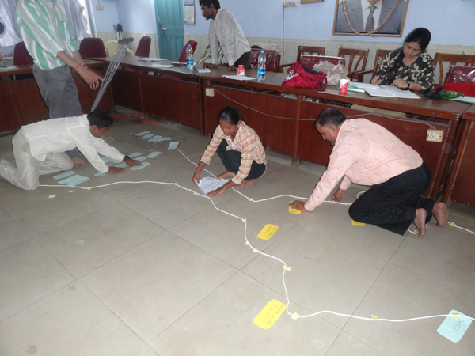
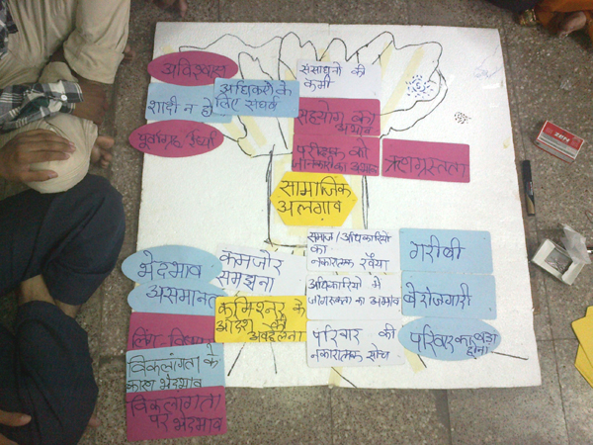

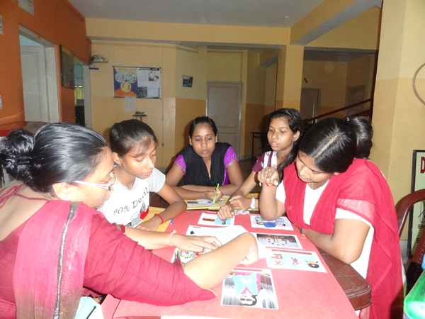
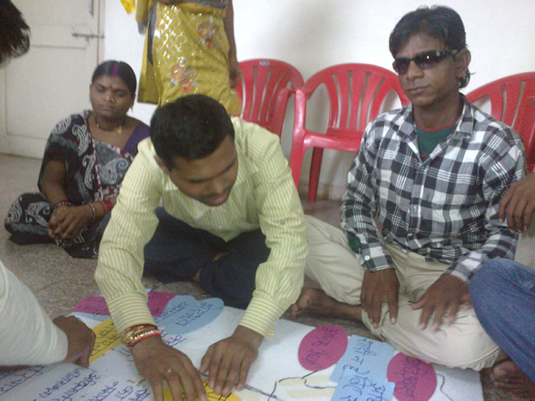
Photos of
Participants
listing and
sorting out
the causes
and effects
as per the
given case from problem analysis of social exclusion of persons with disabilities
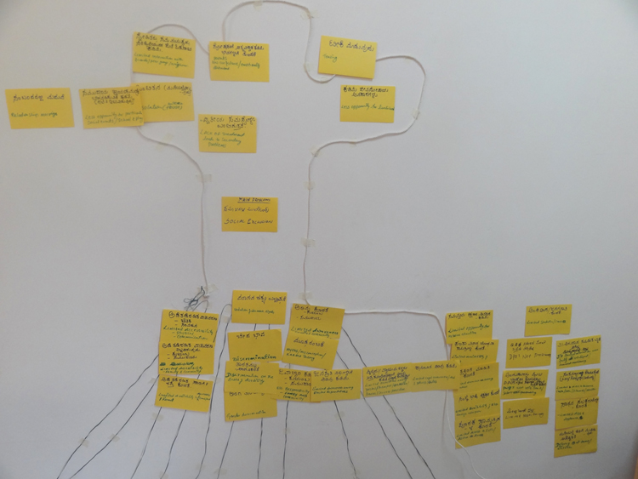
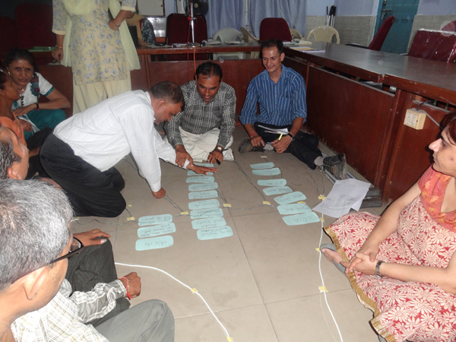
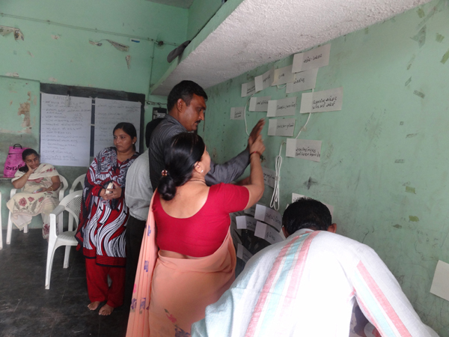
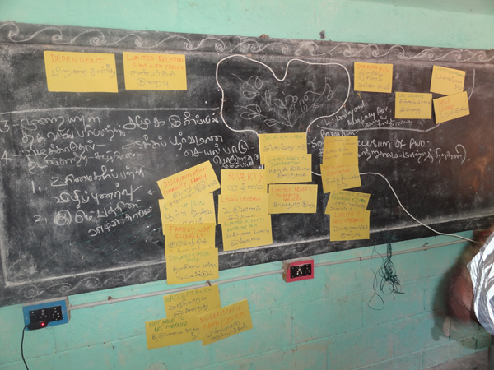
- Once the main cause is identified as social exclusion of persons with disabilities then facilitate the group to identify the sub causes that are connected to the main cause and establish the inter-linkages between them
- Then ask the participants to identify 2-3 main causes, write them out each separately on a rectangular card
- Ask the visually impaired participants to prepare the same cards in Braille so that these could be used by them to understand the inter-linkages among the problems and effects.
- Read aloud the causes written out on the cards in script and Braille one by one and ask the participants to identify if each of these the cause or the effect of the focal problem.
- Show the model of a tactile tree (either drawn on the floor or on a wall with the help of ropes/strings or a thermocole sheet using cellotapes to outline a tree with trunk, branches and roots) and explain that the trunk of the tree depicts the focal problem and ask the participants to indicate from among the points written, which one is the root cause.
- Assist the visually impaired participants to touch and feel the tactile tree and place the focal problem just above the roots.
- Ask two-three participants to come in front and support the group to classify the problem by asking relevant questions.
- Enable the participants to cull out or group the problems under 2-4 subheads like awareness, rights, discrimination (study the sample/flow chart of cause and effect relationships attached with the cases under Handout 2)
- Through discussion, enable the participants to place all the cards on the tree based on whether it was a cause or an effect.
- Ask the participants to arrange the cards made in script and Braille under each of the core problems sequentially based on what leads to what. (The overall effect of the focal problem on the life of persons with disabilities is that they lead a life of poverty, dependence, without dignity and self -respect.)
- Draw the inter-inkages between these and all the other problems and the effects of these problems.
- Explain the cause and effect relationship to the participants using the metaphor of a tree with the help of examples (refer to facilitator’s note). A person does not get a job because s/he is illiterate. Unemployment and illiteracy, which is the cause and which is the effect? The cause and effect relationships are like a staircase: one leads to other. On the upper side you have higher-level causes. One follows and leads to other.
- Take example from the participant’s response and explain how to build the cause and effect relationship.

Facilitator’s Note:
- Provide one of the case studies provided in Handout 2 to the groups: large print to persons with low vision, Braille or talk theatre to the totally blind, picture story board to persons with hearing impairment, regular print for persons with cerebral palsy and locomotor disability
- Take the first 2 paragraphs of the case study as an example and identify 2-3 examples of problems/ issues as samples for the group.
- Visit each participant sub-group and help them to articulate a few of the problems.
- For example, If social exclusion is identified as the problem, then poor infrastructure is the cause and low participation of persons with disabilities in school is the effect. Similarly, different causes and effects were discussed to establish cause and effect relationship.
- Be alert when saying something and be very conscious about the terms and way of speaking; otherwise, persons with visual impairment may find it difficult to understand. For example, when we say small size and large size, it does not mean anything to persons with visual impairment. If we say font size 12 and 24, then it may be more helpful. To be specific, while giving instructions instead of using ‘this’ and ‘that’ and verbal instructions should be accompanied by gestures and local signs
- For instructions make use of the local language
- Write all instruction on the white board /blackboard or on the flipchart and read them aloud
- Write down the responses of the participants too and also read them aloud
- To identify the cause and effect relationship and to clarify the method of analysis take example of a specific situation and ask the participants to enumerate the reasons.
- Explain that policy makers do not consider the needs of persons with disabilities while they are making rules for the marginalised section of the population. For example, in MGNREGA one or two young able-bodied persons may be asked to dig a hole and, based on their ability, rules are being made for all. So the rules are also not accommodating and respecting diversity (elderly, women and persons with disabilities).
- Summarise the discussions periodically.
- Encourage participants to share this experience to gauge how much they have understood
- Encourage persons with hearing impairment to share what they have understood from time to time to check if the sign language interpreter is communicating correctly
- Make sure that the participants identify the causes of social inclusion and not the causes of disability which is quite likely
- Ask the sign language interpreter to first share any additional examples being given by him/her first with the facilitator before communicating these to persons with hearing impairment
- Make an outline of a tree on the wall or floor so that it could be felt by touch by the persons with visual impartment and be visible to those who can see. Use two types of strings to make a tree, a slightly thicker one for the trunk and branches and a thinner one for the roots.
- Assist visually impaired participants to experience the shape of the tree through touch and feel.
- Explain why the metaphor of a tree is being taken as an example. Share that the main causes of the core problem need to be understood and the effects that these causes have. Draw an analogy between the roots, trunk and branches and the root causes, focal problem and the effects.
- Emphasise that working on effects will not bring change about any situation unless attempts are made to change the root cause. For situational analysis it is important to go up to the root cause, then it would be easier to decide how the DPO could address the issues.
- Example: If a non-disabled child is born in the society, what happens?
- The family is happy
- The family provides all possible things required for the child
- They provide, education, all things required for the child
- They mingle with all other children in the society
- They are employed, married, get children and grand children and then they die.

The following explanations may be given:
- So many disabled people go through the same process of life.
- Parents are not happy, do not mingle with society, do not learn skills, get them married.
- Say if one has a headache, what does one do? We take medicine for the headache
- What is the reason for headache, Maybe stress
- How to find out the reasons for stress
- Maybe it is because one’s unemployed
- Why am I not getting a job? Because, it is difficult to commute as I am used to a wheelchair, No proper accessibility for the disabled
- Why is there no proper accessibility? Because, there is no sensitivity towards disability and no mandatory laws
- Why, are we isolated? Since we are excluded, what all happens to us when we are excluded?
- Are we living life like any other person without disability? If not, why? It is because we are excluded
- Perhaps this is because we are not considered as vote bank. Why? It is because we are excluded.
- So when we get headache, we try and find out what the cause of the headache is.

- Similarly when we realise that we are excluded, we should try and find out what the reason for exclusion is.
- The effects and causes could also be colour coded to differentiate between the two
- Once the causes are clubbed and placed at the root of the tree, the arrows go up towards the focal problem. Link the sub causes classified. Similarly link the effects with arrows going upwards from the focal problem like the branches and fruits of a tree.

3.3.3 Case Studies for Problem Analysis (Handout)

xxix. Asha’s Story (visual impairment)

Asha is a 20-year-old visually impaired girl who was born in a small village in West Bengal, India. Her father Dinunath and mother Rasila work in the fields as farm labourers and brother Raju studies in the local primary school.

When she was five years old Asha was affected with a condition described by doctors as ‘dry eyes’ (xerophthalmia, or nutritional blindness) which is the most common cause of childhood blindness. This disease is caused due to vitamin A deficiency. Sources of Vitamin A are available from fruits, vegetables, milk, meat, and egg. Due to poverty, her parents were not able to provide her nutritious and healthy food. As the village is remotely located, the government para-health workers do not reach out to such households for counselling and health advice. Without such support early detection and identification is also not possible.

After Asha contracted this disease, whenever she would accompany her parents to the agricultural fields or for a social function, people in the village would look at her strangely and laugh at her. Other children and neighbours keep away from Asha and their house. Once Asha asked her mother, “Why doesn’t anybody make friends with me?” Her mother replied, “Because you are cursed.” Her parents thought that blindness was sent to a family as a punishment for their sins, perhaps committed in their past lives and so people look down upon them.

Asha’s brother, Raju, goes to school. On several occasions Asha asked her mother, “Ma, why can’t I also go to school?” To which her mother would reply angrily, “Because we do not have so much money. Whatever we have, we have to spend on Raju. In our old age Raju will be our support. What can you do? Anyway, no school will admit you. And even if they do, who will take you to the school and bring you back and what about your books and clothes?” These remarks would make Asha very sad.

At times, she would touch and feel Raju’s books wanting to explore them. This made her father very uncomfortable and he would scold her, “Leave that book! Who will get married to a blind girl anyway! Even if you learn to read and write, it will be impossible.”

As Asha grew older her mobility got more restricted. Her parents instructed her not to step out of the house on her own. She was unable to participate in any village events. When she expressed a wish to go and participate in the annual village mela, a grand event, her parents said irritably, “Why should we take you? What will you go and see there? It is so crowded there.”

No one included her in the village gatherings and functions. Asha was totally ignored and confined to her house. She remained alone, sad and silent yearning to go to school and study like her brother, play with other children and attend village functions.

One day, a community-based rehabilitation (CBR) worker from an NGO approached her parents and suggested to them to admit her to school under the government’s Sarva Siksha Abhiyan programme. Asha’s parents did not know anything about the programme and were reluctant. Asha herself felt unsure and hesitant. It was only after several visits and meetings by the CBR worker that her parents agreed to send her to the local primary school.

Asha began to attend school along with other children from the village. At the school, she faced a tough time as she was older than her other classmates and the teacher made her sit in one corner of the classroom with a Braille kit. There was no guidance provided to her on the use of Braille as the teacher did not know the Braille script. She had to rely mainly on whatever the teachers and other students spoke aloud. At school during the recess, the children, particularly the boys, would make fun of her and tease her. Some would pull her hair and some would try to pull away her school bag. With great difficulty Asha managed to study with support from her brother and other friends in the village who would read aloud while they were studying for their own exams so that she could listen to them.

Finally, the day came when Asha was ready to sit for her Std. X exams. On the first day when she reached the school to write her exam, she was not provided with a writer and hence she was unable to write her exam. On the second day, a junior student volunteered to write her exam and she was able to appear for the remaining subjects. On the last day she had to appear for the music exam as she had opted for this instead of mathematics. The school conducting the exam had not received any instruction for offering this option to her. Hence, on the last day too, Asha was unable to complete her exam.

When the results for the school were declared a few months later, Asha had not been able to clear Std. Xth. Even though she had scored well in most of the exams, she was marked absent for the first and the last exams that she was unable to appear for.

Asha was shattered as she had many hopes and aspirations that she would have liked to fulfil after passing her Std. Xth exams. Her parents and brother were also at a loss and wondered why they ever sent her to school.

With the support of the community-based rehabilitation (CBR) worker, Asha was finally able to complete her education. She gained access to learning material in Braille. Asha aspired to support her family by becoming economically independent and qualified to become a teacher. Even though she was qualified, it became almost impossible for her to get a job. Along with Asha, a group of persons with visual impairment have together filed a petition in the court for employing persons with disabilities under the 3 per cent reservation as stipulated under the PWD Act 1995. But till date they all await the final judgment and are feeling despondent.

Text of talk theatre of Asha’s Story (visual impairment)

I am Asha. Now I am 20 years old. I live with my parents and younger brother in a small village. Our village is very far from the city. Doctors do not visit the health centre of our village. Villagers do not get necessary medicines and no information on nutrition, health and hygiene is available for our community. When I was 5 years old, I began to face problems with my vision. Gradually, the condition deteriorated and I completely lost my vision. I came to know that my vision was lost due to lack of intake of nutritious food, like egg, milk, meat, fruits and vegetables.

Do you know that? I wanted to become independent like others through higher education and employment? With great difficulty I completed my education but am unable to find employment due to my disability.

I still recall my childhood days…

One day I asked my mother, “Mom, why do you not send me to school?”

Asha’s mother: “We don’t have enough money to spend for your education. The little money that we have, we need it for the education of your brother Raju, because in our old age he will take care of us. You are not able to see and will not be able to do anything. By the way, no school will admit you and, even if they admit you, who will take you to school and drop you back home?”

That day I was very upset…

Once I was holding on to my brother Raju’s books, trying to know and feel what would be written in these books. At that time, my father came and scolded me,

Asha’s father: “Why did you take Raju’s books? I warn you not to touch his books anymore!”
Then I began to think that I would be a burden on others for my entire life. Oh! What a life I am living! I began to hate myself.

Nobody wanted to speak to me in my neighbourhood. Do you know why? That was because I am not able to see at all. My parents also thought that I was a curse to the family.

I can remember a few more incidents which influenced my parents to think that my disability was due to their sins committed in past lives.

Once our neighbour visited us and began to advise my mother about me

Ramala Aunty (Neighbour): Asha’s mother…. Are you there in the house?

Asha’s mother: Yes, I am here, Ramaladi…

Ramala Aunty (Neighbour): Your daughter is growing older now. Moreover, she is not able to see. So don’t let her go out on her own. If anything happens to her, then what will you do? It’s not your fault… everything is your fate… We all know you and your family, but all this is due to your past sins….

As I was growing, my movements were restricted. I was not allowed to go outside….

Every year in April, a big fair is organised in our village… Once when my parents were going to the fair with Raju I asked my father if I could also go with them. But my father sharply replied,

Asha’s father: What will you do in the fair? You can’t see anything… there will be a huge crowd in the fair… who will look after you in that crowd?

Despite loneliness, neglect and rejection, one day I saw a ray of hope when Shantidi (who worked in an NGO) came to our house

Shanti Manna (CBR Worker): Is there anyone in the house?

Asha’s mother: Who is there? Raju, open the door and see who is calling?

Shanti Manna (CBR Worker): My name is Shanti. Sister, can you come outside for a while?

Asha’s mother: Who are you? From where have you come?

Shanti Manna (CBR Worker): I have come from a non-government organisation (sanstha)….

Asha’s mother: From where?

Shanti Manna (CBR Worker): Sister, we work with children with disabilities… with those children who cannot see, cannot hear and speak, who have difficulties in moving around and with those who have retarded development and are not like other children of his/her age.

Asha’s mother: Just a moment… I am bringing the mat…please have a seat…What is your name?

Shanti Manna (CBR Worker): I am Shanti Manna…Do you and your husband work in the fields?

Asha’s mother: Yes. He is our son Raju… Raju, please come here… He goes to school… Raju, please show your books to Shanti aunty…

Shanti Manna (CBR Worker): You also have a daughter?

Asha’s mother: Yes, she is not able to see since childhood
Shanti Manna (CBR Worker): That’s not a problem…Do you send her to school with Raju?

Asha’s mother: She is blind. She cannot read and write… She is useless and nothing can be done about her….

Shanti Manna (CBR Worker): As a mother how can you say something like this? She can also continue education like other children and in the future it may happen that she may look after all of you. Here she is…please come here my child…What is your name?

Asha: My name is Asha.

Shanti Manna (CBR Worker): Oh! What a nice name. Don’t you want to go to school and learn?

Asha: Yes, I too want to go to school. Many times I have thought that I could also learn many things like my brother…

Shanti Manna (CBR Worker): Have you heard about the government programme called Sarva Siksha Abhiyan…through this project disabled and non-disabled children together get opportunity to study in the village school free of cost. Besides this, especially for disabled children, there are special arrangements / facilities in each school….

After several visits by Shantidi and discussions with my parents, at last I began to go to school. One teacher from Shantidi’s organisation used to come to our house to teach me Braille (reading – writing)…

I started going to school with my brother. But the school-going days were not very nice and happy. The school teachers did not know Braille. I was asked to sit in a corner of the classroom with Braille slate, stylus and other materials. When the teachers would teach in class, I used to listen very carefully and try to understand and learn the content.

During the recess/break, my classmates used to humiliate me in several ways; try to snatch my bag and pull my hair. I used to prepare my lessons with a lot of difficulty by listening to the lessons by my brother and some of the friends in my village. In this way I continued my studies till the 10th standard and appeared for the Board examination.

On the first day of the Board examination, I found that at the examination centre there was no arrangement for a scribe/writer for me and the teachers didn’t know anything about it. So despite all the preparations, I could not appear for the first exam. From the second day onwards, a student of a lower class helped me to write the rest of the papers. I had chosen music as an optional paper. But no order mentioning this optional subject was communicated to the examination centre by the Secondary Board of School Education. So, the examination authority didn’t allow me to appear for my last exam.

When the results came, I found that I had scored good marks in all the subjects but as I could not appear for the first and last exams, I had been disqualified in the Board examination. All my efforts were in vain. I realised that my dream of becoming independent would never come true. Now my parents thought that it would have been better if they had not allowed me to enrol in school and continue education.

With the support of the community-based rehabilitation (CBR) worker, I was finally able to complete my education. I was able to gain access to learning material in Braille. I wished to support my family by becoming economically independent and so studied hard to become a qualified teacher. Even though I was qualified it became almost impossible to get a job. Together with a group of persons with visual impairment we have filed a petition in the court for fulfilling 3% reservation for employing persons with disabilities as stipulated under the PWD Act 1995. But till date we all still awaiting the final judgment by the court and are feeling despondent.

Picture Story Board of Asha’s Story – Problem Analysis for Social Exclusion

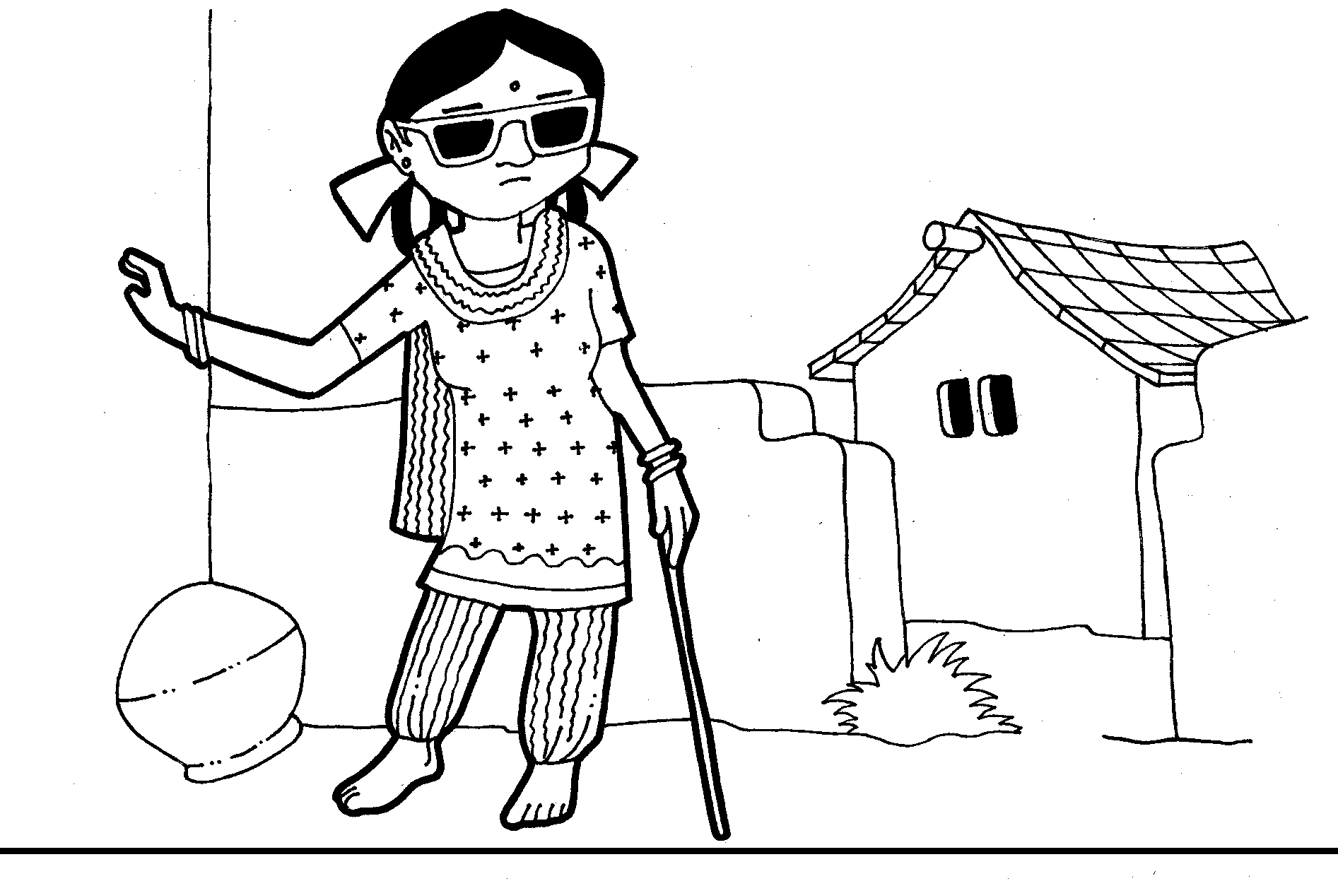
Figure 1: ASHA IS A 20-YEAR-OLD GIRL WITH VISUAL IMPAIRMENT

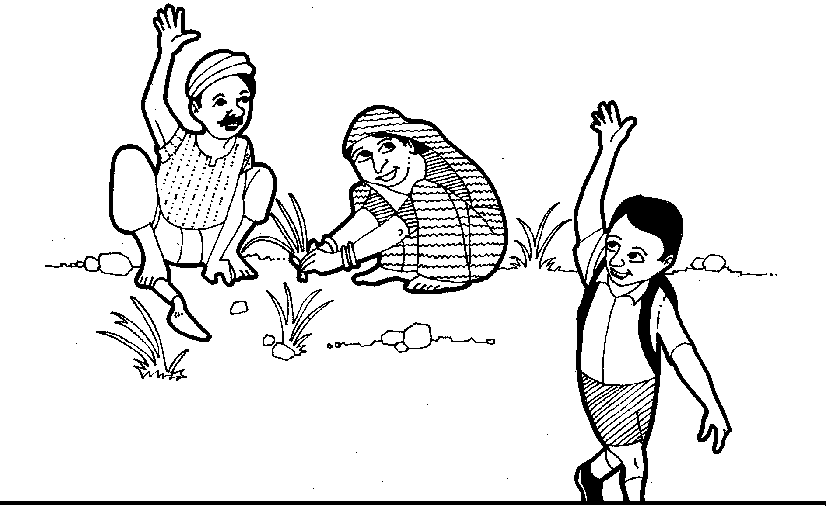
Figure 2: HER FATHER AND MOTHER RASILA WORK IN THE FIELDS. AND
HER BROTHER RAJU STUDIES IN THE LOCAL SCHOOL
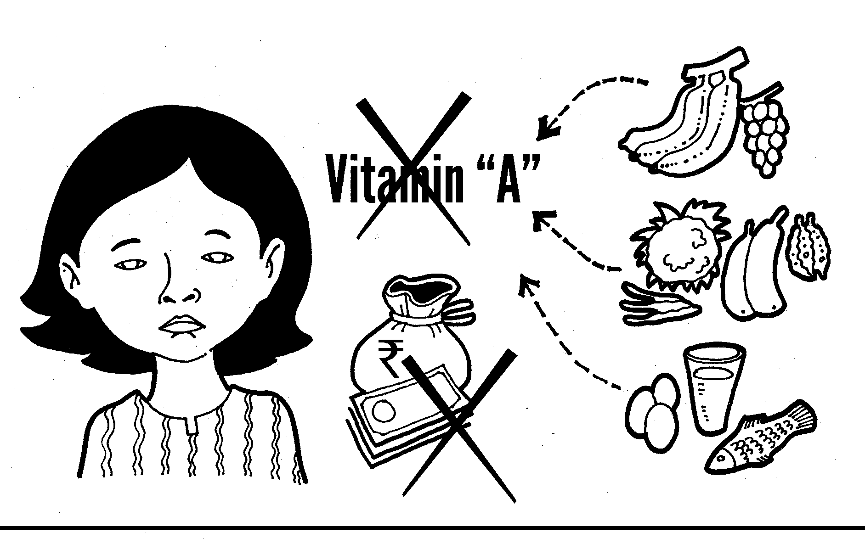
Figure 3: ASHA IS AFFECTED BY DRY EYES. THIS CONDITION IS CAUSED DUE TO
VITAMIN A DEFICIENCY

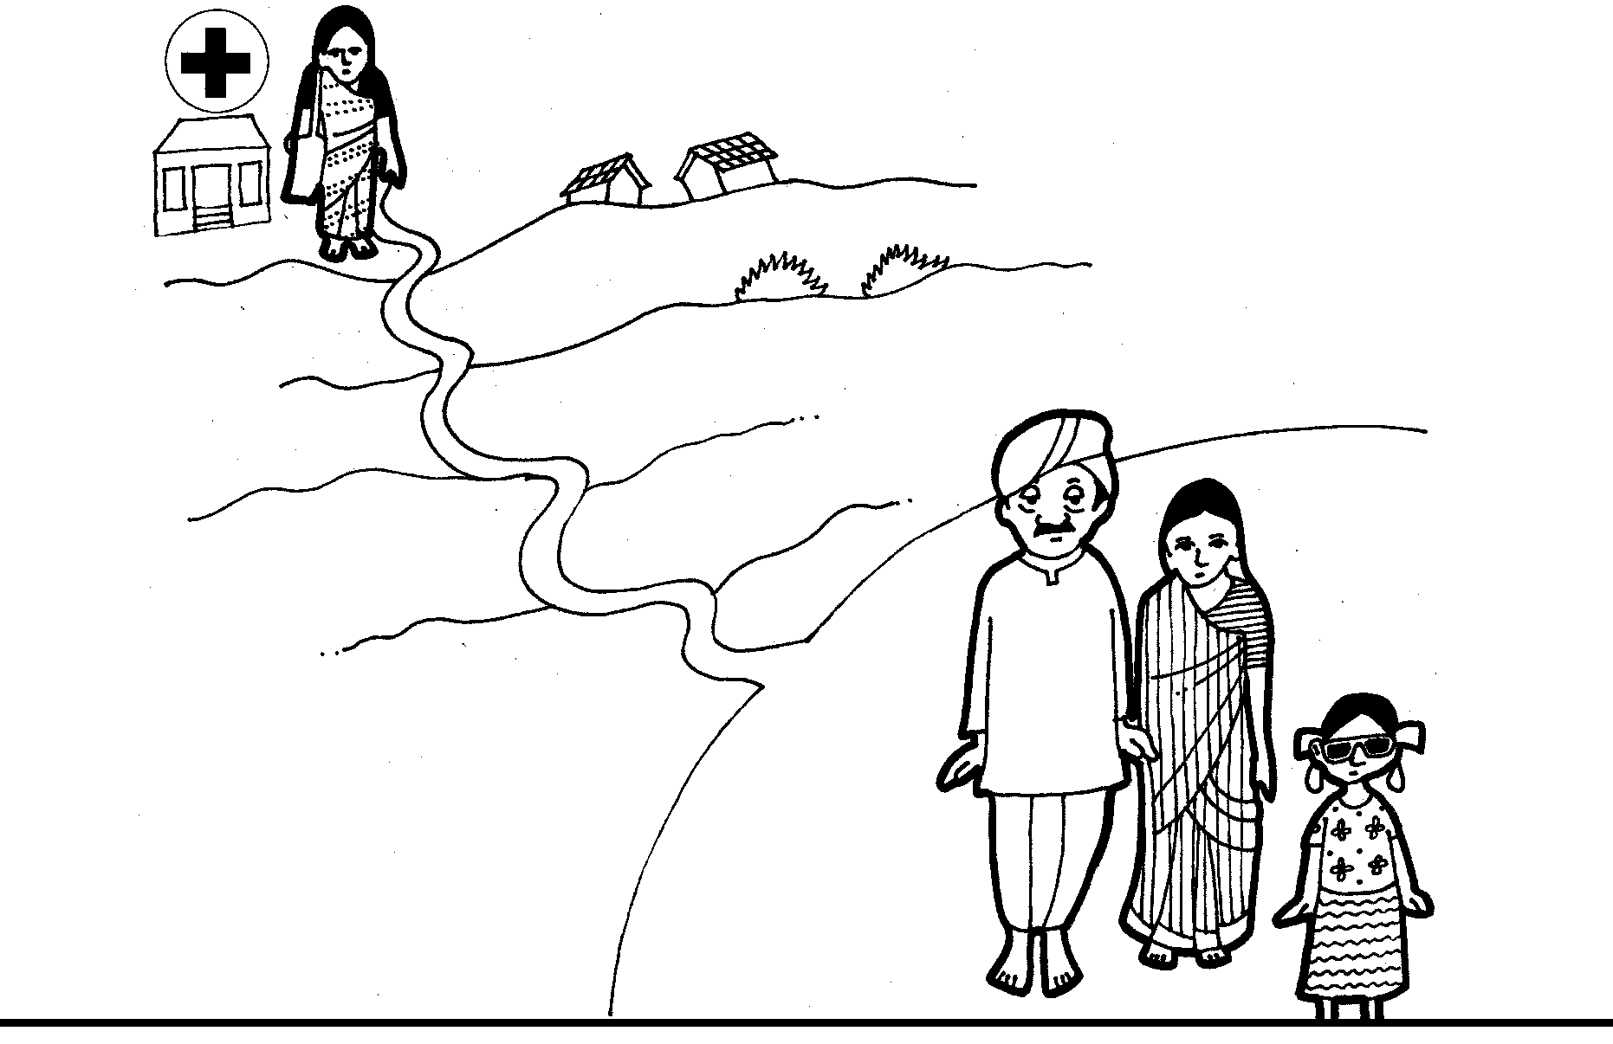
Figure 4: AS THE VILLAGE IS REMOTELY LOCATED THE GOVERNMENT
PARA HEALTH WORKERS DO NOT VISIT IT
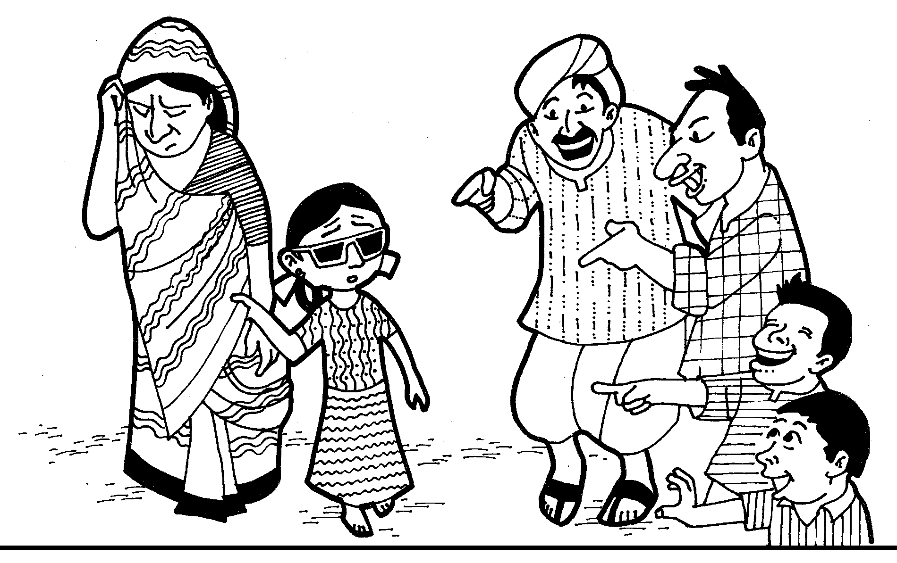
Figure 5:: THE VILLAGERS WOULD LOOK AT ASHA STRANGELY AND LAUGH AT HER.
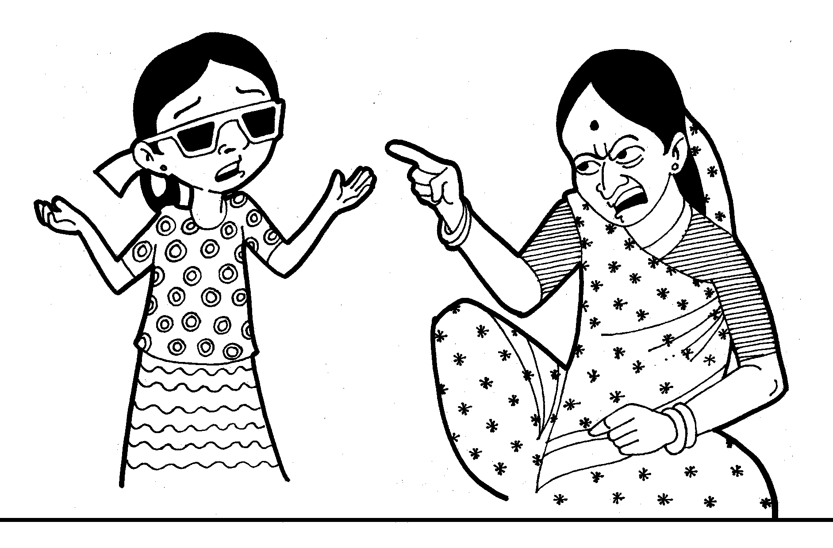
Figure 6: HER MOTHER REPLIES, “BECAUSE YOU ARE CURSED”.
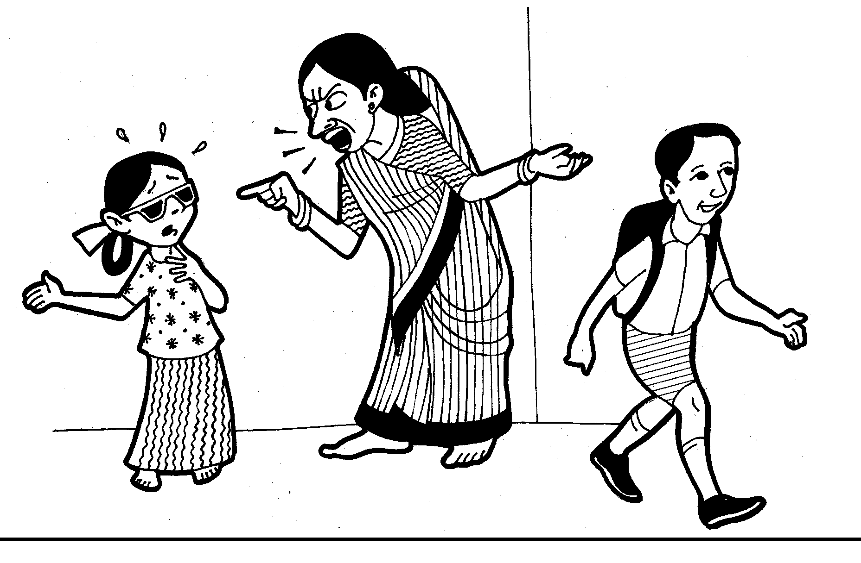
Figure 7: IN OUR OLD AGE RAJU WILL BE OUR SUPPORT. ANYWAYS, NO SCHOOL WILL ADMIT YOU.

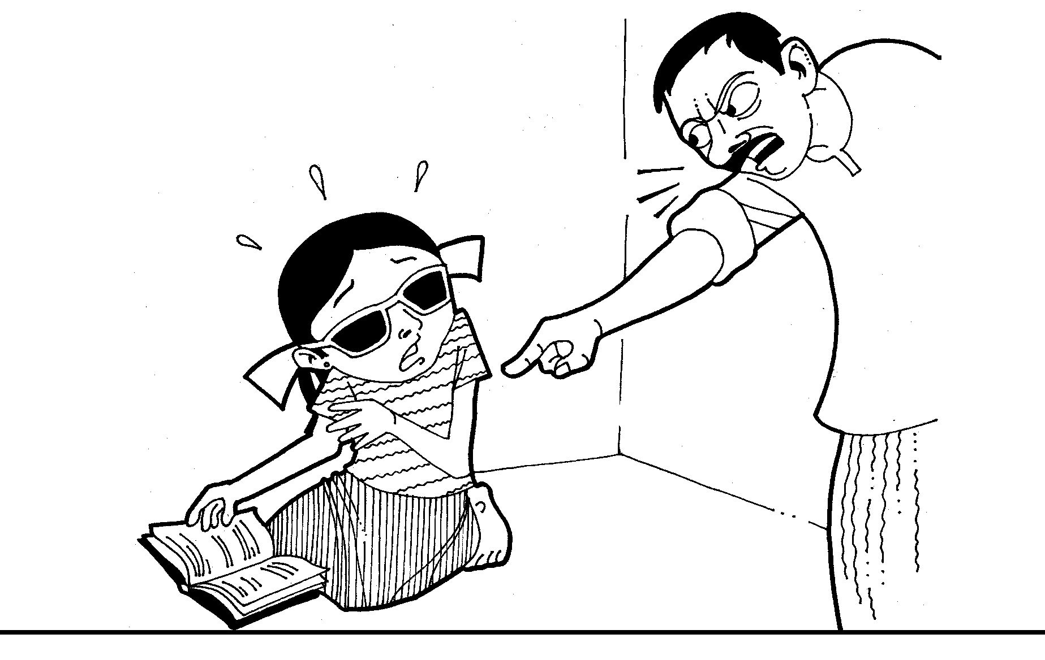
Figure 8: AT TIMES SHE TOUCHES AND FEELS RAJU’S BOOKS WANTING
TO EXPLORE THEM.
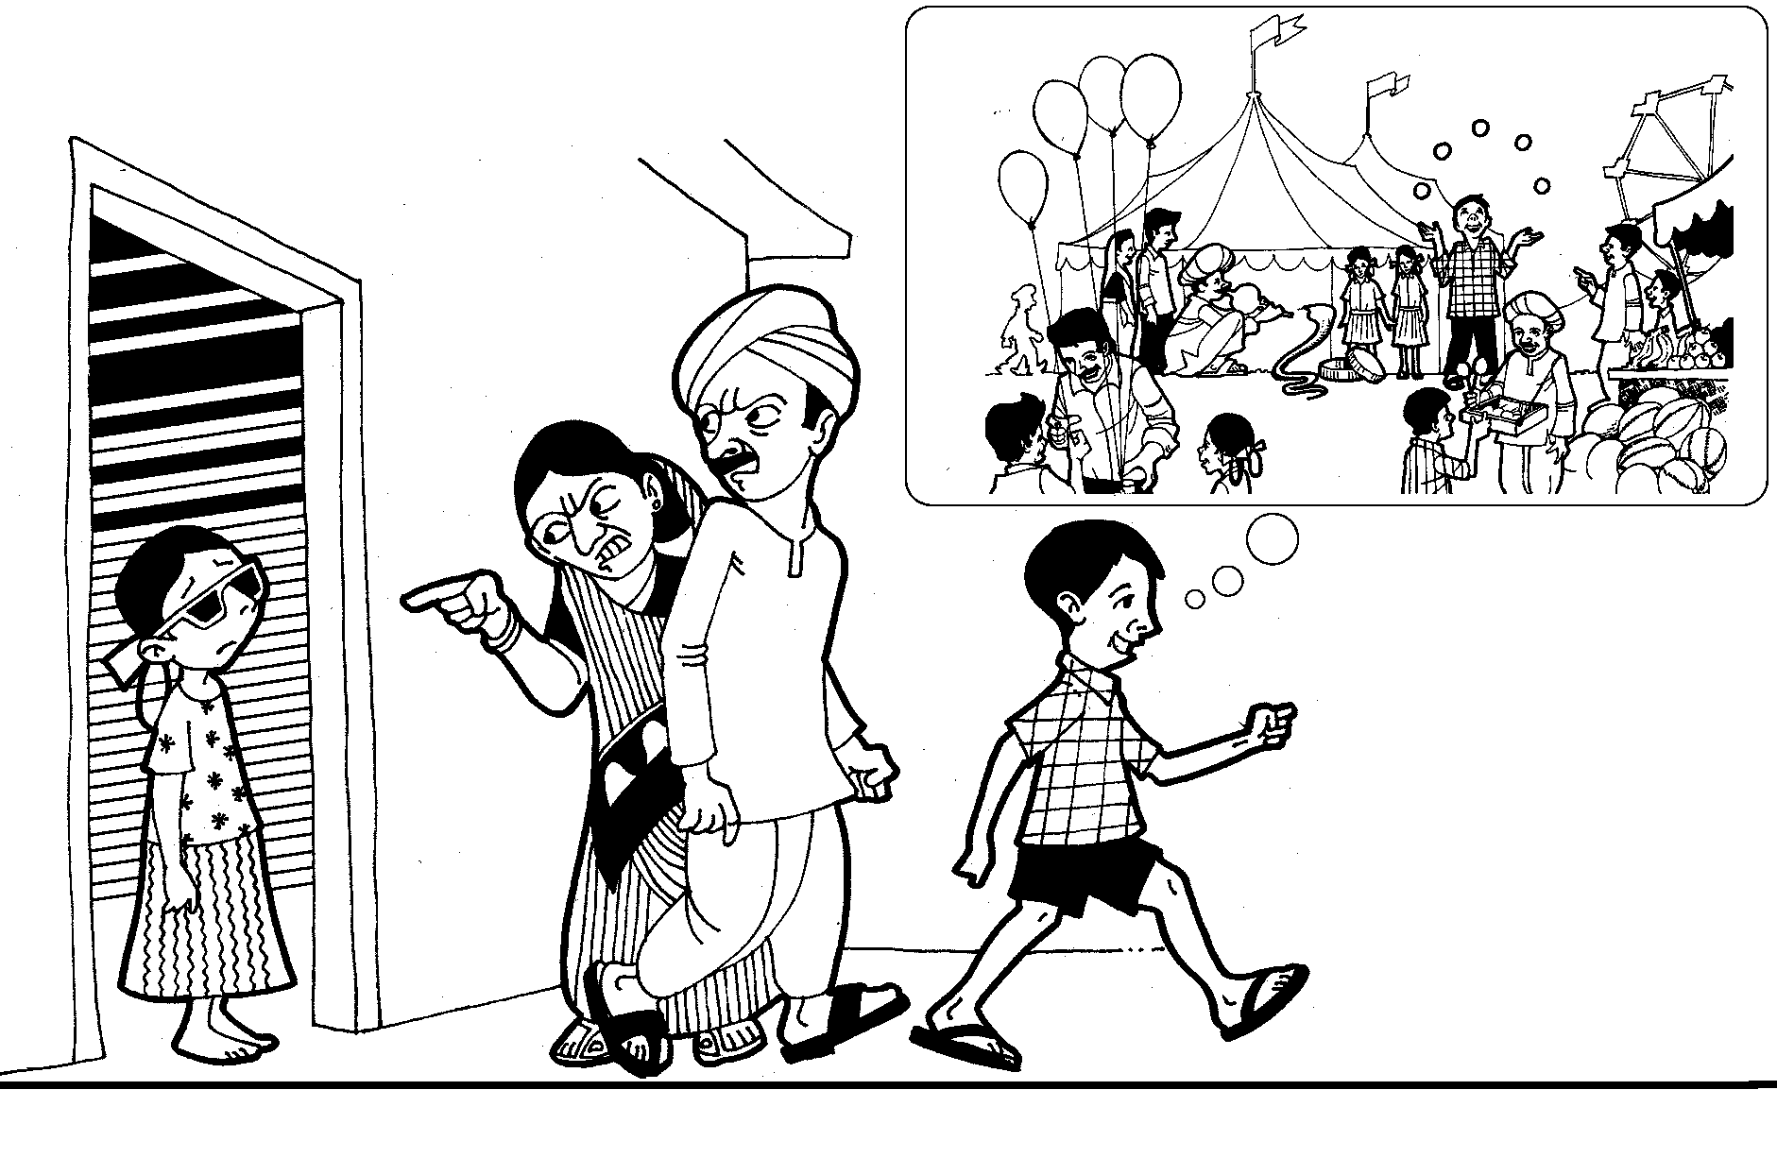
Figure 9: AS ASHA GROWS OLDER, HER MOBILITY BECOMES MORE RESTRICTED
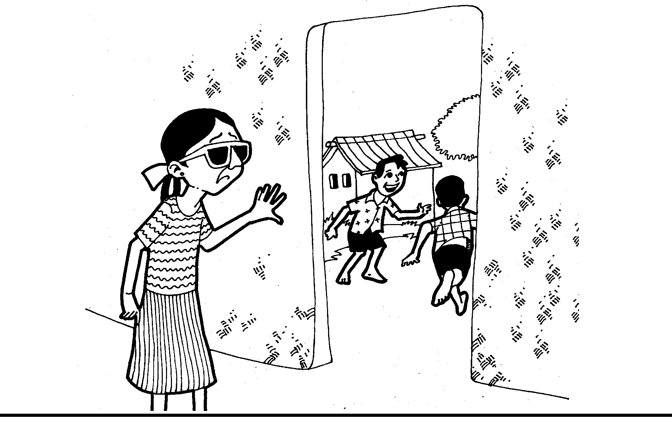
Figure 10: ASHA IS TOTALLY IGNORED AND CONFINED TO HER HOUSE.

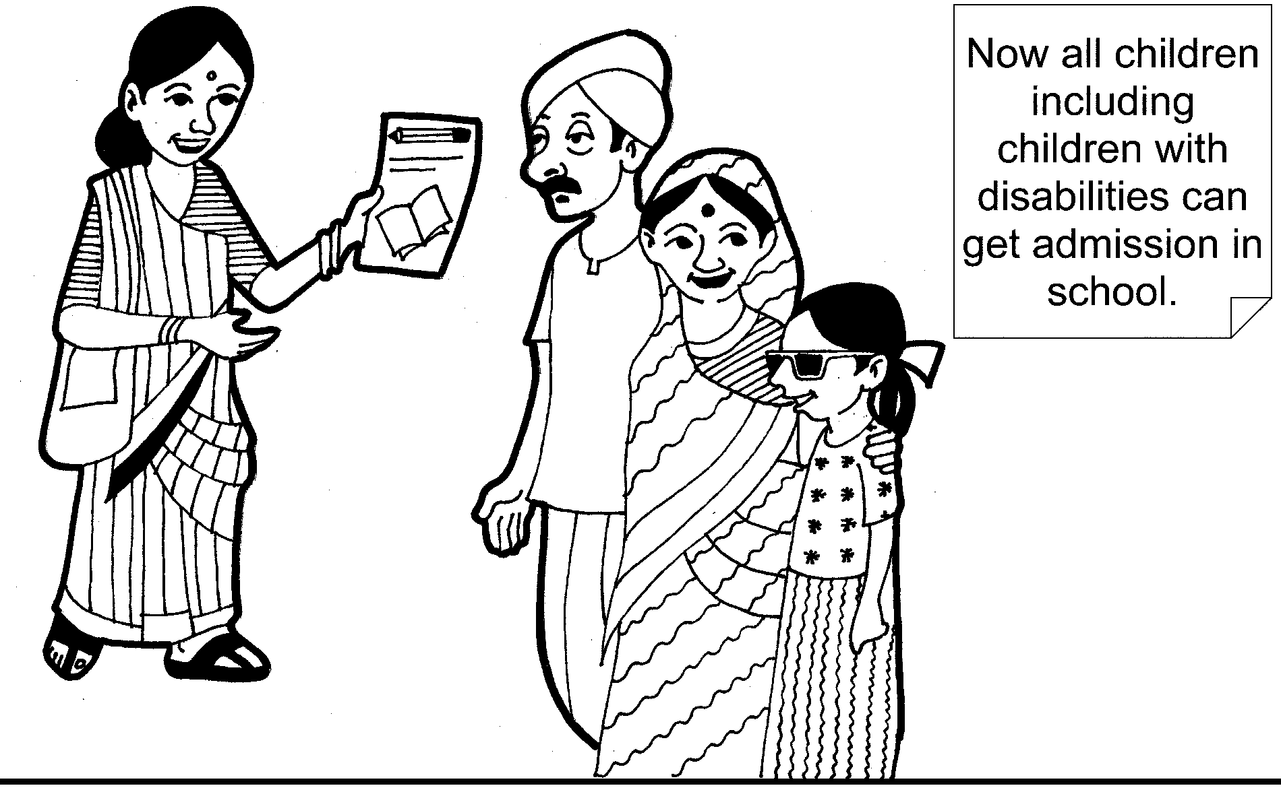
Figure 11: A CBR WORKER APPROACHES ASHA’S PARENTS AND SUGGESTS
TO ADMIT HER TO SCHOOL.

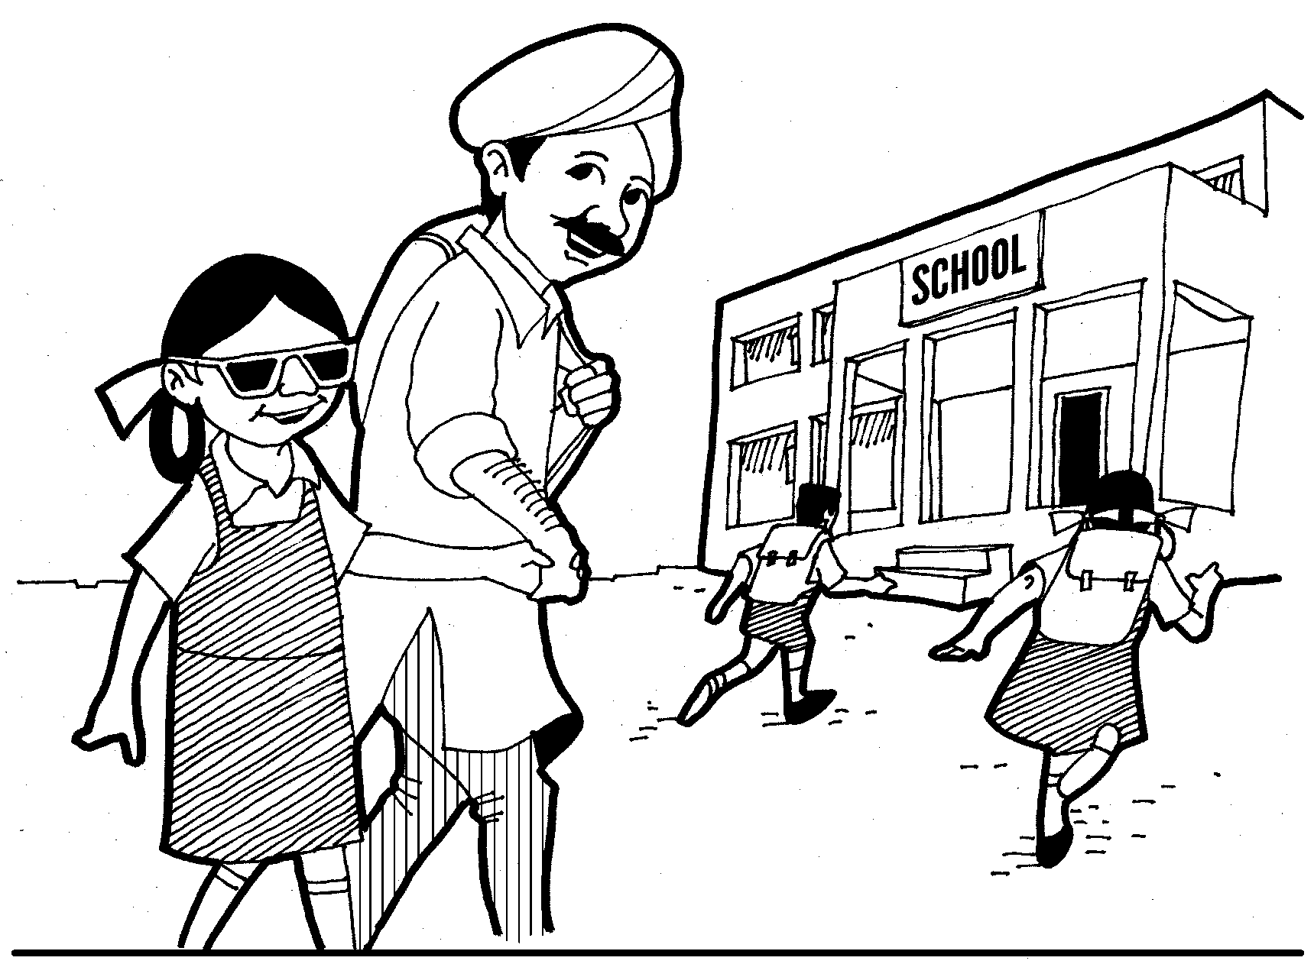
Figure 12: ASHA’S PARENTS DECIDE TO LET HER CONTINUE STUDIES
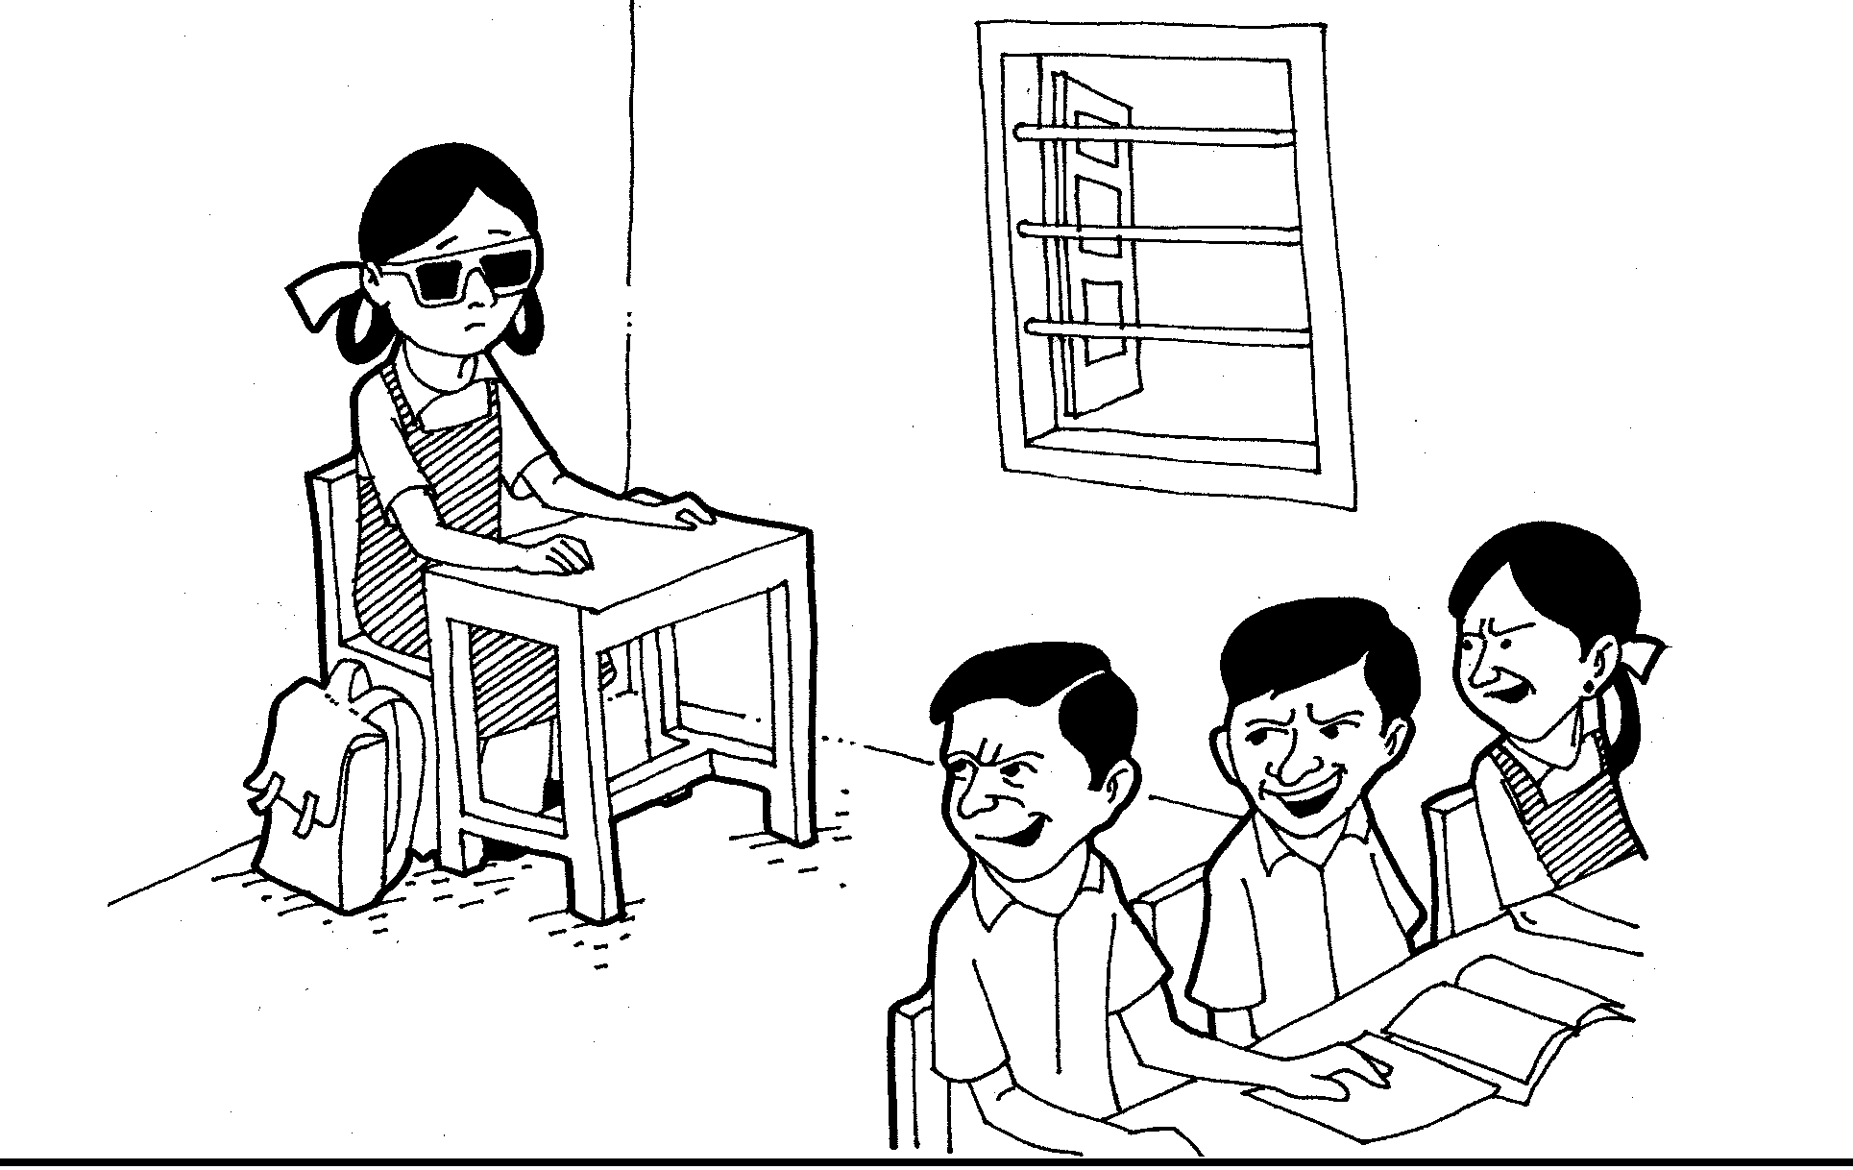
Figure 13: ASHA HAS TO SIT IN A CORNER IN THE CLASSROOM

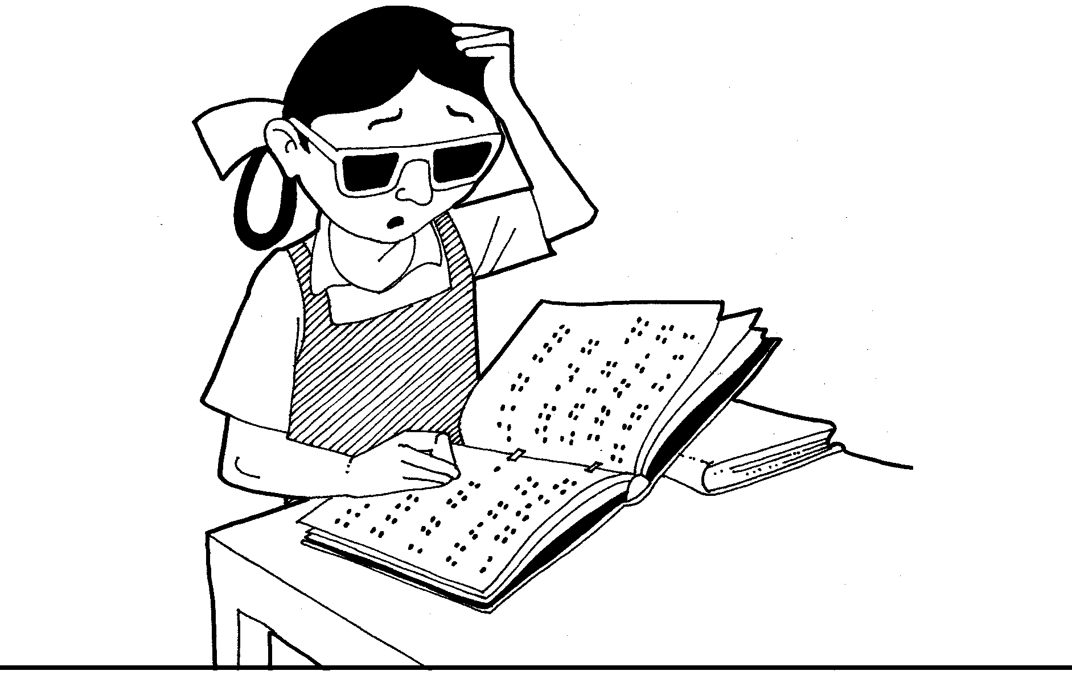
Figure 14: BRAILLE IS NEW TO HER AND SHE DOESN’T KNOW HOW TO USE IT

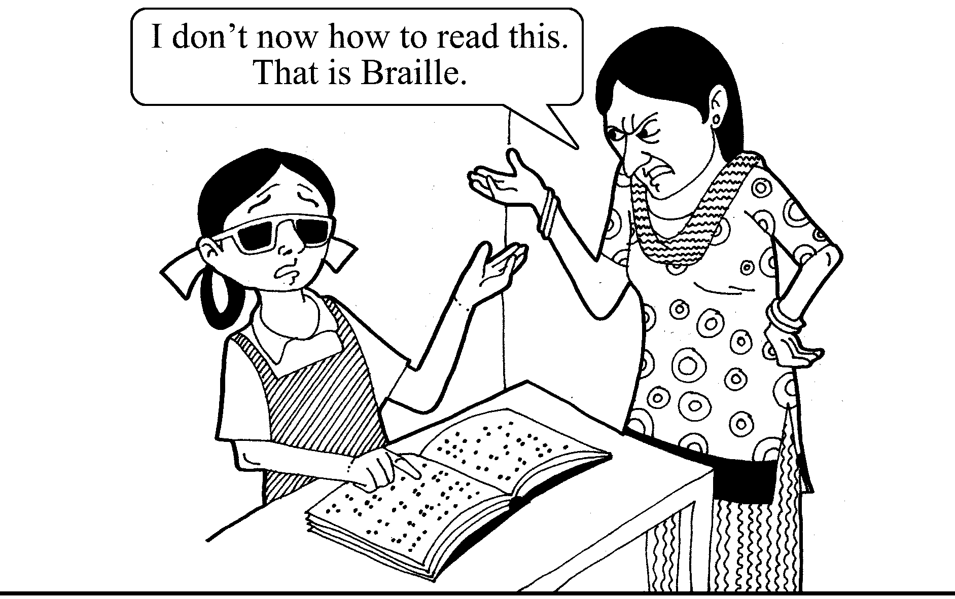
Figure 15: THE TEACHER DOESN’T KNOW ABOUT BRAILLE EITHER

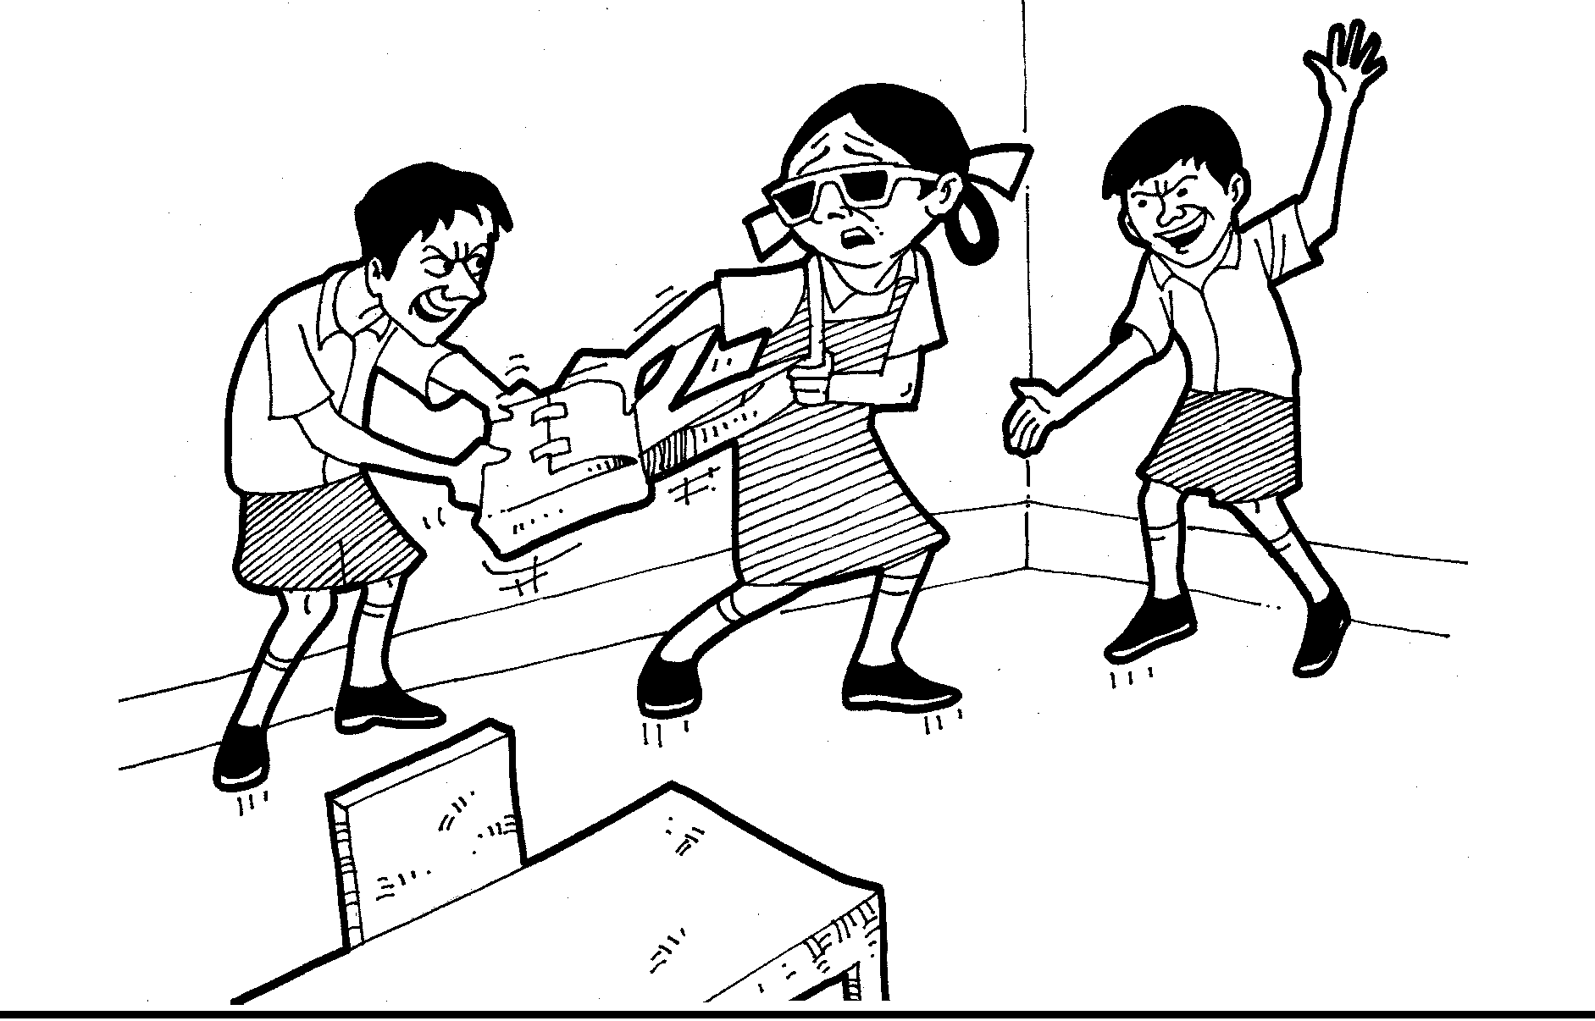
Figure 16: THE BOYS MAKE FUN OF HER AND TEASE HER.

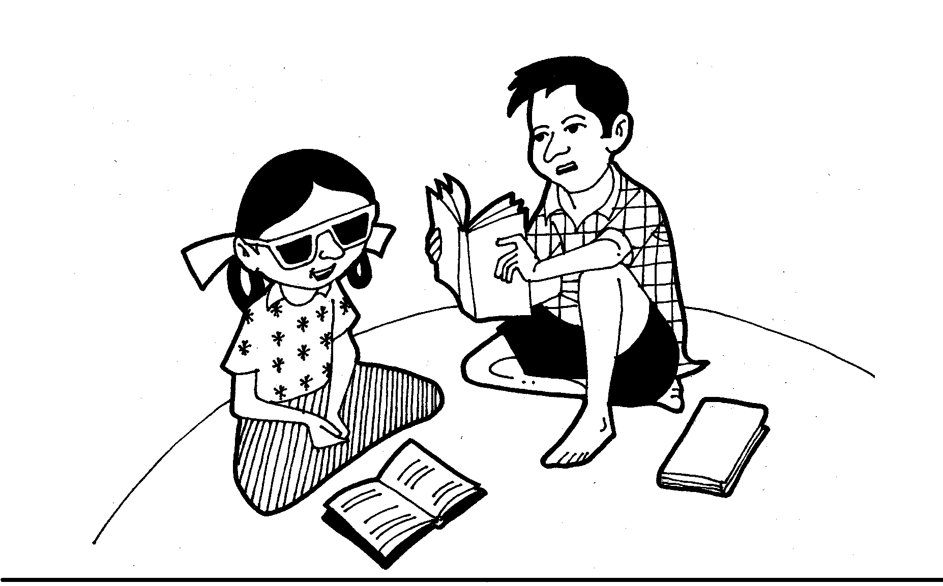
Figure 17: ASHA MANAGES TO STUDY WITH SUPPORT FROM HER BROTHER.
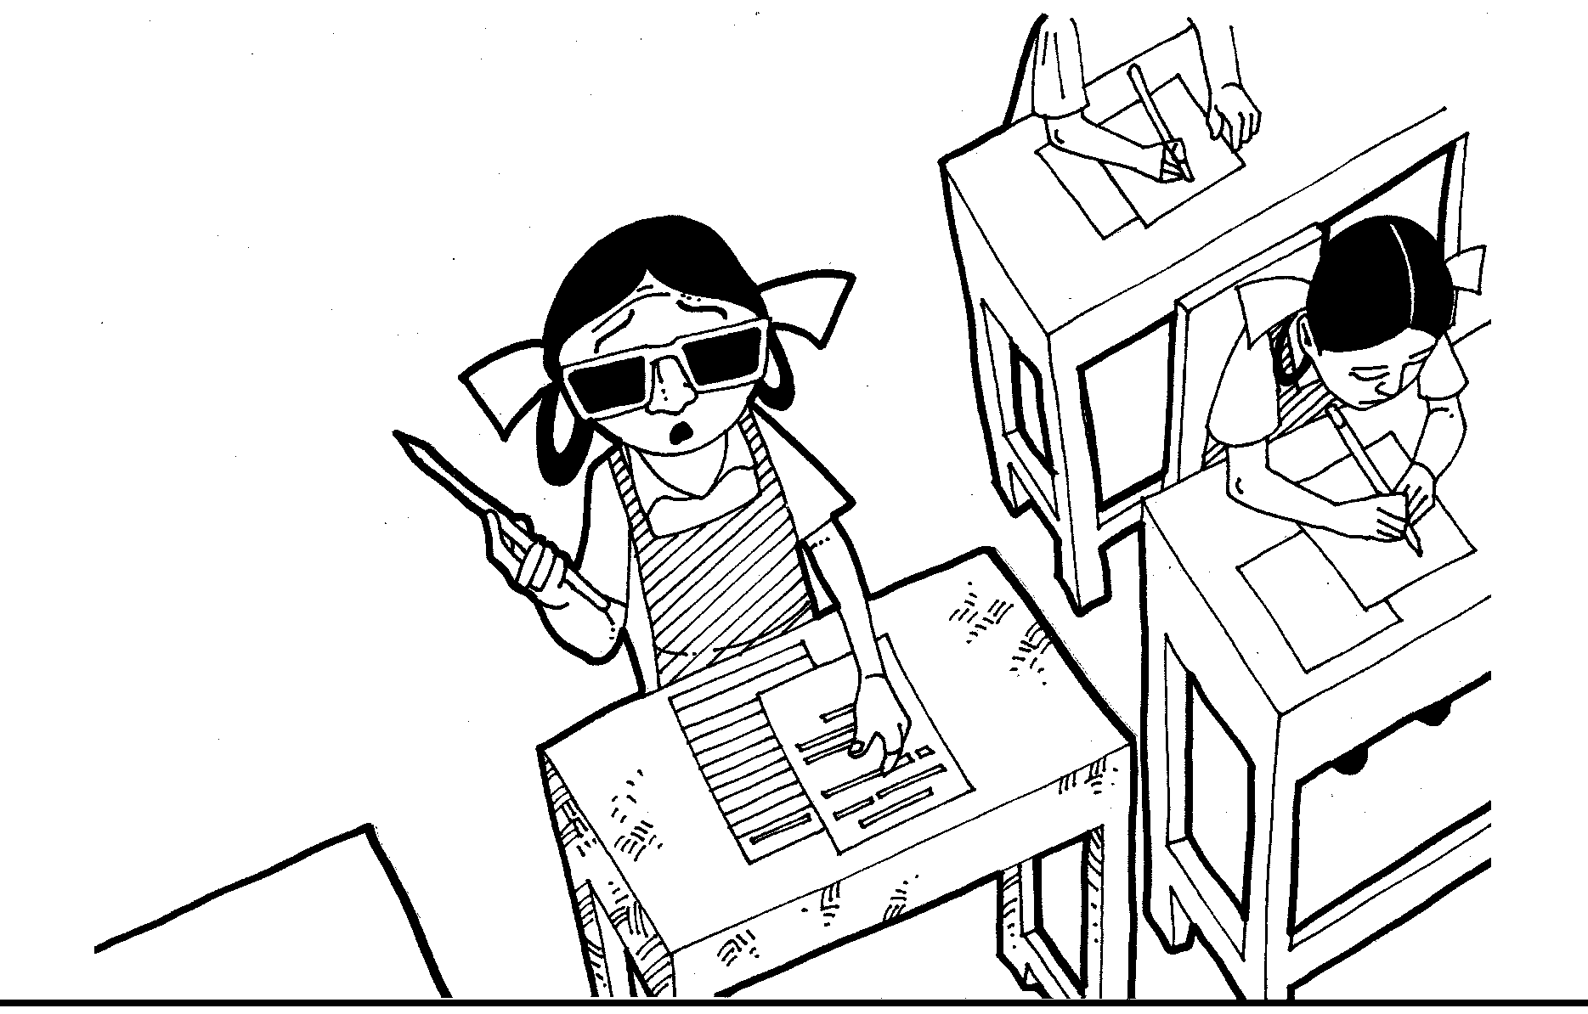
Figure 18: SHE IS NOT PROVIDED WITH A WRITER AND HENCE
SHE IS NOT ABLE TO SIT FOR HER EXAM.
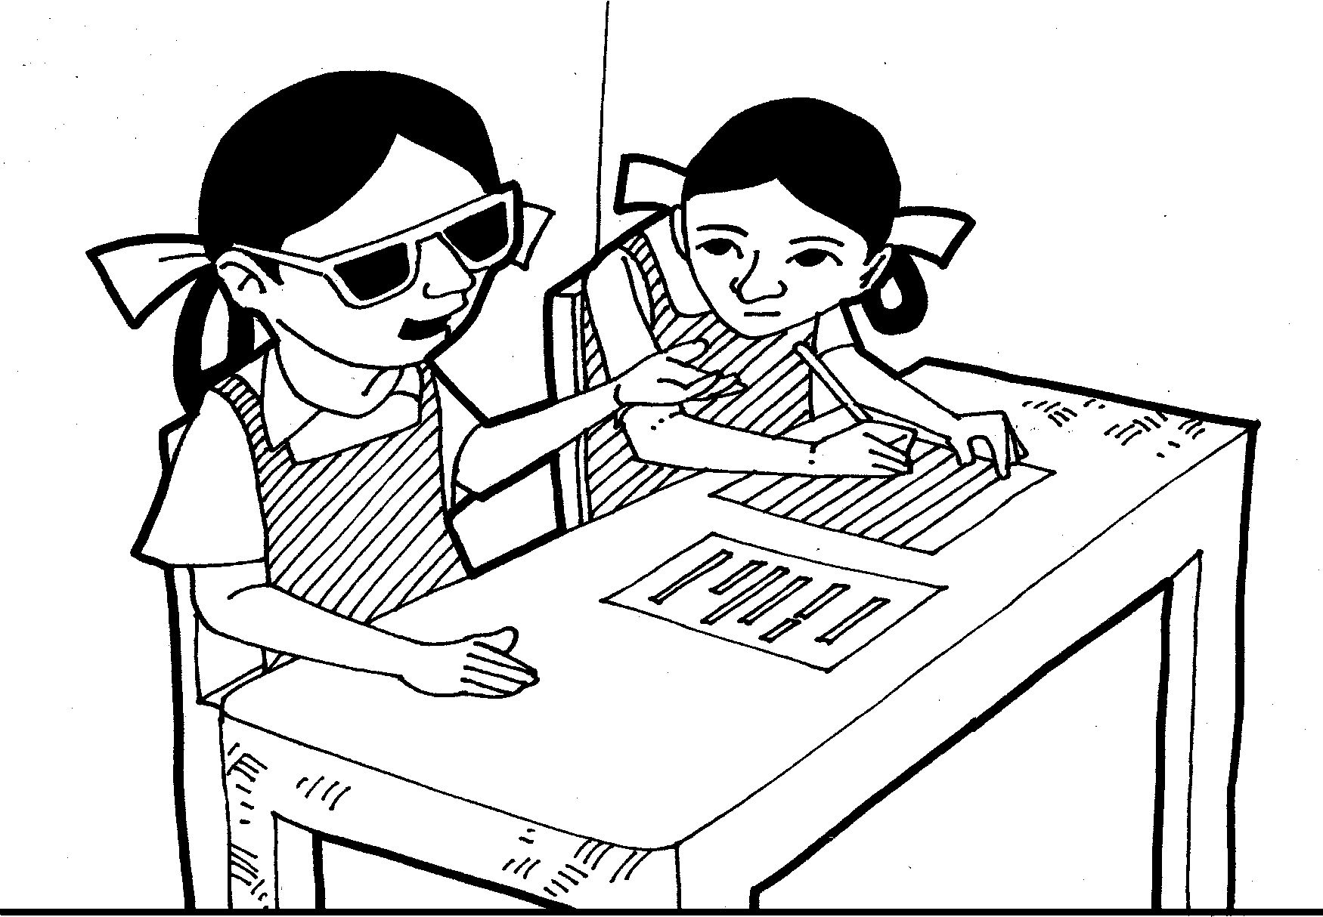
Figure 19: A JUNIOR STUDENT VOLUNTEERS TO WRITE HER EXAM.

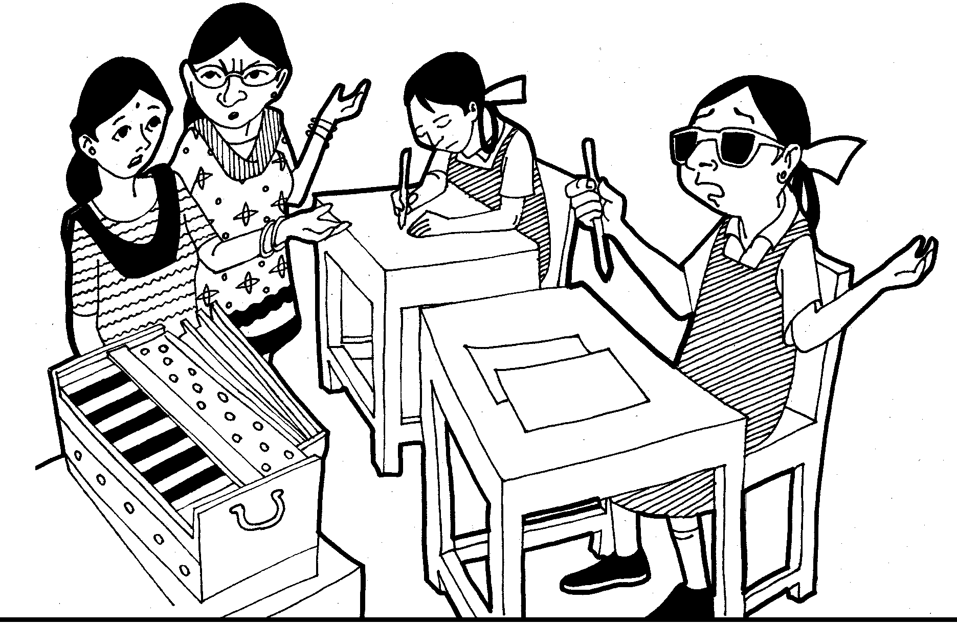
Figure 20: ON THE LAST DAY TOO, ASHA IS NOT ABLE TO PERFORM HER
MUSIC EXAM.
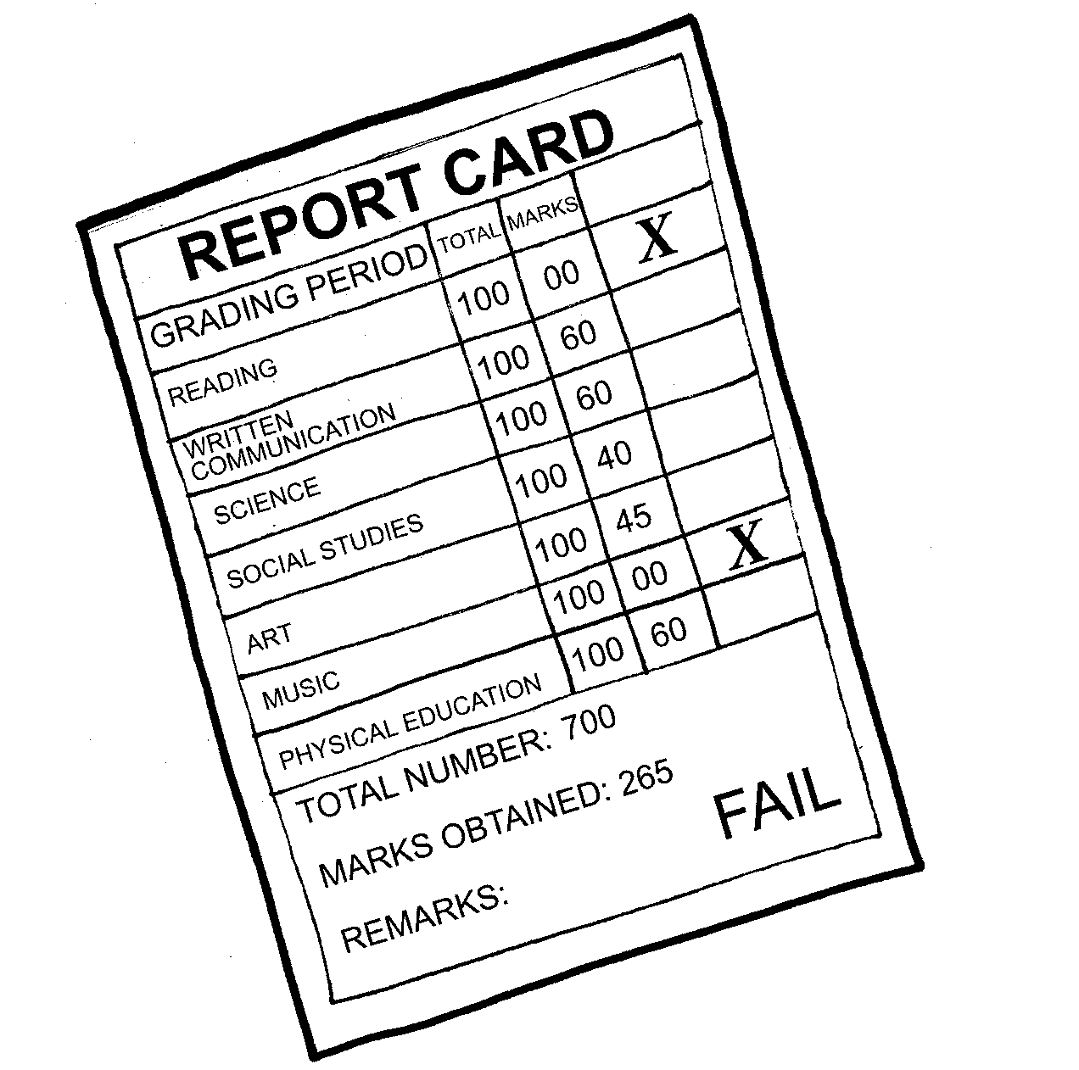
Figure 21: ASHA IS NOT ABLE TO CLEAR STD. X.
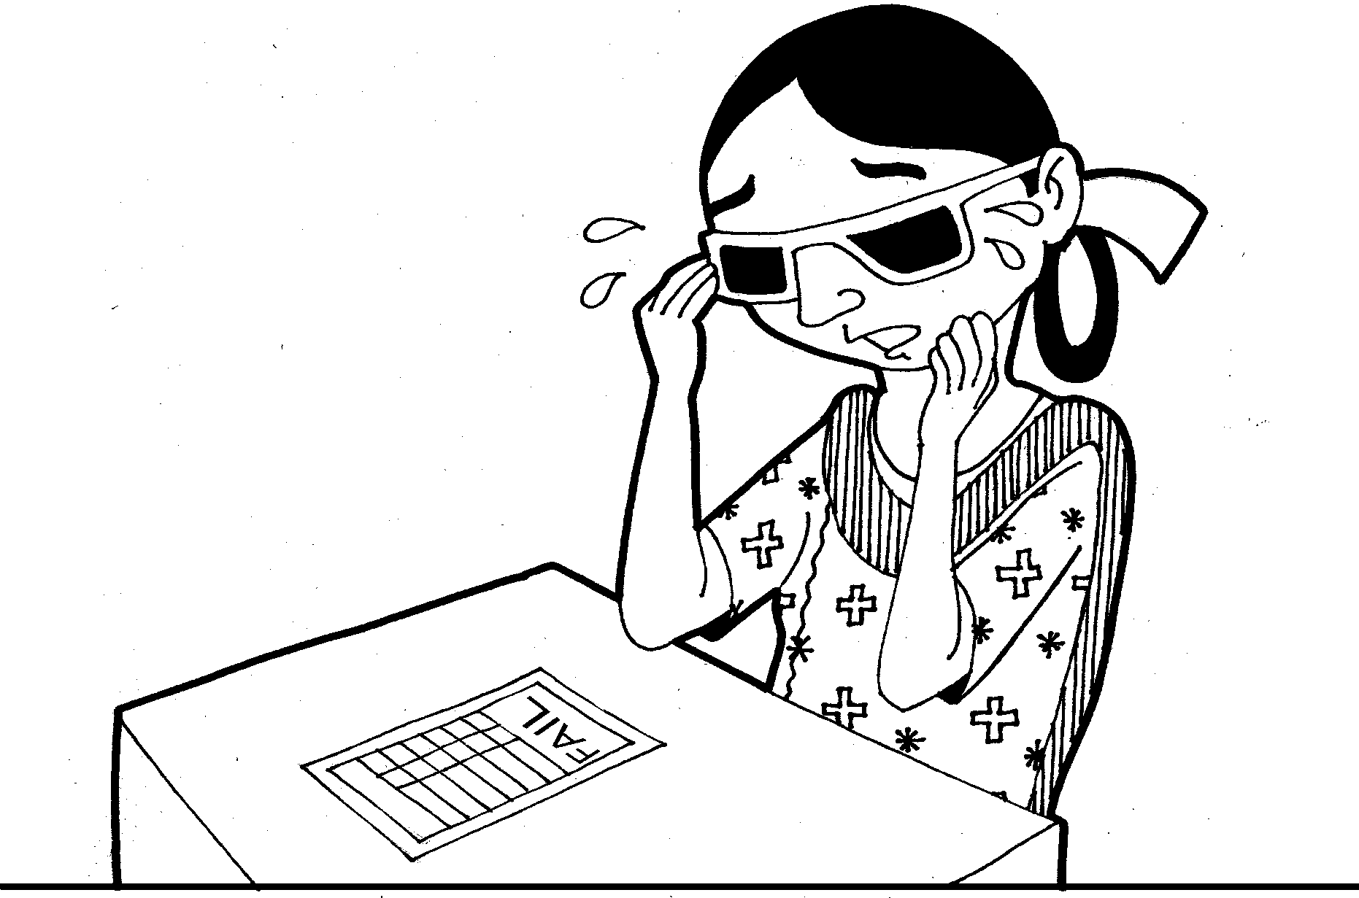
Figure 22: ASHA IS SHATTERED AS SHE HAD MANY HOPES AND
ASPIRATIONS
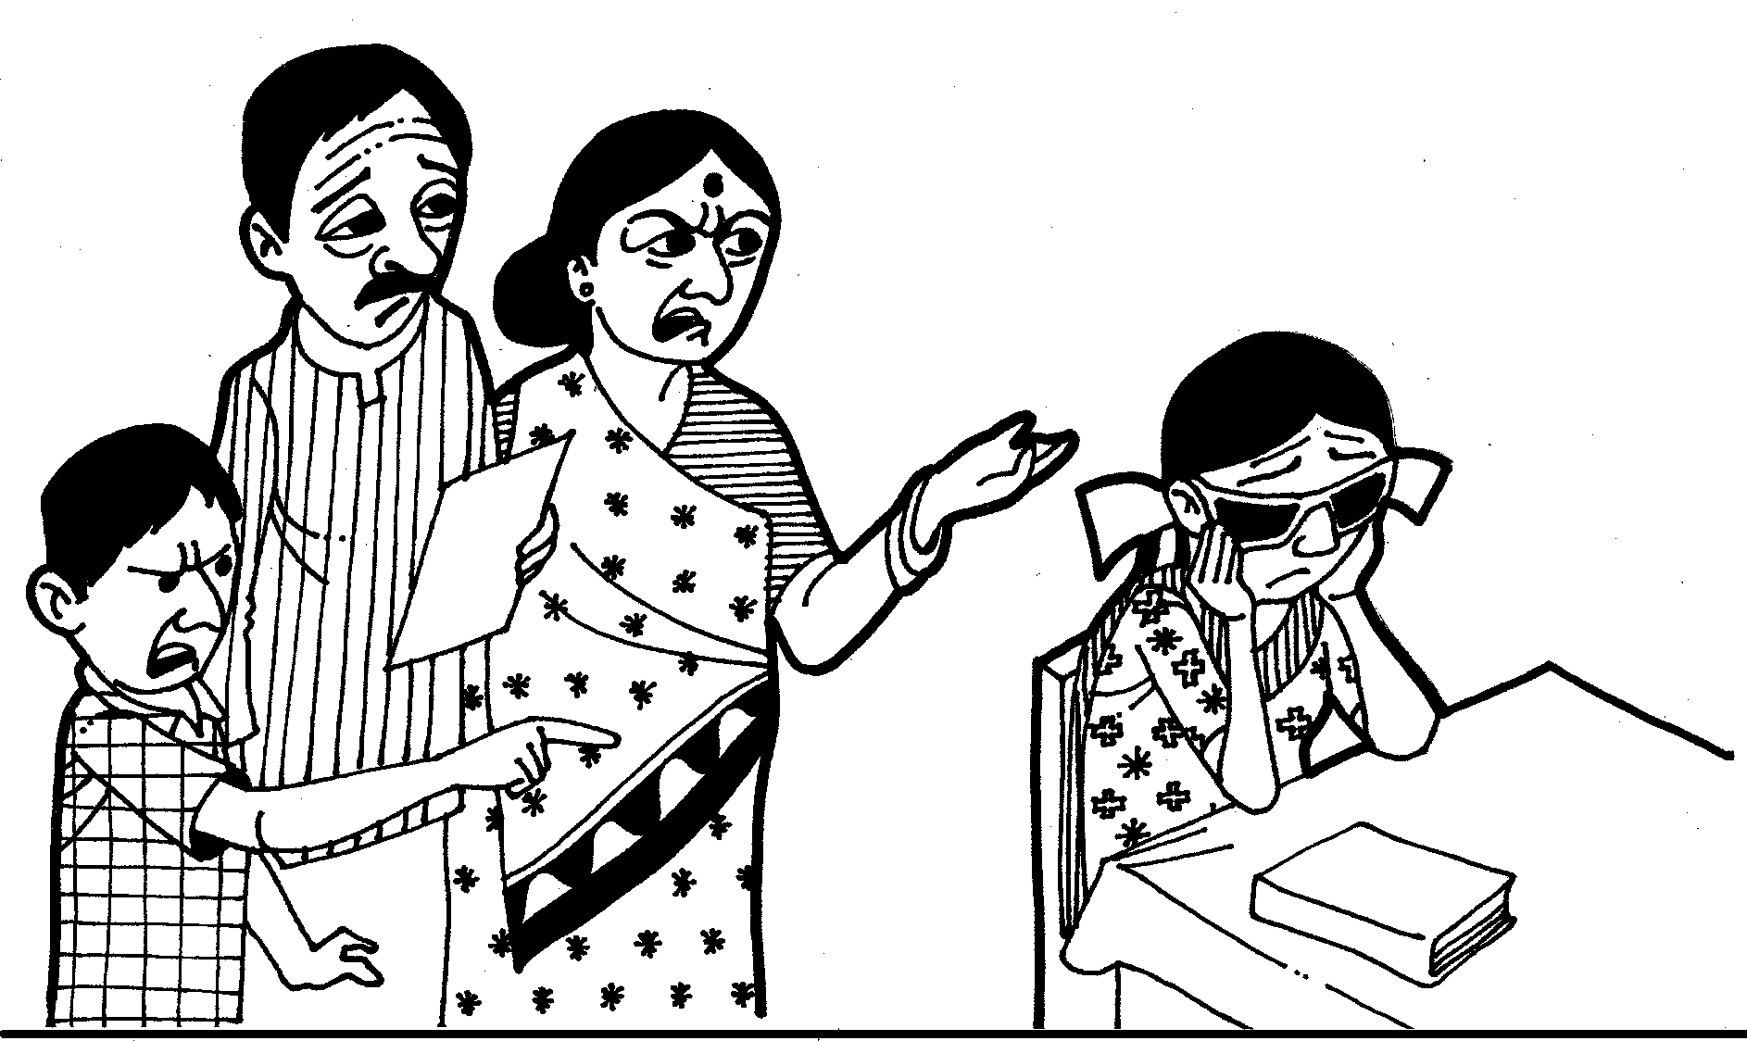
Figure 23: HER PARENTS AND BROTHER ARE ALSO AT A LOSS.

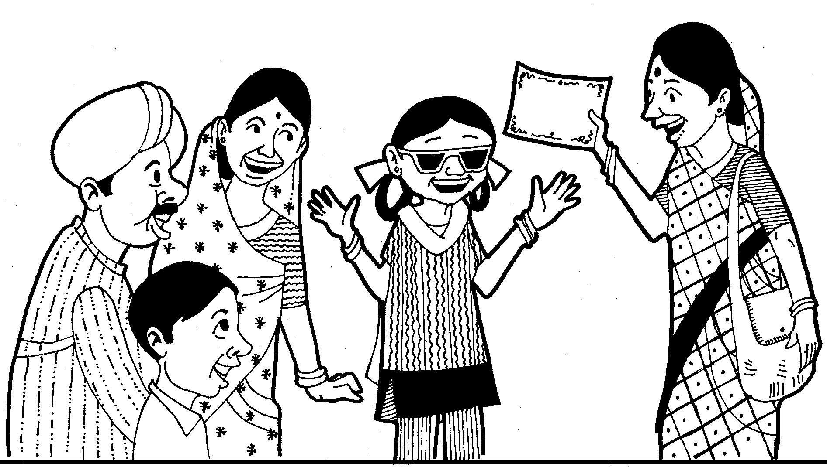
Figure 24: WITH THE SUPPORT OF THE CBR WORKER ASHA IS ABLE TO COMPLETE HER EDUCATION.
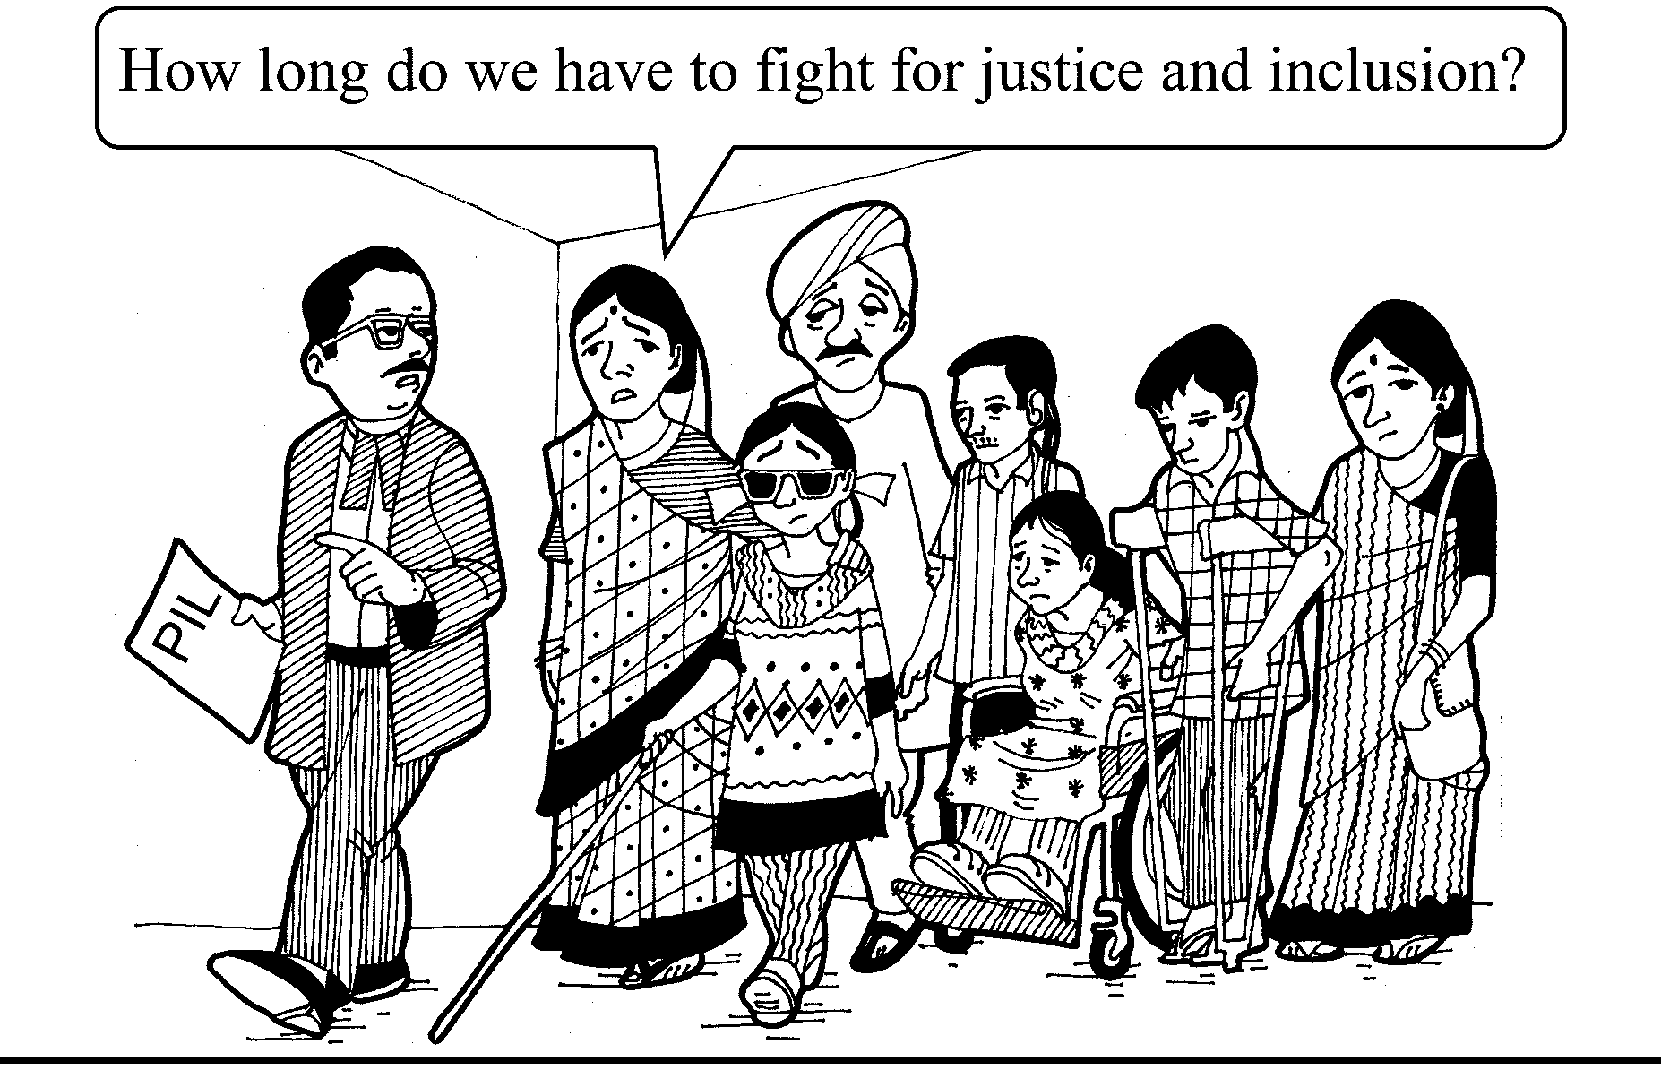
Figure 25 A GROUP OF PERSON WITH VISUAL IMPAIRMENT HAS
FILED A PETITION IN THE COURT.

PROBLEM ANALYSIS
FLOW CHART
ASHA’S STORY–1
Feeling of despair
Despondent / Unsuccessful
Limited access to health services
Limited access to health services
Low self-confidence
Not able to express one’s thoughts and feelings
Anganwadi & ASHA (health) workers not going to the village

Negative ATTITUDE of society
Village located far from school
Limited access to educational services
Low implementation of RTE
Remain closed within 4 walls of the house
Limited availability of aids
Apathetic School Management / admin
Parents not aware
Disability considered a burden by parents

Discrimination by school
Insensitive teachers
Superstitious / beliefs by family
Discrimination between boys & girls
Limited time spent by parents on disabled child

Low participation by child with disability
Limited awareness
Misbehaviour by teacher
Low access to basic services and aids & appliances
No provision of scribe/ writer hence not able to give exam
Limited access to accessible transport
SOCIAL EXCLUSION OF PERSONS WITH DISABILITIES

PROBLEM ANALYSIS
FLOW CHART
ASHA’S STORY– 2
Discrimination in the family and community
Poverty
Limited access to health services
No access to education
Limited access to resources and schemes
Karma and sin
Family not supportive
Isolated and confined inside the home
Non-acceptance
Not able to get married
Low participation in games/ sports
Less income
Limited access to nutritious food
Limited access to information
Limited aids and appliances
Dependent
Limited relationship
Less confident
Limited encouragement
Helpless
Limited
barrier-free environment
SOCIAL EXCLUSION OF PERSONS WITH DISABILITIES

Needs and aspiration of persons with disabilities not met
Teasing by friends
Inferiority complex
Not able to get married
Persons with disabilities struggle to demand their rights
Isolation
Stress
Hesitation

Restrictions on mobility / persons with disability not allowed to go out
Rejection by parents
LIMITED AWARENESS ON DISABILITY
Limited Information
Negative approach and attitude of society
Non-acceptance by parents
Superstitions
Karma theory
Limited knowledge on rehabilitation

Limited knowledge of rules
Traditional rituals
Limited accessibility to barrier-free builT environment
Tribal area/ interior region
Poverty
Malnutrition
Unequal distribution of resources
Discrimination because of disability
Limited access to education system (RTE)
Gender discrimination
Low demand of rights by persons with disabilities
Limited access to health facilities
Limited early intervention
(for disability)
Illiteracy
Prejudice against children with disability
Limited knowledge of teacher on disability
Unavailability of writer
SOCIAL EXCLUSION OF PERSONS WITH DISABILITIES

PROBLEM ANALYSIS
FLOW CHART
ASHA’S STORY– 3

xxx. Chandramathi’s Story (intellectual disability)

Chandramathi is an 18-year-old girl affected with intellectual disability. She lives in Kamatigi village in Bagalakote district of Karnataka, India. Her father Ramappa and mother Annamma work at construction sites as daily wage labourers. Chandramathi has one brother and a younger sister. Her brother, Anjanappa, studies in Std 2nd at a local primary school in the village and younger sister, Rathna, works as an in-house maid.

Chandramathi was 3 years old when her parents noticed that she was not able to speak, walk and eat properly. At times she was not able to recognise her parents and often she would get seizures (fits). When the parents finally noticed that she was not like other children, they approached a health worker in their community to understand about the sickness of their child. The health worker discussed in detail about the family and came to know about its poor economic condition. The mother had no access to nutritious food during pregnancy, had not gone for regular check-ups to the health centre and the children were delivered at home.

The health worker guided the parents to the district hospital as there was no health centre in their village. The district health centre was very far from the village and they had to walk several kilometres as there were no proper roads or facility of transportation. The parents approached the owner of the construction site for financial help and were given only a sum. The parents took the child to Bagalakote district hospital, where the doctor prescribed medicines for managing seizures (fits). He clearly communicated to the parents that their daughter would never be like other children. Chandramathi’s parents were shocked and nervous when they heard this.

Chandramathi remained confined to the house as a recluse and her brother, sister; friends and other children would never play or talk to her as her clothes were always wet and smelt of defecation. When Chandramathi’s parents’ would go out of the house they would lock her inside and the neighbours, children would tease and bully her by throwing things at her from the window and holes in the house. Chandramathi’s parents were afraid to let her out of the house also as she might lose her way or someone might do something shameful to her and it would affect the family’s status. Often, her parents would be cursed by the neighbours that they were undergoing all these troubles as God had punished them for their sins/misdeeds committed in their past lives. The parents would feel sad and dejected after such quarrels with the neighbours and would often beat her up.

One day Chandramathi expressed a wish to accompany her brother to school but her mother scolded and pulled her back saying, “You can’t go to school, if you go to school, there is no use. You need to be sent to a special school, but we cannot afford to do so. We have to spend a lot of money for your medicines and have to feed you. You are of no use to us.”

One day a community-based rehabilitation (CBR) worker from an NGO got information about Chandramathi from the health worker and visited the family. She discussed with her parents about sending their young girl for vocational training so that the family would have some income and she would be fruitfully occupied. At first the parents did not agree, but after several visits by the CBR worker they agreed.

Then the parents took Chandramathi to the vocational training centre but at first the instructor refused to admit her as she had difficulty in climbing the steps and was wobbly in her movements. She would often roll on the floor instead of walking. The instructor was afraid that she would fall and hurt herself. Later, the CBR worker explained to the instructor about Chandramathi’s condition and also informed her about the Rights of Persons with Disabilities Act. The instructor reluctantly admitted her to the vocational training centre. Here she received vocational training and picked up skills in making baskets, candle making and plastic flower making. During the training too she faced many problems like being spoken to rudely by the instructor, less cooperation from co-mates not being given enough time to learn and complete her task, teasing and so on.

After the training, with the help of the CBR worker, Chandramathi’s parents tried to find a job for her, but unfortunately they were not able to do so as the skills taught by the vocational training institute were outdated and new products were available in the market. Then Chandramathi and her parents tried to apply for a loan so that she could start a small business on her own and sell her products in the local market, but the bank refused to give loan to a girl with mental retardation. Now the family’s status is worse than before as her parents are growing old and are not able to go out and do manual work, prices of essential food items are increasing and they would often remain ill due to paucity of nutritious food. Chandramathi’s younger brother dropped out from the school to earn a living as he was the only one who could do something. The younger sister had run away with someone long back.

One day Chandramathi’s father met Raju, who was a 21-year-old young adult with hearing impairment since birth. He was fortunate enough to go to a school for the hearing impaired and had passed the 10th Std. He had completed one year’s diploma course in computers at an NGO that worked with persons with disabilities. After the training Raju began to look for employment but was refused by several employers as they were not able to understand Raju’s means of communication in sign language, Often the employers said that they were not equipped to hire him and that he should find work in special places where they employed persons with disabilities like him Through Chandramathi’s brother, Raju met the CBR worker who informed him about 3 per cent reservation for persons with disabilities in government jobs under the Persons With Disabilities (Equal Opportunities, Protection of Rights and Full Participation) Act 1995 (PWD ACT). Raju decided to apply for work in the local post office but here again when he appeared for an interview the panellists were not able to communicate with him and he was not selected. Both Raju and Chandramathi’s brother are left in despair and are not able to figure out what they could do to overcome their family’s situation from abject poverty.

Picture Story Board - Chandramathi’s Story (intellectual disability)
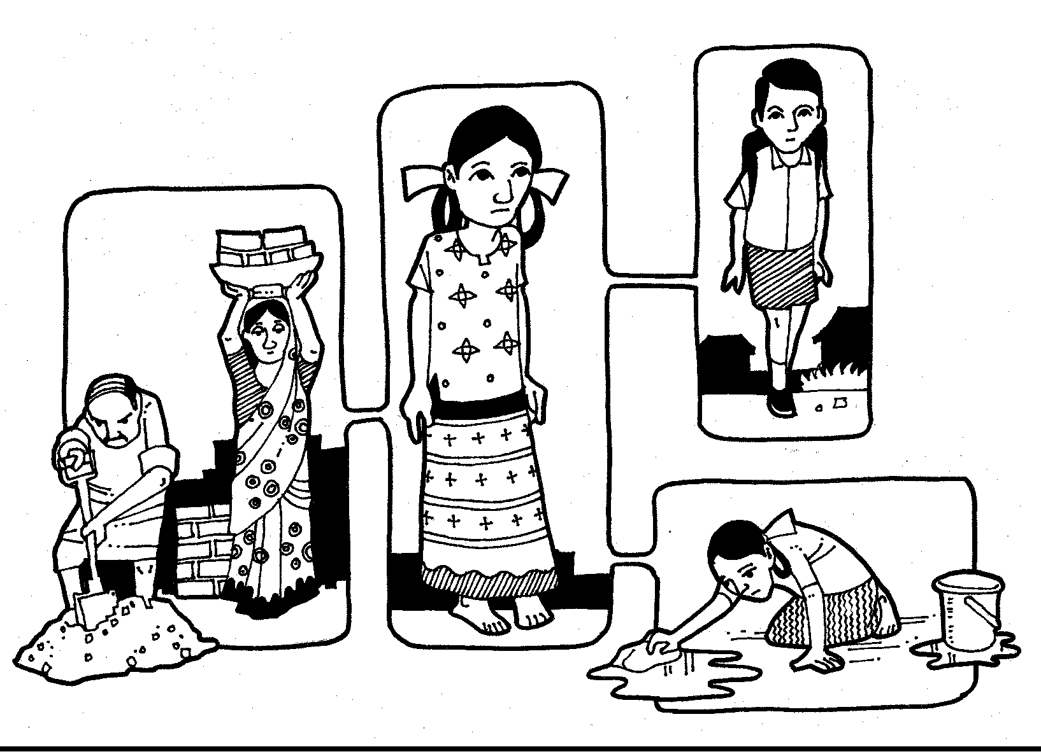
FIGURE 26: CHANDRAMATHI IS AN 18-YEAR-OLD GIRL AFFECTED BY
INTELLECTUAL DISABILITY
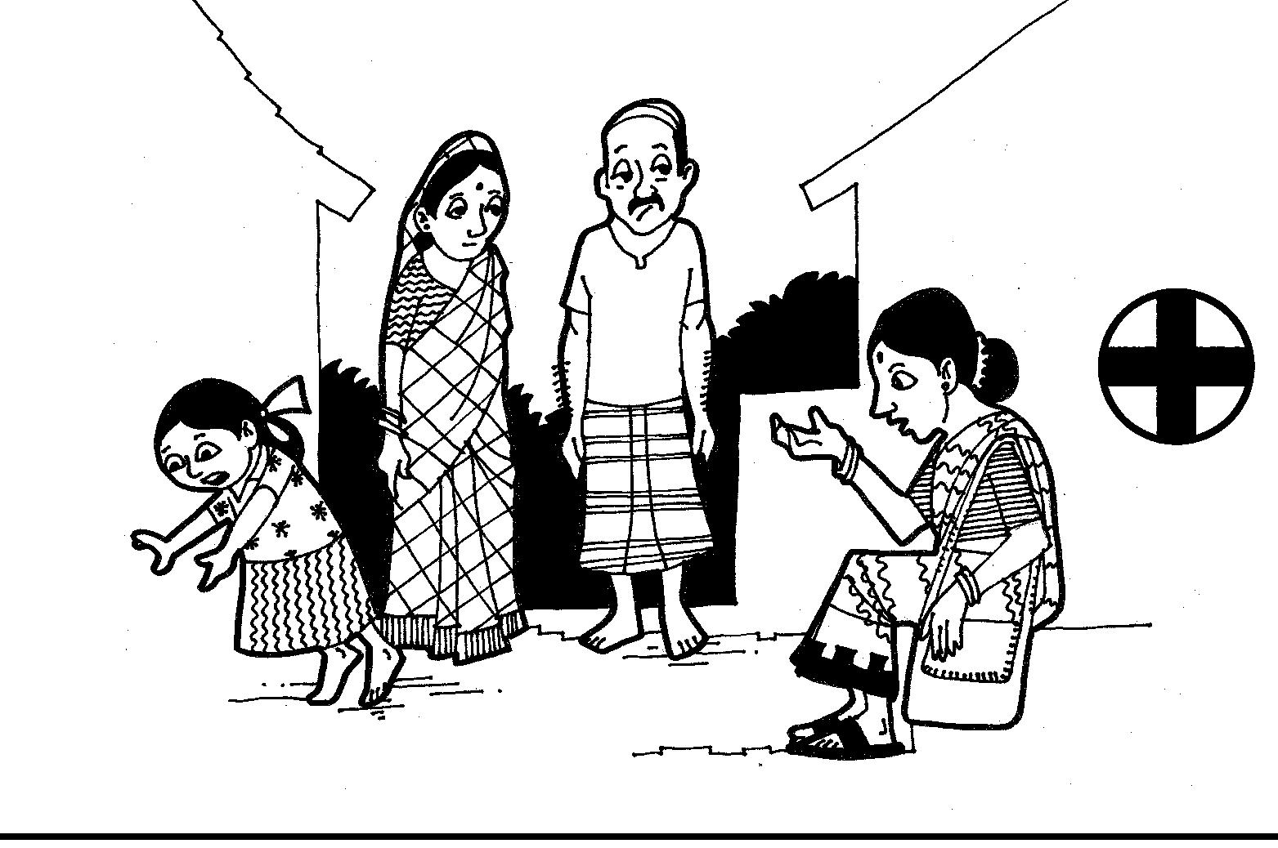
FIGURE 27: CHANDRAMATHI’S PARENTS APPROACH THE HEALTH WORKER
TO UNDERSTAND ABOUT THE SICKNESS OF THEIR CHILD
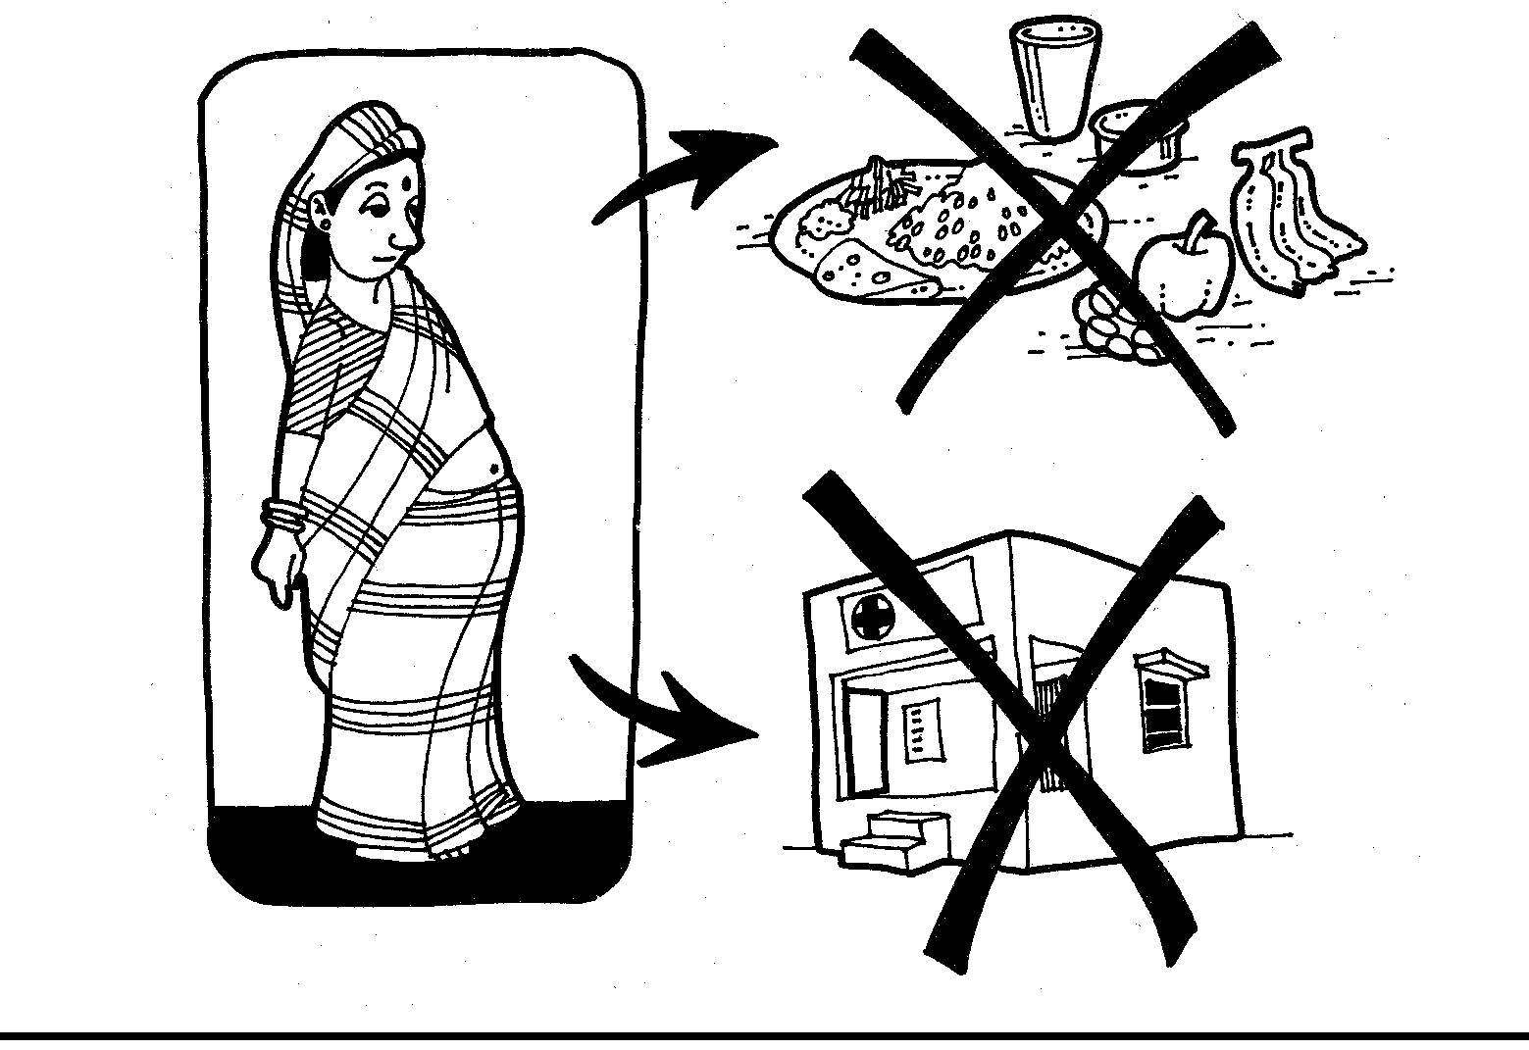
FIGURE 28: THE MOTHER HAD NO ACCESS TO NUTRITIOUS FOOD DURING
PREGNANCY
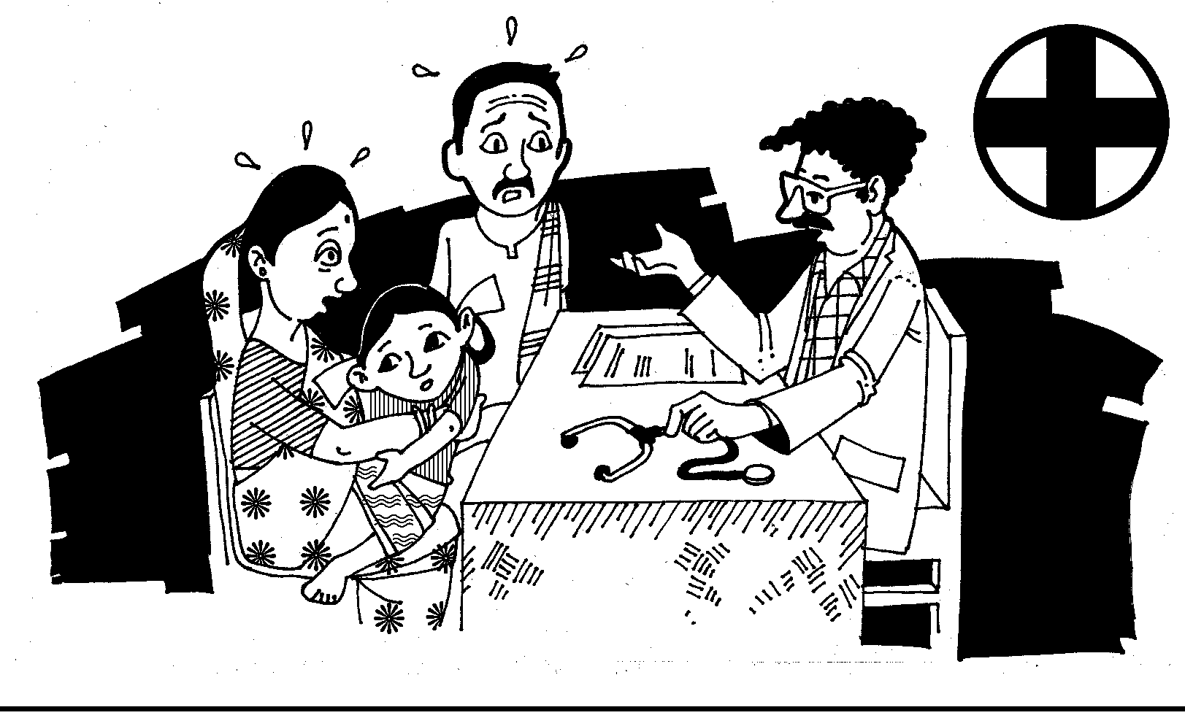
FIGURE 29: DOCTOR INFORMS THE PARENTS THAT THEIR DAUGHTER WOULD
NEVER BE LIKE OTHER CHILDREN
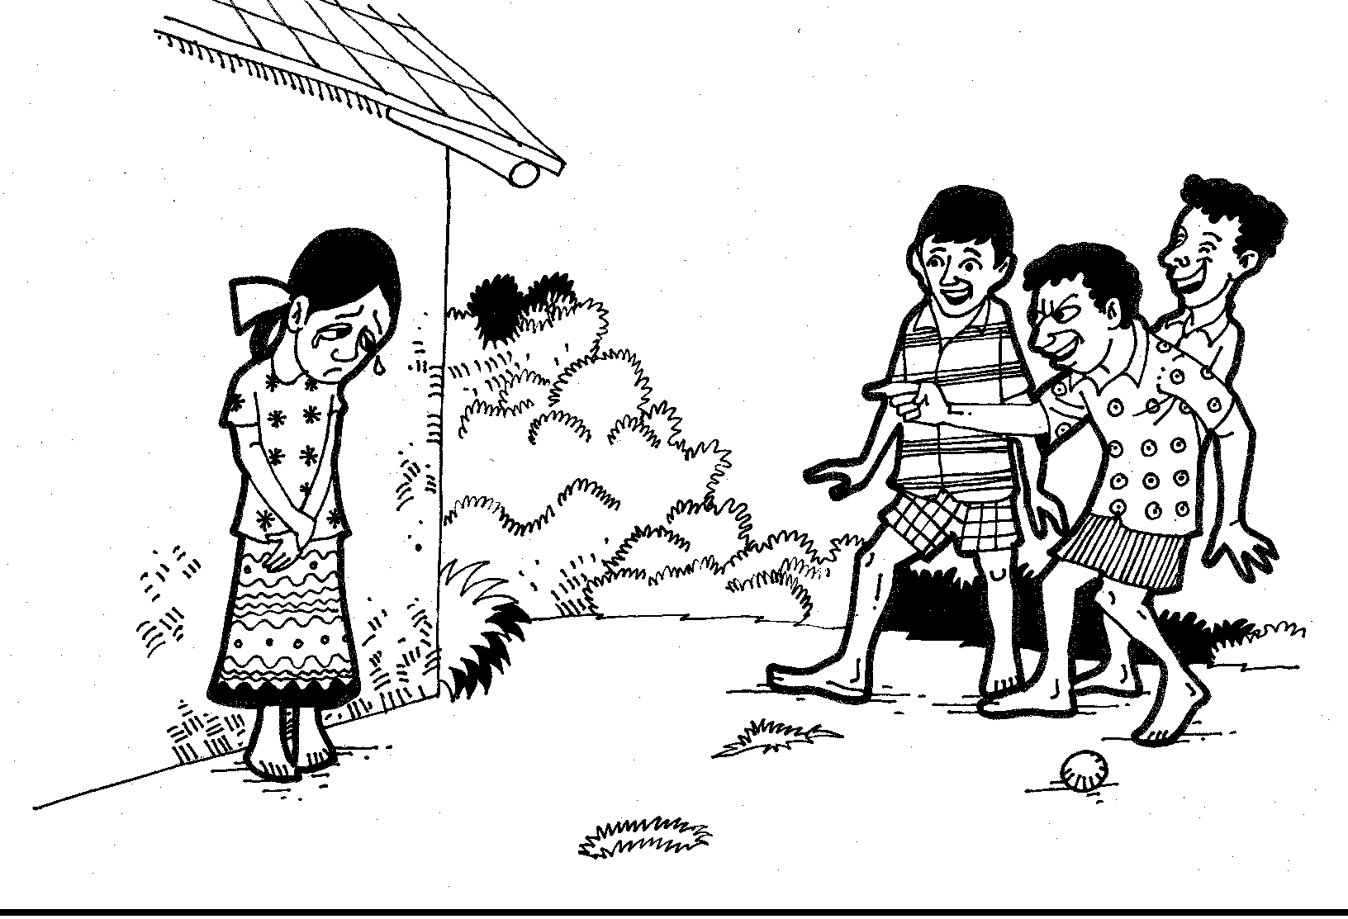
FIGURE 30: CHANDRAMATHI’S BROTHER, SISTER, FRIENDS AND OTHERS
WOULD NEVER PLAY OR TALK TO HER
CASUSES
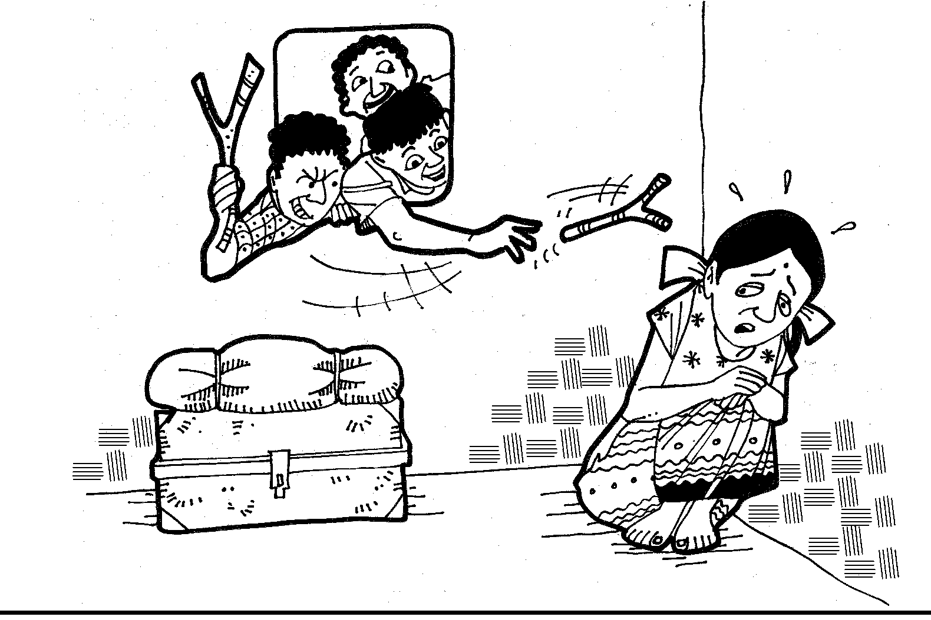
FIGURE 31: OFTEN THEY WOULD TEASE CHANDRAMATHI BY THROWING
THINGS AT HER FROM THE WINDOW
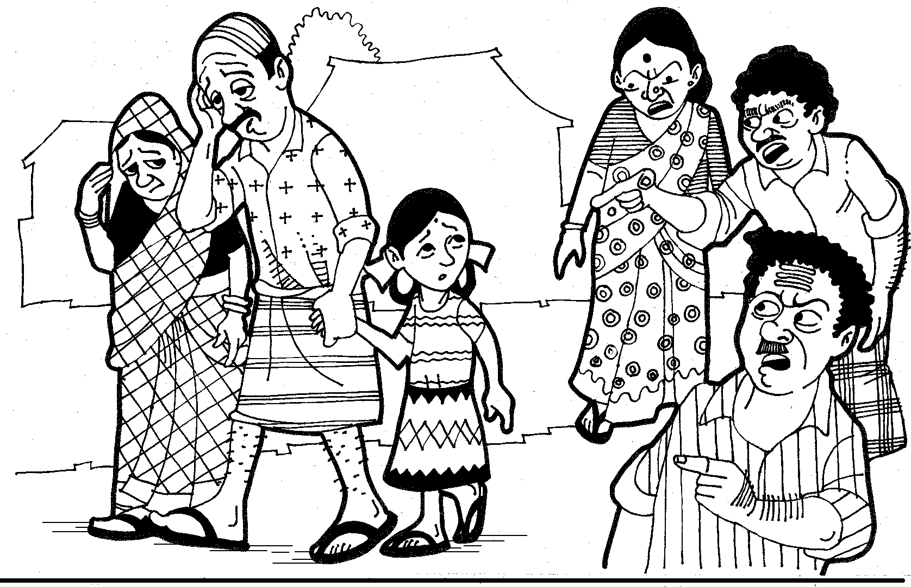
FIGURE 32: OFTEN HER PARENTS WOULD BE CURSED BY THE NEIGHBOURS
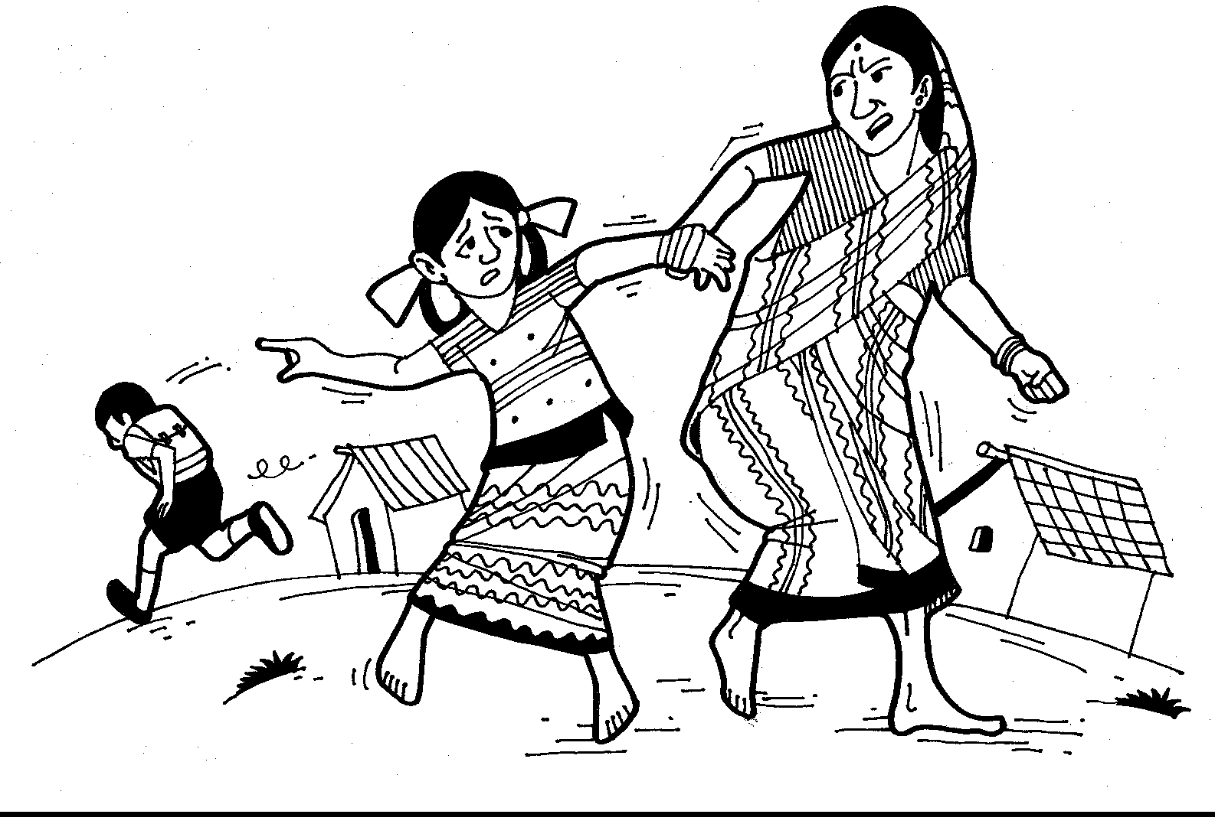
FIGURE 33: CHANDRAMATHI’S MOTHER SCOLDS AND PULLS HER BACK SAYING, “YOU CAN’T GO TO SCHOOL”
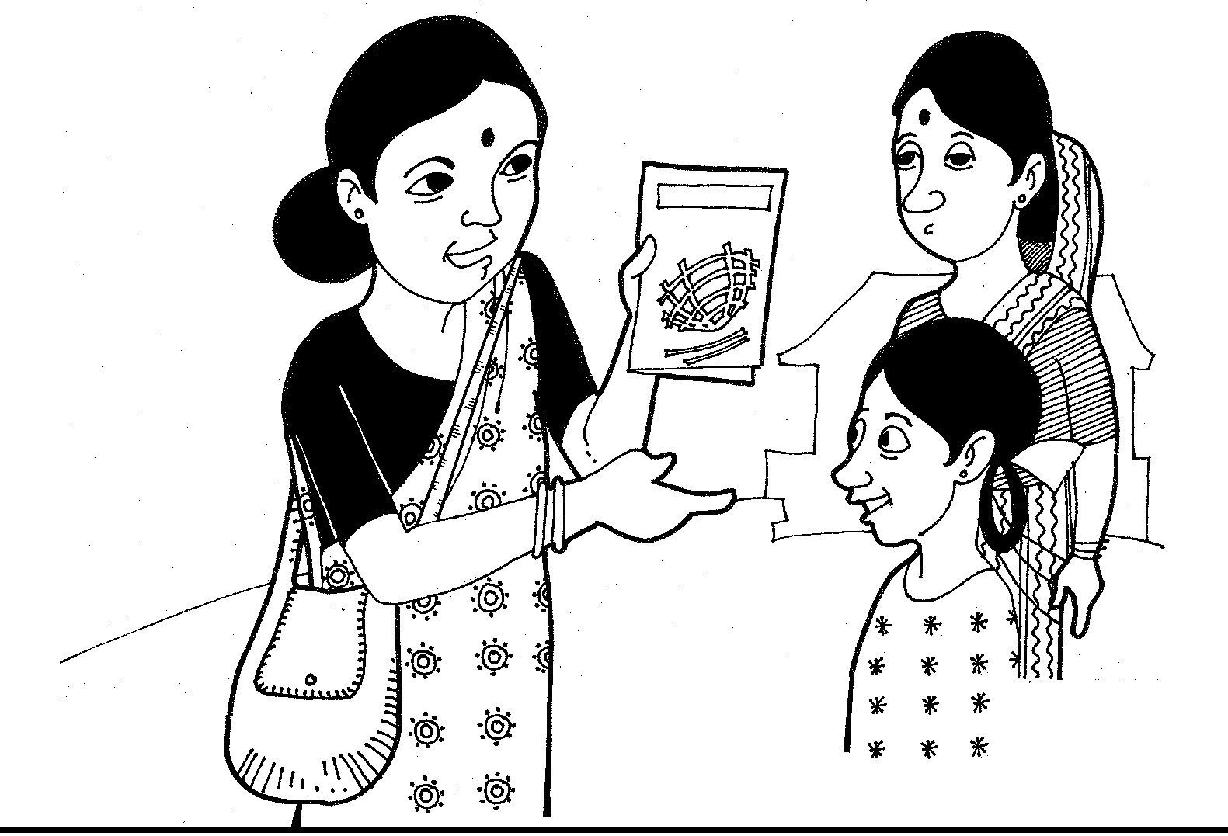
FIGURE 34: COMMUNITY WORKER SUGGESTS TO THE PARENTS TO SEND
THEIR YOUNG GIRL FOR VOCATIONAL TRAINING
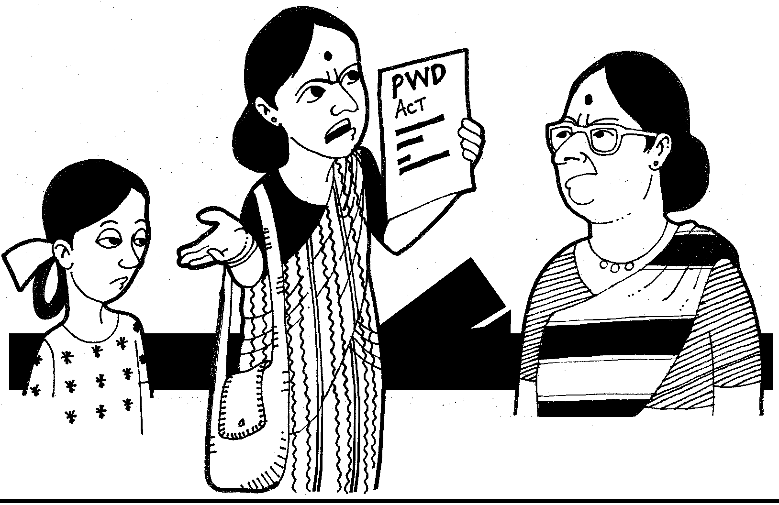
FIGURE 35: THE COMMUNITY WORKER ALSO INFORMS THE FAMILY
ABOUT THE PWD ACT 1995
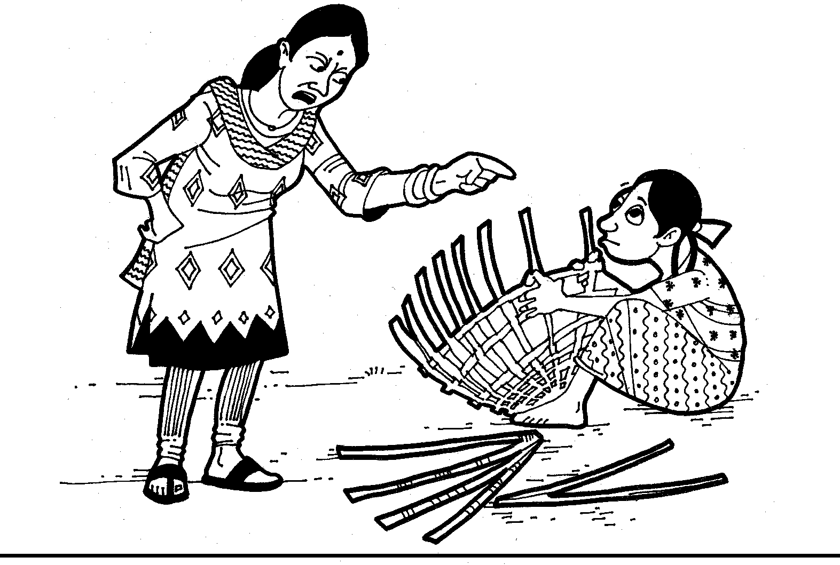
FIGURE 36: AT THE VOCATIONAL TRAINING CENTRE
CHANDRAMATHI IS SPOKEN TO RUDELY BY THE INSTRUCTOR
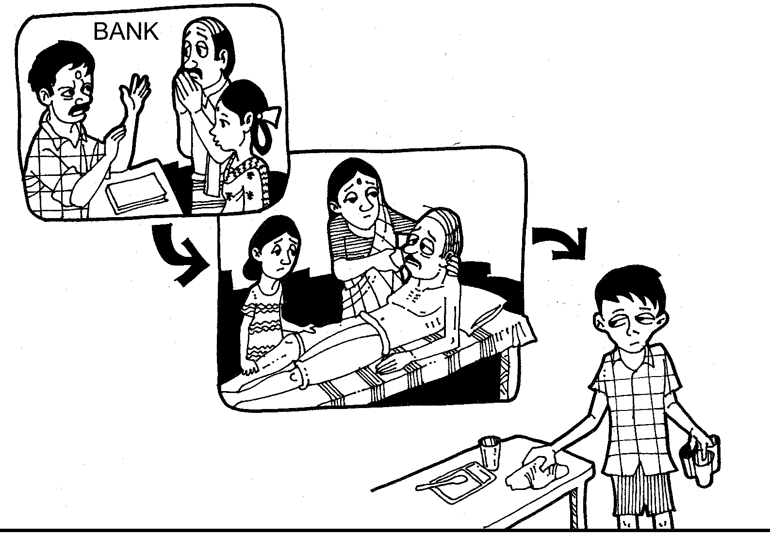
FIGURE 37: THE BANK REFUSES TO GIVE LOAN TO A GIRL WITH MENTAL RETARDATION. THE BROTHER IS FORCED TO EARN A LIVING.
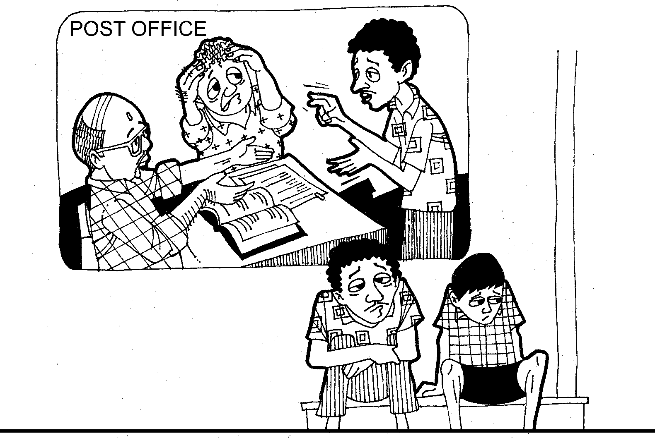
FIGURE 38: THE LOCAL POST OFFICE IS NOT ABLE TO COMMUNICATE
WITH RAJU A BOY, WITH HEARING IMPAIRMENT AND HE IS NOT SELECTED.

PROBLEM ANALYSIS FLOW CHART – CHANDRAMATHI’S STORY
Limited Statistics / census
DPOs not pressurising
PWDs not considered a vote bank
Limited monitoring
3% Budget allocation not fully utilised
Limited Access to Resources (PHC / Schemes/Health)
Limited Aids / Appliances
Isolation (within house)
Less opportunity for participating in social events
Less opportunity for livelihood
Limited interaction with friends/peer group/ neighbour
Low confidence of persons with disabilities emotionally disturbed
Lack of treatment leads to secondary problems
SOCIAL EXCLUSION OF PERSONS WITH DISABILITIES
Teasing
Chronic Poverty
Limited accessibility to physical environment transport and communication
Violation of Human Rights
Inadequate Awareness in Family and Community
Limited opportunity for inclusive education
Limited accessibility in the community / society
Discrimination
Myths / Misconception / Karma Theory
Discrimination on the basis of gender and disability
Limited awareness among Doctors / Therapists / Counselors / Banks / Services Providers/ elected representatives
Limited legal awareness / Act and Policies / Rules
Limited availability of TLM’s
Limited Awareness among teachers
Limited availability of sign language interpreters
Limited Access to ICTs / Assistive Devices

xxxi. Picture Story for Case Analysis
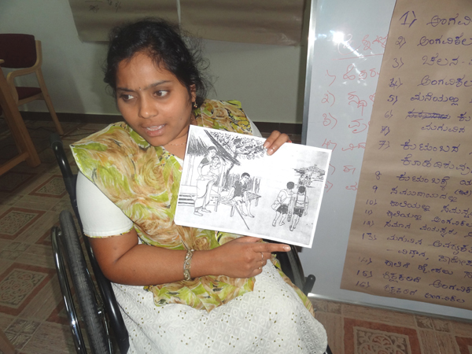
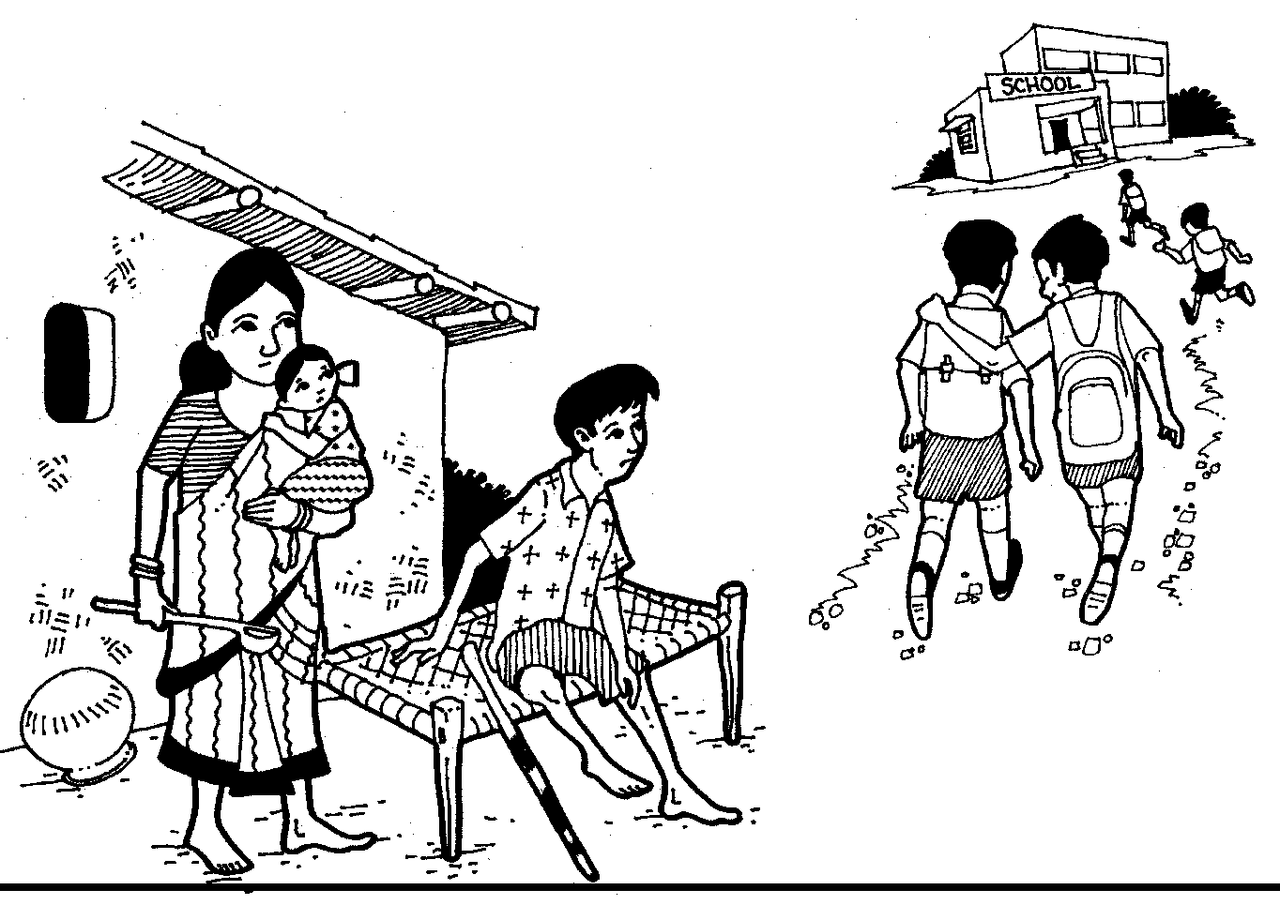
FIGURE 39: SHOW THIS SINGLE PICTURE AND ASK THE
GROUP TO LIST OUT THE CAUSES AND EFFECTS

xxxii. Khurshida’s Story (visual impairment)

Khurshidabanu was born and brought up in Kaprada village in Gujarat. She has been visually impaired since her birth. She has four elder sisters and no brother. One of Khurshida’s elder sisters is also visually impaired. Her three other non-disabled sisters are married and well-settled. The family always faced financial stress because her father Jamiyat Miya is a farmer and the only earning member in the family. As agriculture is heavily dependent on erratic rainfall, the income generated was never enough. Hence, the family was always indebted to the local money lender for one or the other reason like marriage, illness, etc. All the members of the family were engaged in earning and none of them was sent to school.

Once Khurshida grew older, she wished to share the responsibility of the household with her father but was not aware about what she could do. She helped her mother in the household chores and played with her sister’s children when they visited them. Fetching fuel wood and water from the well were the most tedious tasks for Khurshida as many times people would leave unwanted stuff on the pathway and she would bump into them. She often felt very miserable when the neighbour’s children teased her and laughed at her when she passed by. She was never invited to functions in the village like marriages or naming ceremonies of new born babies. In fact, even if she happened to accompany her mother to one of them, she would hear people whispering behind her back that now an evil shadow would be cast on their child as Khurshida had participated.

One day through a radio programme Khurshida came to know about the life stories of a couple of women with visual impairment who had been able to get education and were now gainfully employed. One of them was earning a decent salary as she had a government job and a couple of others were engaged in home-based activities with the support of loans from the local bank. These women with visual impairment who had aired their experiences over the radio were being supported by an NGO.

With the help of a local NGO Khurshida was able to get a disability certificate and bus pass. This was however not easy, as initially her father vehemently objected to the CBR worker taking Khurshida out of the village as he was a male worker. He gathered the village community on this proposition and they all beat him up. On his next visit, the CBR worker came with his boss who was a woman and finally Khurshida’s father agreed to let her go out for getting a disability certificate.

After her mobility training, Khurshida approached the panchayat to apply for work under MGNREGA but was promptly told that there was no work available for blind people, and that too a woman. There was only manual work available and not fit for women. She also applied for a disability pension but this has not yet been approved. She approached the local Mahila Mandal but said that it was not ready to take a blind woman in the group as she would not be able to contribute anything. She was also informed that she should be a member of a disability group where she would find other people like her.

Khurshida then came to know that there was possibility of getting a loan from the local bank under the Swayam Sidhha Microfinance Scheme to start a self-employment venture. She discussed this with her family and they decided to open a petty shop of grocery items in the front yard of the house so that she and her elder sister, who is also visually impaired, could manage it with the support of their parents. Her other sisters also pitched in and began to support her by supplying some saleable items available in their place of residence. Within a couple of months the petty shop began to show signs of profit. This became a source of envy for the neighbours and they all ganged up to try and sabotage her flourishing business by spreading rumors like, if people purchased things from her shop then perhaps their children would be disabled, that she was doing some magic to attract people to buy from her shop and was perhaps selling unhealthy food products, etc. Even though Khurshida’s business was flourishing she faced several obstacles from the community and she began to wonder about what she should do and whom she should approach for help.

PROBLEM ANALYSIS
FLOW CHART
– KHURSHIDA’S
STORY
Health Issues
Low economic condition
Dependent and sub-human living / chronic poverty
Low self-confidence
Limited help/ support from society
Jealousy
SOCIAL EXCLUSION OF PERSONS WITH DISABILITIES
POVERTY
Inadequate agricultural yield
Indebtedness of family
Limited resources
Malnutrition
Limited use of services
Non-acceptance by society in social functions
Limited INFORMATION
Limited availability of support service
Limited data by development organisation
Gender Discrimination
Insensitive towards women with disabilities
Limited opportunities for education and employment for women with disabilities
Discourteous behaviour
Superstitious belief
Disability a stigma
Inaccessible environment
Non-acceptance of women with disabilities in women’s groups

xxxiii. Pramila’s Story (visual impairment)

Pramila is a 30-year-old woman with visual impairment who lives in Harangoan village of Barwani in Madhya Pradesh, India. She was brought up in a poor family with five elder sisters. Her family earned a living as agricultural labourers. As she was visually impaired and the youngest child, she was not expected to work in the fields. Hence when an NGO worker approached her family to provide rehabilitation support, the family agreed. She was educated at the local high school with the support of teachers, friends and family and scored the 1st division in school as well as at the college. She went on to complete her B.Ed. and a certificate course in Computer Application from IGNOU. After completing her education she was informed about a vacancy of a Computer Teacher at the local secondary school through the district Special Employment Exchange of the MP government. This was a golden opportunity for her. She was keen to seek employment so that she could not only support her family, as her father had a huge debt to repay the money lender, but also this would increase her prospects for marriage.

When her friends came to know of her decision to apply for a job, they said, “This is going to be very difficult for you. You better look for something else. Maybe, you can work from home – open a shop or something else. We know of many disabled persons who have applied but the recruiters are not easy to convince. Even if you somehow manage to get in, it won’t be easy for you to adjust to the school environment.” Despite being discouraged, Pramila was determined and she decided to apply. As predicted, the difficulties began even before she entered the examination hall. The admission card for the entrance exam was not provided to her in Braille and hence she had difficulty in locating the room allocated to her at the examination site. When she began to write the exam online, she discovered that the computer was not enabled with the text to speech software and a Braille keyboard. She then requested the examination supervisor for a scribe/ assistant. He angrily replied, “I have to attend to so many applicants. You are not the only one. What is all this you are talking about! I have never heard of this. You should go to a bigger centre where you may get all what you are asking for…” Pramila was unable to take this exam.

Pramila was a member of a local disability group so she approached the secretary of this group for help. The secretary promptly responded and they jointly filed an application with the State Commissioner for Persons with Disabilities. Based on the merit of the case, the Commissioner issued an order to the State Staff Recruitment Board of the Madhya Pradesh Education Department to arrange for a special examination. On-site facilities to enable Pramila to take the entrance exam were provided and Pramila passed the written test with flying colours. She was then required to appear for a panel interview. The interview panel was shocked and reacted when it saw her and asked her several questions about how she could perform her role as she was unable to see. Pramila defended herself well but the recruitment board was not convinced and openly told her, “We cannot appoint you. We don’t think it will be possible for you to manage your class of rowdy students. You should probably look for some other job where you do not have to interact with too many people.” While Pramila was leaving the room, she overheard the panel discussing that it had to fill this position with a person with disability and that it would rather select a suitable male candidate with locomotor disability.

With the support of the disability group, Pramila again filed a complaint with the Disability Commissioner seeking appointment under the 3% reservation of the PWD Act 1995. This time the verdict of the commissioner was not accepted by the Education Department. An appeal was then made to the State High Court which compelled the Education Department to offer her the position after several years.

As a teacher Pramila performed very well and was very popular with the students. She knew each child by name and was on friendly terms with the parents of the children. She also began to have a place in the community, where she was involved in enrolment campaigns of the girl child through the panchayats, counselled pregnant mothers and helped the ASHA health workers identify children for immunisation.

However, her fellow colleagues highly disapproved of Pramila’s style of teaching and interaction with the students and gave negative feedback about her to the school Principal. Pramila was denied a promotion that was due 3 years later as the school authorities were not agreeing to her style of functioning. This was very upsetting for Pramila and she began to wonder when she would have to stop fighting for her rights and how much energy she could muster up to keep on proving herself.

PROBLEM ANALYSISFLOW CHART
PRAMILA’S STORY– 1
DISCRIMINATION

POVERTY
Discrimination based on gender
Discrimination based on disability
Woman with visual impairment not being given a job
Large family

Indebtedness of family

Agriculture dependent on rain/monsoon

LIMITED INFORMATION
Negative attitude of interview committee
Education department not convinced about abilities of persons with disabilities
Negative attitude of principal/ teacher exam supervisor
No access to facilities in examination hall for disabled eg. admission card in Braille, accessible software

WEAK ACCESS TO JUSTICE

Limited powers of Commissioner for Persons with Disabilities

Woman struggling for rights that are due to them
Policies not being implemented
Indifference/ apathy of government machinery
Social exclusion of persons with disabilities
Use of person with disability by family based on their need
Family not considering disabled person fit for participating in agri.activity aagriiculturaactivities
Promotion rules not followed
Investing in persons with disabilities considered wastage of time
Low chances of marriage
Colleague/ teachers uncooperative
Restrictions on mobility
Long struggle for rights by women/ persons with disabilities
Greater effort required by person with disability to prove herself/himself
Despondent attitude
Not aware about 3% reservation

3.4 Engaging Stakeholder Participation

3.4.1 How to Engage Stakeholder Participation (Reading)

A stakeholder is an individual or a group or an institution or a partner who is connected, has a stake, or has a vested interest in the
project. Stakeholders have the potential to be affected, gain or lose with the impact of activities carried out by the project. The participation and involvement of the stakeholder is essential in achieving the goal of the project and ideally they must be involved from the planning stage itself.

Conducting a stakeholder analysis is essential for identifying the issues involved, and for developing a strategic relationship with and between the partners. A Stakeholder Analysis (SA) helps identify the potential threats/ risks and challenges that could be posed to the project and also helps in identifying the actors who could play a positive role in the accomplishment of the project. SA indicates the opportunities and relations that need to be strengthened during the implementation phase. It helps to identify the groups that need to participate in the different stages of the project, devise appropriate strategies for stakeholder engagement and helps to reduce negative impact on project outcomes and on vulnerable groups.

Conducting an SA is an essential component of situation analysis as it enables in identifying the key actors, their importance and influence and how they could be involved in the programme. SA also provides space for examining the role, inclusion, representation and influence of target groups: the distribution of tasks, activities and rewards associated with division of labour between men and women.

SA could be undertaken by organising a workshop, focus group discussion and interviews. Follow the following steps in conducting an SA analysis:

i. Identification of Key Stakeholders
First, identify the key stakeholders whose participation could be sought for the successful implementation and completion of the project. The type of stakeholders could be beneficiaries, supporters, opponents, resource providers and vulnerable groups. Once the list is ready then the stakeholders listed could be prioritised.

TABLE FOR PRIORITISING STAKEHOLDERS
 | Name | Priority level
Beneficiary
Supporters
Opponents
Resource providers
Vulnerable groups
Others

ii. Assessment of Importance and Influence
The next step is to assess the importance, influence and the level of impact each stakeholder has on the project. After the stakeholders have been prioritised, create a profile of each stakeholder. The detailed sheet of each stakeholder could contain all or some of the following information given below:

  - Interest in the project – how will the project benefit them?

  - Perceived expectation or goals in relation to the project – do the stakeholders’ goals or expectation support or are in conflict with the goals of the project?

  - Level of importance for the success of the project – what resources is the stakeholder likely to bring from the project? What is the stakeholder willing to organise for the project? What is the level of interest the stakeholder will have in the project?

  - Potential negative impact on the project – what can the stakeholders prevent from happening? Are there any stakeholders’ interests that are in conflict with project goals?

  - Level of Influence over the project decision making – what is the stakeholders power and status in relation to the project? Does the stakeholder control key resources? Does the stakeholder have informal influence or personal connection that will affect the project? What power do the stakeholders have over implementation of the project or over other stakeholders?

  - Intention to participate according to the project design – does the stakeholder want to be involved or merely need to be informed about the project and its processes? How much does the stakeholder need to participate to make the project a success?

  - Intended use of the project or the project result – how will the stakeholder directly benefit from the project and how will this effect stakeholders motivation?

Once the individual sheets containing the profile of each stakeholder have been made, these could be compiled in the following matrix. The roles of all the stakeholders could be analysed in one matrix to assess the level of importance (interest) and the level of influence (power) it has on the project on a 1-10 scale with 10 indicating very high influence and high importance.

EXAMPLE: STAKEHOLDER PROFILE SUMMARY MATRIX–POLIO ERADICATION
Stakeholder Profile | Role in Project | Motivation | Perceived Expectations and Goals | Importance to the Project for its Success: Level of 1-10 | Potential Negative Impacts of the Stakeholder | Influence on the success or failure of the project Level of 1-10 | Planned / Intended participation methods | How they will use the project for their benefit
Minister of  Health | Overall decision maker | Status for CDC  funds  Success means keeping his job | In line with a  polio eradication project: a knowledgeable minister | 10 | Could pull the  project if another donor priority prevails | 10 | Provide project  document for signature | Status for new  project funding
District Health  Officer | Implementer responsible for outputs | Job-related  success or failure; no financial incentives | Helped design  project; informed and supportive of project goals and objectives | 8 | Could lose  interest or be assigned other priorities | 2 | Help with  implementation | Promotion if the  project is successful
Health  Professional: Doctor, Nurse, Clinic Staff | Implementer | Financial  incentive overtime | Believes in polio  inoculations agrees with the project | 3 – This is part  of their job. | Minimal | 1 | Help with  implementation | Ease of workload
Religious Leader | Cultural  Influence | Beliefs based on  correct or incorrect information | Wants to be  certain that religious practices are not violated | 10 – Parents will  follow what their religious leader says | High potential if  the religious leader says that polio inoculations  could cause harm | 10 | Help with  implementation | Possible  increased credibility
Parent | Beneficiary | Good heath of  child | Fear of illness  because of foreign medicines introduced to child | 10 – must bring  their children to the clinic | Could refuse the  inoculations for the child | 10 – Could  influence their child not to get the inoculation | Recipient | Peace of mind  for children
Child | Beneficiary | Health (no polio) | Fear of shots;  lack of  knowledge about polio | 10 – must get the  inoculation to ensure the project’s numbers are good | Unlikely unless  the parents refuse the inoculation | 1 | Recipient | No polio

Once the list of stakeholders is ready with the level of importance and influence, they will have trust on the project. It will also reflect the relationship in terms of who has more influence and control over whom. The following example from a Polio Eradication Project reflects the stakeholders and the relationship it has with the identified stakeholders. This is very well represented through a Ven diagram. The project – Polio Eradication – is drawn as a big circle. The stakeholders inside and outside the project are represented in smaller circles. The stakeholders represented inside the project circle are: health care professional, child and parent. These are the main stakeholders and are interlinked to one another represented in overlapping circles in the Ven diagram inside the project circle. On the outer side on the periphery of the project circle there are other stakeholders: district health officer, Ministry of Health officer and religious leaders that have greater influence and importance on the project. These stakeholders are represented in larger circles.

Example of Interlinked Stakeholder Circles
Project (Large Circle)

Health Care Professional

CHILD

Religious Leader

PARENT

Size of Circles Indicates Level of Importance and Influence

Stakeholders (Smaller Circles)

MOH Officer
District Health Officer

iii. Engagement and Partnership with Stakeholders
The fourth step is in identifying the role and the level of participation of each stakeholder and the point at which each needs to be engaged in during the implementation phase for a meaningful collaboration. Based on who needs or wants to be involved and how; appropriate partnership strategies will need to be developed for the engagement of each stakeholder. Each stakeholder will be engaged in different ways at each stage of the project: giving and taking information/ advice, consultation, dialogue, working together, partnership and collaboration.

Participation of all stakeholders at each stage of the project is crucial for its successful completion and meaningful impact for the community or target group.

A ladder of participation was developed in the early, ‘90s to enable project planners and developers assess the type of participation/ engagement required from each stakeholder and at what stage. There are various stages of participation and the level of participation is determined by the scope and space for and level of decision making involved in the project by each stakeholder. The ladder could be explained as follows:

- Passive: People or stakeholders participate when they are told to do so and have no stake or role in the decision making.

- Information sharing: Stakeholders either participate by filling out survey forms or in an interview. They do not have a say on the results of the survey or research. Alternatively, stakeholders are provided information about the project but they do not have the opportunity or scope to influence the project as the information is shared after the decisions are taken.

- Consultative: Stakeholders may be consulted and their views and opinions are taken. These are then incorporated into the project wherever need be and possible, at the discretion of the project leader.

- Functional: Stakeholders participate by forming working groups to complete the tasks/ activities that have been pre-determined based on the project objective. They have no role in the project design but their views are taken into account for follow-ups. They are dependent on others for their functioning but in the long run they may become independent.

- Incentive-based: Stakeholders participate by supplying labour or other resources like land for a pilot project and gain materially in the form of cash, food or social goods or training. They have no say in the decision making other than their involvement.

- Interactive: The stakeholders participate with the project planners on an equal basis from the project design stage itself. They participate in the analysis and are able to influence the implementation of the project. This involves structured planning-learning processes and eventually transits towards local control and management of the project.

- Self-development: The stakeholders are the original designers of the project and take control over the project design formulation. External parties play an advisory and supportive role.
Self-development


Interactive
Incentive-based

Functional

Information sharing/ providers
Consultative

Information
sharing/ providers

Consultative
Passive

Participation Ladder
Passive
Finally, list out in a separate sheet the three main participation levels that will be used in your particular project and the purpose for which the stakeholder will be engaged.

iv. Developing Effective Strategies for Stakeholder Engagement
The final step in the SA is to link the stakeholders’ profile with the categories mentioned in the participation ladder and identify practical strategies for the engagement of the stakeholders. Various methods could be used to engage the participation of stakeholders like workshops, interviews, role plays, small group discussions (round robin method).

EXAMPLE: STAKEHOLDER PARTICIPATION-LEVEL MATRIX
Stakeholder Participation Matrix for Polio Eradication Project;
*Checked boxes apply to each Stakeholder in terms of his/her level of participation in the Project

Stakeholder Name /Ladder of Participation Ranking | Information- Sharing | Consultation | Provision of Material Incentives | Functional Group Formation | Collaboration in Decision Making | Empowerment and Self- Actualisation as a Decision Maker
Ministry of Health | xx | xx |  | xx | xx
District Health Officer | xx | xx |  | xx | xx | xx
Health Care Professionals | xx | xx | xx
Religious Leader | xx | xx | xx |  | xx | xx
Parents of local schools, children | xx | xx | xx |  | xx
Children | xx
Source: http://www.cdc.gov/globalhealth/SMDP/
References
- World Bank Group: What is Stakeholder Analysis?
http://www1.worldbank.org/publicsector/anticorrupt/PoliticalEconomy/PDFVersion.pdf

- http://www.who.int/management/partnerships/overall/GuidelinesConductingStakeholderAnalysis.pdf

- World Wildlife Fund (2005); Cross Cutting Tool: Stakeholder Analysis

- Strategic Planning for Voluntary Development Organisations: A Workshop Manual for Facilitators, PRIA, New Delhi.

- Jennifer Rietbergen-McCracken and Deepa Narayan, Stakeholder Analysis. Module II, Washington DC: Social Policy and Resettlement Division, Environment Department, The World Bank, 1997.

- Jennifer Rietbergen-McCracken and Deepa Narayan, Beneficiary Assessment, Washington DC: Social Policy and Resettlement Division, Environment Department, The World Bank, 1997.

- Jennifer Rietbergen - McCracken and Deepa Narayan, Social Assessment, Washington DC: Social Policy and Resettlement Division, Environment Department, The World Bank, 1997.

- Stakeholder Analysis – An Introduction: Participant Webinar Workbook. Sustainable Management Development Program, Division of Public Health Systems and Workforce Development, Center for Global Health, U.S. Centers for Disease Control and Prevention. Version 1.0
http://www.cdc.gov/globalhealth/SMDP/

3.4.2 Session Plan and Facilitation Notes: Engaging Stakeholder Participation

Session I - Converting the Problems of Social Exclusion into Achievable Objectives
Time: 1 hour
Materials: Flipcharts, markers, white board, Reading on How to Engage Stakeholder Participation
Method: Large group discussions in the plenary
Objective:
The participants will be able to convert the problems or barriers to social inclusion based on their own experience into achievable objective/ outcomes.

Process:
- Ask the participants that if ‘Social Exclusion of Persons with Disabilities” is the focal problem, then how this negative state could be converted positively. The answer would be ‘Promoting Social Inclusion of persons with Disabilities’
- Ask the participants to convert all the key causes identified and classified in the previous exercise into a positive statements or achievable objective statements that are practical and achievable.
For example, the broad objective statement could be ‘To create awareness about persons with disabilities or on disability rights’ for the negative state – low awareness
- Similarly convert the effects positively

Facilitator’s Note:
The following are 3 sets of examples of converting the causes into achievable objective statements and the negative state of effects into positive states:

Example 1
Causes Converted Positively
CAUSES | OBJECTIVE STATEMENT
Limited awareness on disability | Create awareness on rights of persons with disabilities
Poverty | Promote livelihood for the families of persons with disabilities and for persons with disabilities
Limited access to information on health | Promote access to information on health services
Injustice / discrimination | Advocacy and lobby for promoting disability rights

Negative Effects Converted Positively
EFFECTS (NEGATIVE STATE) | EFFECTS (POSITIVE STATE)
Dependent | Independent
Isolation | Increased association with friends
Neglect | Empathy
Low self-confidence | Confidence built
Non-acceptance | More encouragement

Example 2
Causes Converted Positively
CAUSES | OBJECTIVE STATEMENT
Violation of Human Rights | Protection of Human Rights
Limited Accessibility  - Physical  - Communication | Creating barrier-free built environment and access to information in accessible formats
Limited awareness | Creating awareness on disability
Limited opportunity for Inclusive Education | Compulsory inclusive education for people with disability
Limited statistics on disability | Promote research and studies to make available data and experiences on disability

Negative Effects Converted Positively
EFFECTS (NEGATIVE STATE) | EFFECTS (POSITIVE STATE)
Isolation | Included with everyone
Low self-confidence | Increased self-confidence
Less opportunity for participation | Create more opportunities for participation in decision making
Teasing | Respect for all

Example 3
Causes Converted Positively
CAUSES | OBJECTIVE STATEMENT
Limited awareness/information on disability | Create awareness on rights of persons with disabilities
Limited access to the built environment | Create barrier built-free environment
Poverty | Create employment/ livelihood opportunities according to skills
Aids and appliances not disbursed properly | Improve access to aids and appliances
Discrimination | Enable persons with disabilities to collectively demand their rights

Negative Effects Converted Positively
EFFECTS (NEGATIVE STATE) | EFFECTS (POSITIVE STATE)
Low self-confidence | Increased self-confidence / shyness
Frustration | Encouragement
Loneliness | Maintains relationships with friend and relatives
Disrespect the needs/aspirations of persons with disabilities | Respect the needs, aspirations of persons with disabilities
Negligence | Acceptance
Stress | Balanced / peaceful/ contented
Unable to get married because of disability | Get opportunity for socialising
Teasing | Friendship/ companionship

Session II: Stakeholder Analysis
Time: 2 hours
Materials: Flipcharts, whiteboard / blackboard / markers, Reading 3
Method: Small group and large group discussion
Objective:
  - The participants will be able to demonstrate from their experience how the problems are converted into achievable objective
  - The participants will be able to develop a list of stakeholders for achieving the stated objective in their own environmental context
  - The participants will be able to analyse the level of influence and control or power each stakeholder has based on their own experience for meeting the stated objective
  - The participants will be able to work out suitable strategies to engage the participation of all the stakeholders for fulfilling the stated objective deriving insights from their own experience

Process:
- Explain the main goal and objectives of an intervention from the list of objectives formulated in the last session and explain how programmes are built on the main causes with examples from the objective formulated in the last session
- Divide the large group into groups of 8-10 persons and ask them to take up one cause each from the objectives listed and identify the stakeholders from the village level to the State level for inclusion of persons with disabilities. Take an example to demonstrate the stakeholders at the village level beginning from the disabled child/ persons, family, neighbours, community, panchayat – pradhan, members, gram sevak, talati/ patwari – Village Management Committee (VMC), School Management Committee (SMC), teachers, etc. Tell the group to make a list in this way from the village to the State to the national level
- Ask the participant to articulate each stakeholder’s association and strategies for engagement.
- Ask the participants which of these stakeholders are more crucial. The crucial ones are referred to as primary stakeholders. The others could be categorised as secondary stakeholders.
- Highlight the need for doing such analysis and planning before taking an action to meet their objectives.

Facilitator’s note:
The following examples could be used to further explain how this could be done:

Example 1
- Take a simple example like ‘arranging a marriage’ to prepare a list of stakeholders
- Explain the difference between listing the tasks to be done and the stakeholders that one would need to interact
- List of the stakeholders for arranging a marriage on a flipchart like: photographer, band party, decorator, caterer, market/ shopkeepers, money lenders, pandit/ maulvi, marriage hall, ghodi/ car, drunkard neighbour, relatives, family, etc.
- Another example could be ‘construction of a house’. Ask the participants to list down whose help they would need or take to build a house.
- List the participants’ responses on the flipchart/ whiteboard / blackboard, i.e. mason, construction worker, neighbours, shopkeepers, transport agency, bank, SHGs, etc. Then ask who would create obstacles in making the house and list these responses separately on the board, i.e. - panchayat, family members, forest department, neighbours, etc.
- Summarise the discussion by saying that all these people have a role to play in building a house. Some of them will support and some others will oppose. But all of them have some interest or gain from this. They are called ‘Stakeholders’. Whatever work is to be done requires the support of others, as it cannot be done alone.
- Coming back to the list of objectives formulated in the previous session, explain to the participants that persons / groups playing a negative role will need to be converted to play a positive role. Each Stakeholder has a level of power or control and influence, for example – parents have less influence and power/control whereas the School Education Board has greater power/control and influence. DPOs need to develop some mechanism to ensure the participation of all stakeholders in order to achieve their objective.

Example 2:
The following are some of the enabling and hindering stakeholders for promoting inclusive education:

Enabling Stakeholder:
- Parents
- Headmaster of the School
- Private Tutor
- Friends
- Directorate of Sarva Siksha Abhiyan
- School Management Committee
- School Inspector
- District Education Inspector
- School Education Board
- Rehabilitation Institutes
- Special Educators
- Commissioner (Disability)
- NGOs working on Education and Disability
- Parents Network
- Students with disabilities

Hindering Stakeholders:
- Headmaster of the School
- School Management Committee
- Parents
- Relatives and community members
- Friends

Stakeholders who will not do anything:
- Families with non-disabled children
- Shopkeepers
- Youth Clubs
- Panchayat
- Political Party
- Political Leaders
- Local Leaders
- Religious Leaders

Political Leaders have great influence but medium importance/ power/control in bringing change in the examination system of the Secondary Examination Board. Similarly Secondary Examination Board has high influence and importance because this government body decides the exam schedule, conducts examination throughout the State and publishes result.

- Ask the participants who is most important in a school. Most likely, the response would be the students. Students have high importance/ control/ power but low influence. The headmaster has high importance/ control/ power and high influence but rickshaw puller who brings students to the school has less importance/control/power and influence as he is not directly linked with the education of children with disabilities.
- A chart showing the inter-relationship of importance and influence could be drawn as given below and ask the participants to place the names of stakeholders in the chart as per their importance and influence.
- Enable participants with visual impairment understand the diagram, place the hand of the participants with visual impairment on a tactile draw diagram and through touch help them to understand how ‘X’ axis (level of importance/control/power) and ‘Y’ axis (level of influence) are merging together.
- After placing stakeholders in the diagram as per their importance and influence, divide the diagram in four parts and explain the approaches to deal with them towards achieving the goal of the DPO.

I M P O R T A N C E/ CONTROL/ POWER

High Medium Low
Higher Secondary School Certificate (HSC) Board  High  Commissioner (Disability)  I  N  F  L  U  E  N  C  E | Political leaders
Medium | Headmaster | Religious leaders
Children with disabilities and their parents  Low |  | Neighbours, shopkeepers

Four approaches to engaging stakeholder participation:
- Empowering: Children with disabilities and their parents have low influence and high importance. So the DPO needs to keep in constant touch with them to make them aware of disability as well as rights of persons with disabilities.
- Sharing: School Board and Commissioner (disability) have high importance and influence. DPOs should keep regular contact with them either by sending letters or meeting personally. They could share the status of persons with disabilities in their village/ block and also seek support (i.e. asking for data on disability - related issues) to strengthen their collective action.
- Strategic Communication: Political leaders have high influence but medium importance. The DPOs should build rapport with them, invite them in their programme and try to mobilise them to support persons with disabilities to lead a dignified life.
- Engaging not so significant stakeholders: The DPOs could also invite religious leaders in their programme to build rapport and to make them feel that they are also important for persons with disabilities and their groups. This will help the DPO in getting support of religious leaders as and when required.

Neighbours and shopkeepers have low influence and importance. So the DPO should involve them in their activities, otherwise they may create obstacles in achieving this objective.

Example 2:
‘Creating awareness on disability rights’
- Ask the group to make a list of stakeholders about 50-60 (given at the end of this exercise) at least for achieving the above objective. Ask the group to make a list of stakeholders from the village, taluka, district, State and national levels.
- There are different techniques to work with stakeholders who are directly and indirectly responsible. A few in the list generated will have direct responsibility in executing the implementation of rights of persons with disabilities. Some would be responsible for linking entitlements to persons with disabilities. Some would be more powerful in making and influencing the framing of policies and adopting suitable amendments to already available policies. There are different methods to approach each group of stakeholders to smooth the life of persons with disability to enjoy their rights at par with others in the society.
- The first group of stakeholders, at village level like village headmen, panchayat secretaries, teachers, health workers, etc., needs to be followed up regularly to meet the desired needs like medical certificate, identity card, pensions, transport concession, etc. Persons with disabilities or village-level DPOs need to build good relationships and communicate in such a manner so that the local service providers are not embarrassed. If the above mentioned service providers are not cooperative then, as a first step, discussions need to be held with them regarding the problem affecting the issue. Engage their participation by first talking to them and negotiate with them to solve the smaller issues.
- The second level of stakeholder groups is at the block and district levels. Involve block level and district level stakeholders in the programme and communicate with them the facts and figures as evidence to convince them to look into the needs and requests of persons with disabilities. This type of involvement with the block level and district level authorities helps to address any hurdles in getting the entitlement and provision meant for persons with disabilities. This means that the DPO should have full knowledge of the issue that they are presenting.
- The third level of stakeholders has a more powerful influence or control in policy making and amendments to rules. To engage policy makers on disability or any particular development issues the DPO should seek the support from other similar groups and also build alliance with other community - based groups to present the issues to authorities at the State and national levels. To draw the attention of State-level authorities, DPOs need to network with other community-based groups at block level, district level and State level to influence the State-level authorities.

Facilitator’s note:
- Ask the participants questions to enable them to understand why creating awareness is important both for stakeholders and for persons with disabilities. Why is it important to have a broader objective beyond just addressing persons with disabilities? Explain that as per the social model, there are several stakeholders who can contribute to mainstreaming. It is important that these stakeholders are made aware of the needs and rights of persons with disabilities, and also their roles are well articulated.

TABLE OF STAKEHOLDER ANALYSIS (Example)
(√) symbol is used in the table for High, Medium and Low Influence and (O) symbol used is for High, Medium and Low control or power
Stakeholder | High influence/ control or power | Medium  influence/  control or  power | Less influence/ control or power | Strategies for engaging participation
Persons with Disabilities | √ |  | O | Persons with disabilities should accept their disability, CBR training, contact with other persons with disabilities, be aware of their rights, develop role models of persons with disabilities, involve persons with disabilities in the activities of the DPOs/ Self-help groups
Parents |  |  | O √ | Counselling for acceptance, creating awareness, ask for policy changes and advocacy
Family/ relatives/ community/ villagers |  | O | √ | Counselling for acceptance, creating awareness, share positive stories of persons with disabilities
Director of Disability Affairs Department/ Social Defence Department/ Department of Social Justice and Empowerment | √ | O |  | Sensitisation, press for implementation and monitoring of schemes, advocate with them to sensitise other departments
Media | √ |  | O | Rapport building and regular follow-up and updates
Panchayat Representatives/ committees at all levels | O | √ |  | Sensitisation on disability and advocate with the panchayat to implement schemes
Police /ACP | √ | O |  | Invite them for meetings, follow-up and changing policies and practices
MLA / MP / MLC | √ |  | O | Invite them for meetings, influence and follow up for changing policies and practices
DC | √ | O |  | Discuss issues and issue notice for action
Doctors/ health departments./ district and State civil hospitals |  | √ O |  | Sensitisation, counselling, guidance and confidence building, CBR
District & block level court / lawyers/ judges (High and District Courts) | √ | √ O |  | Sensitisation, file cases and demonstrate case laws
DPOs | √ |  |  | Sensitisation, advocate for disability rights
Corporators/ counsellors | √ | O |  | Conducting awareness programmes for the officials and provide suggestions to government
Chief Commissioner for Persons with Disabilities /Commissioner for Persons with Disabilities | √ | O |  | Bring to notice disability issues, raise awareness about disability laws/ policies, provide suggestions to government departments
Department of Women and Child Development | √ | O
Rural Development Department (Panchayat Raj) | √ | O
Child Welfare Committee | √ O
State Human Rights Commission | √ | O
Juvenile Justice Board | √ O
Chief Minister | √ |  | O
Child Rights Commission | √ | O
Rotary Club | O | √
WHO Rehabilitation Centre | √ | O
Transport Department |  | √ O
Youth and Linguistic Club | √ O
Religious leaders | √ |  | O
Women’s Commission | √ | O
Rehabilitation Council of India | √ | O
Celebrities from film and sports industry | √ |  | O
District Disability Rehabilitation Centre | √ | O
Banks |  | √ O
Post Office | O | √
Gram Panchayat – sarpanch, elected members, gram sevaks | O | √
TDO/DDO/BDO/ Talati/ Mamlatdar | O |  | √ | Raise issues of persons with disabilities in the gram sabha, training /sensitisation on disability during their meetings (monthly), advocacy for pro-active disclosure
DPO, DEO, GCERT, NCERT, MHRT / Education Department/ school/ teachers/ students |  | O | √ | Sensitisation, making available accessible books/ TLMs, promoting inclusive education, reviewing curriculum from a disability perspective
State Transport |  | O | √
Asha worker / Anganwadi / Balwadi worker/ ANMS/ Doctors /health professionals |  |  | √ | Awareness and information through meetings, incorporate early identification and diagnosis in this curriculum, raise issues in the village health committee, enable persons with disabilities to be representatives on these committees
Post, bank, railway, courier |  | √ | O
Family and Child Welfare Department |  | O | √
Consumer protection units | √ O
ITI |  | √ O
Corporates | O |  | √
Religious institutions | O |  | √
Anti-corruption bureau | √ | O
Bank officer |  | √ O |  | Sensitisation, provide evidence-based data on exclusion or non-participation of children with disabilities in schools
Chairman block level |  | O | √
Counsellor block level |  | O | √
Depot manager transport |  | √ O
Fire engine officer | O | √
Other NGOs in the block /Social groups |  | √ |  | Network, support on other issues,  engage in advocacy on disability issue
Public works department | O | √
Post | O | √
Electric department | O | √
Telecommunication | O | √
Temple authority |  | √ O
Employment exchange/ Employers (Public and Private) |  | √ O |  | Sensitise on abilities of persons with disabilities, inform about incentives and provision of 3% reservation under PWD Act, advocate recruitment, equal pay for equal work, sharing of experiences of employers who have employed persons with disabilities
District rehab office |  | O | √
SC / ST Corporation |  | √ O
District bank authority |  | √ O
District transport officer |  | √ O

3.4.3 Scope and Applicability
This section elaborates the rational, objectives and the pedagogical approaches for conducting ‘Perspective Building and Situation Analysis’ for persons with cross disabilities, particularly persons with visual impairment (the totally blind and low vision), hearing impaired, cerebral palsy and other disabilities. In each of the sessions specific mention has been made how the learning needs of each of the groups could be addressed. For persons who are totally blind, material is to be made available in Braille as well as in audio form as there could be persons with visual impairment who may not be familiar with Braille. All matter written on flipcharts/ whiteboard is to be read aloud more than once. For persons with low vision material is to be made available in large print and they should also be seated in the front row. Communicating with persons with speech and hearing impaired is a challenge as there are variations in using sign language; hence it needs to be ensured that the sign language interpreter knows the sign language that the persons with hearing impairment understands. Visuals are useful for persons with sign hearing impairment as sign language does not follow the grammar pattern of languages. The concepts and sentences need to be broken down and communication is in terms of objects or words with suitable day-to-day examples. Visuals are also useful for persons who are semi-literate or illiterate. If this is done with the tips mentioned in the facilitator’s note, the applicability and scope of this module could be universalised.

The only thing that perhaps needs to be done is to generate region-specific cases for the approaches as well as for analysing the causes and effects of social exclusion of persons with disabilities. In the current toolkit, cases have been made keeping in focus the situation of persons with disabilities from western, eastern and southern parts of India. Once the concepts and methodology and pedagogical approach are clearly understood, region / country-specific cases could be evolved by the members of the DPO who have some background in participatory training.
